UNITED STATES

SECURITIES AND EXCHANGE COMMISSION
Washington, D. C. 20549

__________________

FORM 10-Q

__________________

(Mark One)

- QUARTERLY REPORT PURSUANT TO SECTION 13 OR 15(d) OF THE SECURITIES EXCHANGE ACT OF 1934

For the quarterly period ended March 28, 2021

or

- TRANSITION REPORT PURSUANT TO SECTION 13 OR 15(d) OF THE SECURITIES EXCHANGE ACT OF 1934 Commission File Number 1-6682
__________________

HASBRO, INC.

(Exact name of registrant as specified in its charter)

Rhode Island

(State or other jurisdiction of incorporation or organization)

05-0155090

(I.R.S. Employer Identification No.)

1027 Newport Avenue

Pawtucket, Rhode Island

(Address of Principal Executive Offices)

02861

(Zip Code)

(401) 431-8697

Registrant's telephone number, including area code

Securities registered pursuant to Section 12(b) of the Act:

Title of each class

Trading Symbol(s)

Name of each exchange on which registered

Common Stock, $0.50 par value per share

HAS

The NASDAQ Global Select Market

Indicate by check mark whether the registrant (1) has filed all reports required to be filed by Section 13 or 15(d) of the Securities Exchange Act of 1934 during the preceding 12 months (or for such shorter period that the registrant was required to file such reports), and (2) has been subject to such filing requirements for the past 90 days. Yes [x] No [ ]

Indicate by check mark whether the registrant has submitted electronically every Interactive Data File required to be submitted pursuant to Rule 405 of Regulation S-T during the preceding 12 months (or for such shorter period that the registrant was required to submit such files). Yes [x] No [ ]

Indicate by check mark whether the registrant is a large accelerated filer, an accelerated filer, a non-accelerated filer, a smaller reporting company, or an emerging growth company. See definitions of "large accelerated filer," "accelerated filer," "smaller reporting company," and "emerging growth company" in Rule 12b-2 of the Exchange Act.

Large accelerated filer | x | Accelerated filer | ☐
Non-accelerated filer | ☐ | Smaller reporting company | ☐
 |  | Emerging growth company | ☐

If an emerging growth company, indicate by check mark if the registrant has elected not to use the extended transition period for complying with any new or revised financial accounting standards provided pursuant to Section 13(a) of the Exchange Act. [ ]

Indicate by check mark whether the registrant is a shell company (as defined in Rule 12b-2 of the Exchange Act). | Yes ☐ No [x]
The number of shares of Common Stock, par value $.50 per share, outstanding as of April 27, 2021 was 137,568,617.

PART I. FINANCIAL INFORMATION

Item 1. Financial Statements.

HASBRO, INC. AND SUBSIDIARIES

Consolidated Balance Sheets

(Millions of Dollars Except Share Data)

(Unaudited)

 |  |  |  | March 28, |  |  | March 29, |  |  | December 27,
 |  |  |  | 2021 |  |  | 2020 |  |  | 2020
ASSETS
Current assets
Cash and cash equivalents including restricted cash of $72.1 million, $86.2 million and $73.2 million |  |  | $ | 1,430.4 |  | $ | 1,237.9 |  | $ | 1,449.7
Accounts receivable, less allowance for doubtful accounts of $32.5 million, $16.9 million and $28.1 million |  |  |  | 810.4 |  |  | 963.8 |  |  | 1,391.7
Inventories |  |  |  | 429.2 |  |  | 444.4 |  |  | 395.6
Prepaid expenses and other current assets |  |  |  | 566.0 |  |  | 672.4 |  |  | 609.6
 | Total current assets |  |  | 3,236.0 |  |  | 3,318.5 |  |  | 3,846.6
Property, plant and equipment, less accumulated depreciation of $563.5 million, $513.2 million and $553.0 million |  |  |  | 482.7 |  |  | 455.9 |  |  | 489.0
Other assets
Goodwill |  |  |  | 3,691.4 |  |  | 3,572.7 |  |  | 3,691.7
Other intangible assets, net of accumulated amortization of $999.7 million, $932.0 million and $964.6 million |  |  |  | 1,513.0 |  |  | 1,615.8 |  |  | 1,530.8
Other |  |  |  | 1,266.0 |  |  | 1,461.5 |  |  | 1,260.2
 | Total other assets |  |  | 6,470.4 |  |  | 6,650.0 |  |  | 6,482.7
 | Total assets |  | $ | 10,189.1 |  | $ | 10,424.4 |  | $ | 10,818.3
LIABILITIES, NONCONTROLLING INTERESTS AND SHAREHOLDERS' EQUITY
Current liabilities
Short-term borrowings |  |  | $ | 8.8 |  | $ | 9.4 |  | $ | 6.6
Current portion of long-term debt |  |  |  | 148.9 |  |  | 64.5 |  |  | 432.6
Accounts payable |  |  |  | 312.1 |  |  | 308.5 |  |  | 425.5
Accrued liabilities |  |  |  | 1,283.6 |  |  | 1,356.2 |  |  | 1,538.6
 | Total current liabilities |  |  | 1,753.4 |  |  | 1,738.6 |  |  | 2,403.3
Long-term debt |  |  |  | 4,674.1 |  |  | 5,156.3 |  |  | 4,660.0
Other liabilities |  |  |  | 777.7 |  |  | 739.0 |  |  | 793.9
 | Total liabilities |  | $ | 7,205.2 |  | $ | 7,633.9 |  | $ | 7,857.2
Redeemable noncontrolling interests |  |  |  | 24.0 |  |  | 26.0 |  |  | 24.4

Shareholders' equity

Preference stock of $2.50 par value. Authorized 5,000,000 shares; none issued

Common stock of $0.50 par value. Authorized 600,000,000 shares; issued 220,286,736 shares at March 28, 2021, March 29, 2020, and December 27, 2020
Additional paid-in capital

Retained earnings

Accumulated other comprehensive loss

Treasury stock, at cost; 82,724,111 shares at March 28, 2021; 83,279,734 shares at March 29, 2020; and 82,979,403 shares at December 27, 2020
Noncontrolling interests

— | — | —
110.1 | 110.1 | 110.1
2,339.6 | 2,282.4 | 2,329.1
4,226.8 | 4,191.8 | 4,204.2
(206.4) | (294.8) | (195.0)
(3,550.6) | (3,560.3) | (3,551.7)
40.4 | 35.3 | 40.0

Total shareholders' equity |  | 2,959.9 |  |  | 2,764.5 |  |  | 2,936.7
Total liabilities, noncontrolling interests and shareholders' equity | $ | 10,189.1 |  | $ | 10,424.4 |  | $ | 10,818.3

See accompanying condensed notes to consolidated financial statements.

HASBRO, INC. AND SUBSIDIARIES

Consolidated Statements of Operations

(Millions of Dollars Except Per Share Data)

(Unaudited)

 |  | Quarter Ended
 | March 28, |  |  |  | March 29,
 | 2021 |  |  |  | 2020
Net revenues | $ | 1,114.8 |  | $ | 1,105.6
Costs and expenses:
Cost of sales |  | 289.9 |  |  | 262.7
Program cost amortization |  | 97.5 |  |  | 132.2
Royalties |  | 108.9 |  |  | 112.8
Product development |  | 61.8 |  |  | 53.8
Advertising |  | 87.9 |  |  | 101.7
Amortization of intangibles |  | 32.9 |  |  | 36.8
Selling, distribution and administration |  | 288.6 |  |  | 279.1
Acquisition and related costs |  | — |  |  | 149.8
Total costs and expenses |  | 967.5 |  |  | 1,128.9
Operating profit (loss) |  | 147.3 |  |  | (23.3)
Non-operating expense (income):
Interest expense |  | 47.9 |  |  | 54.7
Interest income |  | (1.2) |  |  | (4.7)
Other income, net |  | (28.9) |  |  | (1.3)
Total non-operating expense, net |  | 17.8 |  |  | 48.7
Earnings (loss) before income taxes |  | 129.5 |  |  | (72.0)
Income tax expense (benefit) |  | 12.0 |  |  | (4.1)
Net earnings (loss) |  | 117.5 |  |  | (67.9)
Net earnings attributable to noncontrolling interests |  | 1.3 |  |  | 1.8
Net earnings (loss) attributable to Hasbro, Inc. | $ | 116.2 |  | $ | (69.7)
Net earnings (loss) per common share:
Basic | $ | 0.84 |  | $ | (0.51)
Diluted | $ | 0.84 |  | $ | (0.51)
Cash dividends declared per common share | $ | 0.68 |  | $ | 0.68
See accompanying condensed notes to consolidated financial statements.

HASBRO, INC. AND SUBSIDIARIES

Consolidated Statements of Comprehensive Earnings

(Millions of Dollars)

(Unaudited)

 |  | Quarter Ended
 | March 28, |  |  |  | March 29,
 | 2021 |  |  |  | 2020
Net earnings (loss) | $ | 117.5 |  | $ | (67.9)
Other comprehensive earnings (losses):
Foreign currency translation adjustments, net of tax |  | (16.1) |  |  | (131.8)
Unrealized holding losses on available-for-sale securities, net of tax |  | — |  |  | (0.4)
Net gains on cash flow hedging activities, net of tax |  | 5.6 |  |  | 25.0
Reclassifications to earnings, net of tax:
Net gains on cash flow hedging activities |  | (1.1) |  |  | (3.7)
Amortization of unrecognized pension and postretirement amounts |  | 0.2 |  |  | 0.3
Total other comprehensive loss, net of tax | $ | (11.4) |  | $ | (110.6)
Total comprehensive earnings attributable to noncontrolling interests |  | 1.3 |  |  | 1.8
Total comprehensive earnings (loss) attributable to Hasbro, Inc. | $ | 104.8 |  | $ | (180.3)

See accompanying condensed notes to consolidated financial statements.

HASBRO, INC. AND SUBSIDIARIES

Consolidated Statements of Cash Flows

(Millions of Dollars)

(Unaudited)

 |  | Quarter Ended
 | March 28, |  |  |  | March 29,
 | 2021 |  |  |  | 2020
Cash flows from operating activities:
Net earnings (loss) | $ | 117.5 |  | $ | (67.9)
Adjustments to reconcile net earnings to net cash provided by operating activities:
Depreciation of plant and equipment |  | 25.0 |  |  | 23.8
Amortization of intangibles |  | 32.9 |  |  | 36.8
Asset impairments |  | — |  |  | 40.9
Program cost amortization |  | 97.5 |  |  | 132.2
Deferred income taxes |  | 16.3 |  |  | (3.2)
Stock-based compensation |  | 16.7 |  |  | 10.7
Other non-cash items |  | 5.4 |  |  | 8.3
Change in operating assets and liabilities net of acquired balances:
Decrease in accounts receivable |  | 592.0 |  |  | 653.7
Increase in inventories |  | (42.1) |  |  | (13.9)
Decrease (increase) in prepaid expenses and other current assets |  | 44.9 |  |  | (23.0)
Program spend, net |  | (147.1) |  |  | (168.0)
Decrease in accounts payable and accrued liabilities |  | (382.6) |  |  | (315.8)
Other |  | 1.2 |  |  | (23.0)
Net cash provided by operating activities |  | 377.6 |  |  | 291.6
Cash flows from investing activities:
Additions to property, plant and equipment |  | (23.9) |  |  | (30.8)
Acquisitions, net of cash acquired |  | — |  |  | (4,403.9)
Other |  | (1.6) |  |  | 4.2
Net cash utilized by investing activities |  | (25.5) |  |  | (4,430.5)
Cash flows from financing activities:
Proceeds from borrowings with maturity greater than three months |  | 72.4 |  |  | 1,017.7
Repayments of borrowings with maturity greater than three months |  | (344.9) |  |  | (50.2)
Net proceeds from (repayments of) other short-term borrowings |  | 2.0 |  |  | (1.4)
Stock-based compensation transactions |  | 4.7 |  |  | 1.8
Dividends paid |  | (93.4) |  |  | (93.1)
Payments related to tax withholding for share-based compensation |  | (9.3) |  |  | (5.3)
Redemption of equity instruments |  | — |  |  | (47.4)
Other |  | (2.3) |  |  | (2.6)
Net cash (utilized) provided by financing activities |  | (370.8) |  |  | 819.5
Effect of exchange rate changes on cash |  | (0.6) |  |  | (23.1)
Decrease in cash, cash equivalents and restricted cash |  | (19.3) |  |  | (3,342.5)
Cash, cash equivalents and restricted cash at beginning of year |  | 1,449.7 |  |  | 4,580.4
Cash, cash equivalents and restricted cash at end of period | $ | 1,430.4 |  | $ | 1,237.9
Supplemental information
Cash paid during the period for:
Interest | $ | 34.5 |  | $ | 13.5
Income taxes | $ | 18.3 |  | $ | 19.9

See accompanying condensed notes to consolidated financial statements.

HASBRO, INC. AND SUBSIDIARIES

Consolidated Statements of Shareholders' Equity and Redeemable Noncontrolling Interests

(Millions of Dollars)

(Unaudited)

 |  |  |  |  |  |  |  | Quarter Ended March 28, 2021
 |  | Common |  | Additional |  | Retained |  | Accumulated Other |  |  | Treasury |  |  |  |  | Total |  |  | Redeemable Noncontrolling
 |  |  |  |  |  |  |  |  |  |  |  |  | Noncontrolling Interests |  |  | Shareholders'
 |  | Stock |  | Paid-in Capital |  | Earnings |  | Comprehensive Loss |  |  | Stock |  |  |  |  | Equity |  |  |  | Interests
Balance, December 27, 2020 | $ | 110.1 |  | 2,329.1 |  | 4,204.2 |  | (195.0) |  |  | (3,551.7) |  | 40.0 |  | $ | 2,936.7 |  |  | $ | 24.4
Net earnings attributable to Hasbro, Inc. |  | — |  | — |  | 116.2 |  | — |  |  | — |  | — |  |  | 116.2 |  |  |  | —
Net earnings attributable to noncontrolling |  | — |  | — |  | — |  | — |  |  | — |  | 1.3 |  |  | 1.3 |  |  |  | —
interests |  |  |  |  |  |  |  |  |  |  |  |  |  |  |  | 1.3 |  |  |  | —
Other comprehensive earnings |  | — |  | — |  | — |  | (11.4) |  |  | — |  | — |  |  | (11.4) |  |  |  | —
Stock-based compensation transactions |  | — |  | (5.8) |  | — |  | — |  |  | 1.1 |  | — |  |  | (4.7) |  |  |  | —
Stock-based compensation expense |  | — |  | 16.7 |  | — |  | — |  |  | — |  | — |  |  | 16.7 |  |  |  | —
Dividends declared |  | — |  | — |  | (93.6) |  | — |  |  | — |  | — |  |  | (93.6) |  |  |  | —
Distributions paid to noncontrolling owners |  | — |  | (0.4) |  | — |  | — |  |  | — |  | (0.9) |  |  | (1.3) |  |  |  | (0.4)
and other foreign exchange |  |  |  | (0.4) |  |  |  |  |  |  |  |  |  |  |  | (1.3) |  |  |  | (0.4)
Balance, March 28, 2021 | $ | 110.1 |  | 2,339.6 |  | 4,226.8 |  | (206.4) |  |  | (3,550.6) |  | 40.4 |  | $ | 2,959.9 |  |  | $ | 24.0

 |  |  |  |  |  |  |  | Quarter Ended March 29, 2020
 |  | Common |  | Additional |  | Retained |  | Accumulated Other |  |  | Treasury |  |  |  |  | Total |  |  | Redeemable Noncontrolling
 |  |  |  |  |  |  |  |  |  |  |  |  | Noncontrolling Interests |  |  | Shareholders'
 |  | Stock |  | Paid-in Capital |  | Earnings |  | Comprehensive Loss |  |  | Stock |  |  |  |  | Equity |  |  |  | Interests
Balance, December 29, 2019 | $ | 110.1 |  | 2,275.7 |  | 4,354.6 |  | (184.2) |  |  | (3,560.7) |  | — |  | $ | 2,995.5 |  |  | $ | —
Noncontrolling interests related to |  | — |  | — |  | — |  | — |  |  | — |  | 39.9 |  |  | 39.9 |  |  |  | 23.6
acquisition of Entertainment One Ltd. |  |  |  |  |  |  |  |  |  |  |  |  |  |  |  | 39.9 |  |  |  | 23.6
Net loss attributable to Hasbro, Inc. |  | — |  | — |  | (69.7) |  | — |  |  | — |  | — |  |  | (69.7) |  |  |  | —
Net earnings attributable to |  | — |  | — |  | — |  | — |  |  | — |  | 1.8 |  |  | 1.8 |  |  |  | —
noncontrolling interests |  |  |  |  |  |  |  |  |  |  |  |  |  |  |  | 1.8 |  |  |  | —
Other comprehensive loss |  | — |  | — |  | — |  | (110.6) |  |  | — |  | — |  |  | (110.6) |  |  |  | —
Stock-based compensation transactions |  | — |  | (4.0) |  | — |  | — |  |  | 0.4 |  | — |  |  | (3.6) |  |  |  | —
Stock-based compensation expense |  | — |  | 10.7 |  | — |  | — |  |  | — |  | — |  |  | 10.7 |  |  |  | —
Dividends declared |  | — |  | — |  | (93.1) |  | — |  |  | — |  | — |  |  | (93.1) |  |  |  | —
Distributions paid to noncontrolling |  | — |  | — |  | — |  | — |  |  | — |  | (6.4) |  |  | (6.4) |  |  |  | 2.4
owners and other foreign exchange |  |  |  |  |  |  |  |  |  |  |  |  |  |  |  | (6.4) |  |  |  | 2.4
Balance, March 29, 2020 | $ | 110.1 |  | 2,282.4 |  | 4,191.8 |  | (294.8) |  |  | (3,560.3) |  | 35.3 |  | $ | 2,764.5 |  |  | $ | 26.0

See accompanying condensed notes to consolidated financial statements.

HASBRO, INC. AND SUBSIDIARIES

Condensed Notes to Consolidated Financial Statements

(Millions of Dollars and Shares Except Per Share Data)

(Unaudited)

- Basis of Presentation

In the opinion of management, the accompanying unaudited interim consolidated financial statements contain all normal and recurring adjustments necessary to present fairly the consolidated financial position of Hasbro, Inc. and all majority-owned subsidiaries ("Hasbro" or the "Company") as of March 28, 2021 and March 29, 2020, and the results of its operations and cash flows and shareholders' equity for the periods then ended in accordance with accounting principles generally accepted in the United States of America ("U.S. GAAP"). The preparation of consolidated financial statements in conformity with U.S. GAAP requires management to make estimates and assumptions that affect the amounts reported in the consolidated financial statements and notes thereto. Actual results could differ from those estimates.

The quarters ended March 28, 2021 and March 29, 2020 were each 13-week periods.

The results of operations for the quarter ended March 28, 2021 are not necessarily indicative of results to be expected for the full year 2021, nor were those of the comparable 2020 period representative of those actually experienced for the full year 2020.

Segment Realignment

Beginning with the first quarter of 2021, the Company realigned its financial reporting segments and business units, in order to align its reportable segments more closely with its current business structure. Reclassifications of certain prior year financial information has been made to conform to the current-year presentation. None of the changes impact the Company's previously reported consolidated net revenue, operating profits (losses), net earnings (losses) or net earnings (losses) per share. See note 14 for more information on the Company’s 2021 segment realignment.

Legal Settlement

During the first quarter of 2021, the Company realized a gain of $25.6 million from a legal settlement related to a dispute associated with historical eOne foreign exchange hedging activities. The gain is included in other income, net within the Company's consolidated financial statements, included in Part I of this Form 10-Q.

Significant Accounting Policies

The Company's significant accounting policies are summarized in Note 1 to the consolidated financial statements included in the Company's Form 10-K for the year ended December 27, 2020.

These condensed consolidated financial statements have been prepared without audit, pursuant to the rules and regulations of the Securities and Exchange Commission ("SEC"). Certain information and disclosures normally included in the consolidated financial statements prepared in accordance with U.S. GAAP have been condensed or omitted pursuant to such rules and regulations. The Company filed with the SEC audited consolidated financial statements for the fiscal year ended December 27, 2020 in its Annual Report on Form 10-K ("2020 Form 10-K"), which includes all such information and disclosures and, accordingly, should be read in conjunction with the financial information included herein.

Recently Adopted Accounting Standards

In August 2018, the FASB issued Accounting Standards Update No. 2018-14 (ASU 2018-14) Compensation – Retirement Benefits – Defined Benefit Plans – General (Subtopic 715-20)- Disclosure Framework – Changes to the Disclosure Requirements for Defined Benefit Plans. The amendments in this update modify the disclosure requirements for employers that sponsor defined benefit pension or other postretirement plans. For public companies, this standard is effective for annual reporting periods beginning after December 15, 2020, and early adoption is permitted. The Company adopted the standard in the first quarter of 2021 and the adoption of the standard did not have a material impact on its consolidated financial statements.

In December 2019, the FASB issued Accounting Standards Update No. 2019-12 (ASU 2019-12), Income Taxes (Topic 740): Simplifying the Accounting for Income Taxes. The amendments in this update remove certain exceptions for performing intraperiod tax allocations, recognizing deferred taxes for investments, and calculating income taxes in interim periods. The guidance also simplifies the accounting for franchise taxes, transactions that result in a step-up in the tax basis of goodwill, and the effect of enacted changes in tax laws or rates in interim periods. ASU 2019-12 is effective for fiscal years beginning after

Condensed Notes to Consolidated Financial Statements
(Millions of Dollars and Shares Except Per Share Data)

December 15, 2020 and early adoption is permitted. The Company adopted the standard in the first quarter of 2021 and the adoption of the standard did not have a material impact on its consolidated financial statements.

Issued Accounting Pronouncements

In March of 2020, the FASB issued Accounting Standards Update No. 2020-04 (ASU 2020-04) Reference Rate Reform (Topic 848): Facilitation of the Effects of Reference Rate Reform on Financial Reporting. The amendments in this update provide optional expedients and exceptions for applying U.S. GAAP to contracts, hedging relationships, and other transactions, for a limited period of time, to ease the potential burden of recognizing the effects of reference rate reform on financial reporting. The amendments in this update apply to contracts, hedging relationships and other transactions that reference the London Inter-Bank Offered Rate ("LIBOR") or another reference rate expected to be discontinued due to the global transition away from LIBOR and certain other interbank offered rates. An entity may elect to apply the amendments provided by this update beginning March 12, 2020 through December 31, 2022. The Company does not currently expect the change from LIBOR to an alternate rate to have a material impact on its consolidated financial statements, and is continuing to evaluate the standard's potential impact to its consolidated financial statements.

- Revenue Recognition

Revenue Recognition

Revenue is recognized when control of the promised goods or content is transferred to the customers, in an amount that reflects the consideration the Company expects to be entitled to in exchange for transferring those goods or content. The Company accounts for a contract when it has approval and commitment from both parties, the rights of the parties are identified, payment terms are identified, the contract has commercial substance, and collectability of consideration is probable.

Contract Assets and Liabilities

Within our Consumer Products and Entertainment segments the Company may receive royalty payments from licensees in advance of the licensees’ subsequent sales to their customers, or in advance of the Company’s performance obligation being satisfied. In addition, the Company may receive payments from its digital gaming business in advance of the recognition of the revenues. The Company defers revenues on these advanced payments until its performance obligation is satisfied and records the aggregate deferred revenues as contract liabilities. The current portion of contract liabilities were recorded within Accrued Liabilities and the long-term portion were recorded as Other Non-current Liabilities in the Company’s consolidated balance sheets. The Company records contract assets in the case of (1) minimum guarantees, which are recognized ratably over the term of the respective license period, being recognized in advance of contractual invoicing, and (2) film and television distribution revenue recorded for content delivered but for which payment will occur over the license term. The current portion of contract assets were recorded in Prepaid Expenses and Other Current Assets, respectively, and the long-term portion were recorded as Other Long-Term Assets.

At March 28, 2021, March 29, 2020 and December 27, 2020 the Company had the following contract assets and liabilities in its consolidated balance sheets:

 |  |  | March 28, 2021 |  |  | March 29, 2020 |  |  |  | December 27, 2020
Assets
Contract assets - current |  |  | $ | 257.9 |  | $ | 271.0 |  | $ | 284.4
Contract assets - long term |  |  |  | 70.0 |  |  | 87.5 |  |  | 77.0
 | Total |  | $ | 327.9 |  | $ | 358.5 |  | $ | 361.4
Liabilities
Contract liabilities - current |  |  | $ | 146.9 |  | $ | 185.6 |  | $ | 161.0
Contract liabilities - long term |  |  |  | 16.6 |  |  | 20.6 |  |  | 18.2
Total |  |  | $ | 163.5 |  | $ | 206.2 |  | $ | 179.2

For the quarter ended March 28, 2021, the Company collected $78.6 million of the contract assets and recognized $53.3 million of contract liabilities that were included in the December 27, 2020 balances.

Condensed Notes to Consolidated Financial Statements
(Millions of Dollars and Shares Except Per Share Data)

Unsatisfied performance obligations relate primarily to in-production television content to be delivered in the future under existing agreements with partnering content providers such as broadcasters, distributors, television networks and subscription video on demand services. As of March 28, 2021, unrecognized revenue attributable to unsatisfied performance obligations expected to be recognized in the future was $329.7 million. Of this amount, we expect to recognize approximately $219.9 million in the remainder of 2021, $89.1 million in 2022, and 15.8 million in 2023. These amounts include only fixed consideration.

Disaggregation of revenues

The Company disaggregates its revenues from contracts with customers by reportable segment: Consumer Products, Entertainment and Wizards of the Coast & Digital Gaming. The Company further disaggregates revenues within its

Consumer Products segment by major geographic region: North America, Europe, Latin America, and Asia Pacific; and within its Entertainment segment by category: Film & TV; Family Brands; and Music. Finally, the Company disaggregates its revenues by brand portfolio into five brand categories: Franchise Brands, Partner Brands, Hasbro Gaming, Emerging Brands, and Entertainment. We believe these collectively depict how the nature, amount, timing and uncertainty of revenue and cash flows are affected by economic factors. See Note 14 for further information.

- Business Combination

On December 30, 2019, the Company completed its acquisition of eOne, a global independent studio that specializes in the development, acquisition, production, financing, distribution and sales of entertainment content. The aggregate purchase price of $4.6 billion was comprised of $3.8 billion of cash consideration for shares outstanding and $0.8 billion related to the redemption of eOne's outstanding senior secured notes and the payoff of eOne's revolving credit facility. The Company financed the acquisition with proceeds from the following debt and equity financings: (1) the issuance of senior unsecured notes in an aggregate principal amount of $2.4 billion in November 2019, (2) the issuance of 10.6 million shares of common stock at a public offering price of $95.00 per share in November 2019 (resulting in net proceeds of $975.2 million) and (3) $1.0 billion in term loans provided by a term loan agreement, which were borrowed on the date of closing. See Note 8 for further discussion of the issuance of the senior unsecured notes and term loan agreement.

The addition of eOne accelerates the Company's brand blueprint strategy by expanding our brand portfolio with eOne's global preschool brands, adding proven TV and film expertise and executive leadership as well as by enhancing brand building capabilities and our storytelling capabilities to strengthen Hasbro brands.

eOne's results of operations and financial position have been included in the Company's consolidated financial statements and accompanying condensed footnotes since the date of the acquisition.

The acquisition was accounted for as a business combination under FASB Accounting Standards Codification Topic 805, Business Combinations (“Topic 805”). Pursuant to Topic 805, the Company allocated the eOne purchase price to tangible and identifiable intangible assets acquired and liabilities assumed based on their estimated fair values as of the acquisition date, December 30, 2019. The excess of the purchase price over those fair values was recorded to goodwill.

The following table summarizes the intangible assets acquired as part of the eOne Acquisition:

 | Weighted Average
Intangible assets acquired | Amortization Period |  |  | Fair Value
Established brands | 10 years |  | $ | 615.0
Trade names | 15 years |  |  | 100.0
Artist relationships | 14 years |  |  | 100.0
Music catalogs | 12 years |  |  | 120.0
Other | 8 years |  |  | 121.0
Total intangible assets acquired | 11 years |  | $ | 1,056.0

Condensed Notes to Consolidated Financial Statements
(Millions of Dollars and Shares Except Per Share Data)

Intangible assets consist of intellectual property associated with established brands, eOne artist relationships, eOne music catalogs and trademarks and tradenames with estimated useful lives ranging from 7 to 15 years, determined based on when the related cash flows are expected to be realized. The fair value of the intangible assets acquired was determined based on the estimated future cash flows to be generated from the acquired assets, considering assumptions related to contract renewal rates and estimated brand franchise revenue growth. eOne acquired intangible asset amortization expense for the quarters ended March 28, 2021 and March 29, 2020 were $24.9 million and $25.0 million, respectively.

Deferred tax liabilities within other liabilities were adjusted to record the deferred tax impact of purchase price accounting adjustments, primarily related to intangible assets.

Investments in productions and content, or IIP and IIC, were valued at $564.8 million on the acquisition date, and include the fair value of completed films and television programs which have been produced by eOne or for which eOne has acquired distribution rights, as well as the fair value of films and television programs in production, pre-production and development. For films and television programs, fair values were estimated based on forecasted cash flows, discounted to present value. For titles less than 3 years old and titles in development, the content assets will be amortized using the individual film forecast method, wherein the amortization will phase to the revenues incurred. For titles over 3 years old, the estimated useful life is 10 years, and will be amortized straight-line over that period.

Goodwill of $3.2 billion represents the excess of the purchase price over the fair value of the underlying tangible and identifiable intangible assets acquired and liabilities assumed. The acquisition goodwill represents the value placed on the combined company’s brand building capabilities, our storytelling capabilities and franchise economics in TV, film and other mediums to strengthen Hasbro brands. In addition, the acquisition goodwill depicts added benefits of long-term profitable growth through in-sourcing toy and game production for the acquired preschool brands and cost-synergies, as well as future revenue growth opportunities. The goodwill recorded as part of this acquisition was included within the Entertainment and Consumer Products segments for the year ended December 27, 2020. The goodwill associated with the acquisition will not be amortized for financial reporting purposes and will not be deductible for federal tax purposes. See note 5 for information on the Company's goodwill reallocation during the first quarter of 2021.

For the quarter ended March 29, 2020, the Company incurred $149.8 million of charges related to the eOne Acquisition, which were recorded in acquisition and related costs within the Company’s Consolidated Statement of Operations.

Included within the Entertainment segment results for the quarter ended March 29, 2020 were $98.5 million of acquisition and related charges. The remaining charges were included in Corporate and Other.

The acquisition and related costs for the quarter ended March 29, 2020 consisted of the following:

- Acquisition and integration costs of $95.7 million, including $47.4 million of expense associated with the acceleration of eOne stock-based compensation and $38.2 million of advisor fees settled at the closing of the acquisition, as well as integration costs; and

- Restructuring and related costs of $54.1 million, including severance and retention costs of $13.2 million as well as $40.9 million in impairment charges for certain definite-lived intangible and production assets. The impairment charges of $40.9 million were driven by the change in strategy for the combined company’s entertainment assets.

Condensed Notes to Consolidated Financial Statements
(Millions of Dollars and Shares Except Per Share Data)

(4) Earnings Per Share
Net earnings per share data for the quarters ended March 28, 2021 and March 29, 2020 were computed as follows:
 |  |  |  |  | 2021 |  |  |  |  |  | 2020
Quarter |  |  |  |  | Basic |  |  | Diluted |  |  | Basic |  |  | Diluted
Net earnings (loss) attributable to Hasbro, Inc. |  |  |  | $ | 116.2 |  |  | 116.2 |  | $ | (69.7) |  |  | (69.7)
Average shares outstanding |  |  |  |  | 137.7 |  |  | 137.7 |  |  | 137.1 |  |  | 137.1
Effect of dilutive securities:
Options and other share-based awards |  |  |  |  | — |  |  | 0.4 |  |  | — |  |  | —
Equivalent Shares |  |  |  |  | 137.7 |  |  | 138.1 |  |  | 137.1 |  |  | 137.1
Net earnings (loss) attributable to Hasbro, Inc. per common share |  |  |  | $ | 0.84 |  |  | 0.84 |  | $ | (0.51) |  |  | (0.51)

For the quarters ended March 28, 2021 and March 29, 2020, options and restricted stock units totaling 2.2 million and 4.1 million respectively, were excluded from the calculation of diluted earnings per share because to include them would have been anti-dilutive. Of the 2020 amount, 1.2 million shares would have been included in the calculation of diluted shares had the Company not had a net loss in the first quarter of 2020. Assuming that these awards and options were included, under the treasury stock method, they would have resulted in an additional 0.4 million shares being included in the diluted earnings per share calculation for the quarter ended March 29, 2020.

(5) Goodwill

During the first quarter of 2021, the Company realigned its financial reporting structure creating the following three principal reportable segments: Consumer Products, Wizards of the Coast & Digital Gaming and Entertainment. In our realignment, some, but not all, of our reporting units were changed. As a result of these changes, the Company reallocated its goodwill among the revised reporting units based on the change in relative fair values of the respective reporting units.

 |  |  | Consumer Products |  | Wizards of the Coast & Digital |  | Entertainment |  |  | Total
 |  |  |  |  | Gaming |  |  |  |  | Total
2021
Balance at December 27, 2020 |  | $ | 1,385.7 |  | 53.1 |  | 2,252.9 |  | $ | 3,691.7
Goodwill allocation |  |  | 199.4 |  | 254.2 |  | (453.6) |  |  | —
Foreign exchange translation |  |  | (0.1) |  | 0.2 |  | (0.4) |  |  | (0.3)
Balance at March 28, 2021 |  | $ | 1,585.0 |  | 307.5 |  | 1,798.9 |  | $ | 3,691.4

In conjunction with the goodwill reallocation described above, during the first quarter of 2021, the Company performed an impairment test of goodwill balances held by the reporting units impacted by the segment realignment. The reporting units were tested as of December 28, 2020 and included our Europe, Asia Pacific, Global Consumer Products Licensing, Wizards of the Coast and Family Brands reporting units. Based on the results of the goodwill assessment, we determined that the fair values of each of these reporting units exceeded their carrying values. As such, we concluded that there was no indication of goodwill impairment for these reporting units.

Condensed Notes to Consolidated Financial Statements
(Millions of Dollars and Shares Except Per Share Data)

- Other Comprehensive Earnings (Loss)

Components of other comprehensive earnings (loss) are presented within the consolidated statements of comprehensive earnings (loss). The following table presents the related tax effects on changes in other comprehensive earnings (loss) for the quarters ended March 28, 2021 and March 29, 2020.

Other comprehensive earnings (loss), tax effect:
Tax benefit on unrealized holding gains

Tax expense on cash flow hedging activities
Reclassifications to earnings, tax effect:

Tax expense on cash flow hedging activities

Amortization of unrecognized pension and postretirement amounts

Total tax effect on other comprehensive earnings (loss)

Quarter Ended

 | March 28, |  |  | March 29,
 | 2021 |  |  | 2020
$ | — |  | $ | 0.1
 | (1.0) |  |  | (7.2)
 | 0.2 |  |  | 0.3
 | (0.1) |  |  | (0.1)
$ | (0.9) |  | $ | (6.9)

Changes in the components of accumulated other comprehensive earnings (loss) for the three months ended March 28, 2021 and March 29, 2020 are as follows:

 |  |  |  |  |  |  | Unrealized
 |  |  |  |  |  |  | Holding |  |  |  | Total
 |  |  |  |  | Gains |  | Gains |  | Foreign |  | Total
 |  | Pension and |  |  |  |  | (Losses) on |  |  |  | Accumulated
 |  | Pension and |  |  | (Losses) on |  | Available- |  | Currency |  | Other
 |  | Postretirement |  |  | Derivative |  | for-Sale |  | Translation |  | Comprehensive
 |  | Amounts |  |  | Instruments |  | Securities |  | Adjustments |  | Loss
2021
Balance at December 27, 2020 |  | $ | (40.7) |  | (22.1) |  | 0.4 |  | (132.6) |  | (195.0)
Current period other comprehensive earnings (loss) |  |  | 0.2 |  | 4.5 |  | — |  | (16.1) |  | (11.4)
Balance at March 28, 2021 |  | $ | (40.5) |  | (17.6) |  | 0.4 |  | (148.7) |  | (206.4)
2020
Balance at December 29, 2019 |  | $ | (36.2) |  | (5.2) |  | (0.2) |  | (142.6) |  | (184.2)
Current period other comprehensive earnings (loss) |  |  | 0.3 |  | 21.3 |  | (0.4) |  | (131.8) |  | (110.6)
Balance at March 29, 2020 |  | $ | (35.9) |  | 16.1 |  | (0.6) |  | (274.4) |  | (294.8)

Gains (Losses) on Derivative Instruments

At March 28, 2021, the Company had remaining net deferred losses on foreign currency forward contracts, net of tax, of $1.4 million in accumulated other comprehensive loss ("AOCE"). These instruments hedge payments related to inventory purchased in the first quarter of 2021 or forecasted to be purchased during the remainder of 2021 through 2022, intercompany expenses expected to be paid or received during 2021, television and movie production costs paid in 2021, and cash receipts for sales made at the end of the first quarter of 2021 or forecasted to be made in the remainder of 2021 and, to a lesser extent, 2022. These amounts will be reclassified into the consolidated statements of operations upon the sale of the related inventory or recognition of the related sales or expenses.

In addition to foreign currency forward contracts, the Company entered into hedging contracts on future interest payments related to the 3.15% Notes, that were repaid in full in the aggregate principal amount of $300.0 million during the first quarter of 2021 (See Note 8) and, the 5.10% Notes due 2044. At the date of debt issuance, these contracts were terminated and the fair value on the date of settlement was deferred in AOCE and is being amortized to interest expense over the life of the related notes using the effective interest rate method. At March 28, 2021, deferred losses, net of tax of $16.2 million related to these instruments remained in AOCE. For the quarters ended March 28, 2021 and March 29, 2020, previously deferred losses of $0.5 million, were reclassified from AOCE to net earnings.

Condensed Notes to Consolidated Financial Statements
(Millions of Dollars and Shares Except Per Share Data)

Of the amount included in AOCE at March 28, 2021, the Company expects net losses of approximately $3.8 million to be reclassified to the consolidated statements of operations within the next 12 months. However, the amount ultimately realized in earnings is dependent on the fair value of the hedging instruments on the settlement dates.

(7) Accrued Liabilities
Components of accrued liabilities for the periods ended March 28, 2021, March 29, 2020 and December 27, 2020 were as follows:
 |  |  |  | March 28, 2021 |  |  | March 29, 2020 |  |  | December 27, 2020
Participations and residuals |  |  | $ | 289.8 |  | $ | 375.4 |  | $ | 295.6
Royalties |  |  |  | 126.7 |  |  | 120.8 |  |  | 229.2
Deferred revenue |  |  |  | 146.9 |  |  | 185.6 |  |  | 161.0
Payroll and management incentives |  |  |  | 36.2 |  |  | 36.5 |  |  | 132.4
Dividends |  |  |  | 93.5 |  |  | 93.2 |  |  | 93.4
Other taxes |  |  |  | 67.5 |  |  | 49.6 |  |  | 81.9
Advertising |  |  |  | 69.7 |  |  | 44.1 |  |  | 58.6
Severance |  |  |  | 44.0 |  |  | 43.9 |  |  | 49.7
Other |  |  |  | 409.3 |  |  | 407.1 |  |  | 436.8
Total accrued liabilities |  |  | $ | 1,283.6 |  | $ | 1,356.2 |  | $ | 1,538.6

Condensed Notes to Consolidated Financial Statements
(Millions of Dollars and Shares Except Per Share Data)

- Financial Instruments

The Company's financial instruments include cash and cash equivalents, accounts receivable, short-term borrowings, accounts payable and certain accrued liabilities. At March 28, 2021, March 29, 2020 and December 27, 2020, the carrying cost of these instruments approximated their fair value. The Company's financial instruments at March 28, 2021, March 29, 2020 and December 27, 2020 also include certain assets and liabilities measured at fair value (see Notes 11 and 12) as well as long-term borrowings. The carrying costs, which are equal to the outstanding principal amounts, and fair values of the Company's long-term borrowings as of March 28, 2021, March 29, 2020 and December 27, 2020 are as follows:

 |  |  | March 28, 2021 |  |  |  |  |  | March 29, 2020 |  |  |  |  |  | December 27, 2020
 |  | Carrying |  |  | Fair |  |  | Carrying |  |  | Fair |  |  |  | Carrying |  |  | Fair
 |  | Cost |  |  | Value |  |  | Cost |  |  | Value |  |  |  | Cost |  |  | Value
3.90% | Notes Due 2029 | $ | 900.0 |  |  | 961.9 |  | $ | 900.0 |  |  | 774.5 |  | $ | 900.0 |  |  | 1,011.2
3.55% | Notes Due 2026 |  | 675.0 |  |  | 731.2 |  |  | 675.0 |  |  | 641.6 |  |  | 675.0 |  |  | 752.7
3.00% | Notes Due 2024 |  | 500.0 |  |  | 533.9 |  |  | 500.0 |  |  | 480.6 |  |  | 500.0 |  |  | 540.6
6.35% | Notes Due 2040 |  | 500.0 |  |  | 639.6 |  |  | 500.0 |  |  | 498.2 |  |  | 500.0 |  |  | 636.5
3.50% | Notes Due 2027 |  | 500.0 |  |  | 535.8 |  |  | 500.0 |  |  | 465.4 |  |  | 500.0 |  |  | 544.5
2.60% | Notes Due 2022 |  | 300.0 |  |  | 309.6 |  |  | 300.0 |  |  | 295.3 |  |  | 300.0 |  |  | 311.5
5.10% | Notes Due 2044 |  | 300.0 |  |  | 333.8 |  |  | 300.0 |  |  | 251.7 |  |  | 300.0 |  |  | 338.1
3.15% Notes Due 2021 ⁽¹⁾ |  |  | — |  |  | — |  |  | 300.0 |  |  | 299.9 |  |  | 300.0 |  |  | 302.3
6.60% | Debentures Due 2028 |  | 109.9 |  |  | 134.4 |  |  | 109.9 |  |  | 122.6 |  |  | 109.9 |  |  | 137.4
Variable % Notes Due December 30, 2022 |  |  | 300.0 |  |  | 300.0 |  |  | 400.0 |  |  | 400.0 |  |  | 300.0 |  |  | 300.0
Variable % Notes Due December 30, 2024 |  |  | 570.0 |  |  | 570.0 |  |  | 600.0 |  |  | 600.0 |  |  | 577.5 |  |  | 577.5
Production Financing Facilities |  |  | 201.8 |  |  | 201.8 |  |  | 175.6 |  |  | 175.6 |  |  | 165.5 |  |  | 165.5
Total long-term debt |  | $ | 4,856.7 |  |  | 5,252.0 |  | $ | 5,260.5 |  |  | 5,005.4 |  | $ | 5,127.9 |  |  | 5,617.8
Less: Deferred debt expenses |  |  | 33.7 |  |  | — |  |  | 39.7 |  |  | — |  |  | 35.3 |  |  | —
Less: Current portion |  |  | 148.9 |  |  | — |  |  | 64.5 |  |  | — |  |  | 432.6 |  |  | —
Long-term debt |  | $ | 4,674.1 |  |  | 5,252.0 |  | $ | 5,156.3 |  |  | 5,005.4 |  | $ | 4,660.0 |  |  | 5,617.8

- During the first quarter of 2021 the Company repaid in full its 3.15% Notes, in the aggregate amount of $300.0 million due in May 2021.

In November 2019, in conjunction with the Company's acquisition of eOne, the Company issued an aggregate of $2.4 billion of senior unsecured debt securities (the "Notes") consisting of the following tranches: $300.0 million of notes due 2022 (the "2022 Notes") that bear interest at a fixed rate of 2.60%, $500.0 million of notes due 2024 (the "2024 Notes") that bear interest at a fixed rate of 3.00%, $675.0 million of notes due 2026 (the "2026 Notes") that bear interest at a fixed rate of 3.55% and $900.0 million of notes due 2029 (the "2029 Notes") that bear interest at a fixed rate of 3.90%. Net proceeds from the issuance of the Notes, after deduction of $20.0 million of underwriting discount and fees, totaled $2.4 billion. These costs are being amortized over the life of the Notes, which range from three to ten years. The Notes bear interest at the stated rates but may be subject to upward adjustment if the credit rating of the Company is reduced by Moody's or Standard & Poors. The adjustment can be from 0.25% to 2.00% based on the extent of the ratings decrease. The Company may redeem the Notes at its option at the greater of the principal amount of the Notes or the present value of the remaining scheduled payments discounted using the effective interest rate on applicable U.S. Treasury bills at the time of repurchase, plus (1) 15 basis points (in the case of the 2022 Notes); (2) 25 basis points (in the case of the 2024 Notes); (3) 30 basis points (in the case of the 2026 Notes); and (4) 35 basis points (in the case of the 2029 Notes). In addition, on and after October 19, 2024 for the 2024 Notes, September 19, 2026 for the 2026 Notes and August 19, 2029 for the 2029 Notes, such series of Notes will be redeemable, in whole at any time or in part from time to time, at the Company's option at a redemption price equal to 100% of the principal amount of the Notes to be redeemed plus any accrued and unpaid interest.

Condensed Notes to Consolidated Financial Statements
(Millions of Dollars and Shares Except Per Share Data)

In September 2019, the Company entered into a $1.0 billion Term Loan Agreement (the "Term Loan Agreement”) with Bank of America N.A. (“Bank of America”), as administrative agent, and certain financial institutions as lenders, pursuant to which such lenders committed to provide, contingent upon the completion of the eOne Acquisition and certain other customary conditions to funding, (1) a three-year senior unsecured term loan facility in an aggregate principal amount of $400.0 million (the “Three-Year Tranche”) and (2) a five-year senior unsecured term loan facility in an aggregate principal amount of $600.0 million (the “Five-Year Tranche” and together with the Three-Year Tranche, the “Term Loan Facilities”). Loans under the Term Loan Facilities bear interest at the Company’s option, at either the Eurocurrency Rate or the Base Rate, in each case plus a per annum applicable rate that fluctuates (1) in the case of the Three-Year Tranche, between 87.5 basis points and 175.0 basis points, in the case of loans priced at the Eurocurrency Rate, and between 0.0 basis points and 75.0 basis points, in the case of loans priced at the Base Rate, and

- in the case of the Five-Year Tranche, between 100.0 basis points and 187.5 basis points, in the case of loans priced at the Eurocurrency Rate, and between 0.0 basis points and 87.5 basis points, in the case of loans priced at the Base Rate, in each case, based upon the non-credit enhanced, senior unsecured long-term debt ratings of the Company by Fitch Ratings Inc., Moody’s Investor Service, Inc. and S&P Global Rankings, subject to certain provisions taking into account potential differences in ratings issued by the relevant rating agencies or a lack of ratings issued by such rating agencies. Loans under the Five-Year Tranche require principal amortization payments that are payable in equal quarterly installments of 5.0% per annum of the original principal amount thereof for each of the first two years after funding, increasing to 10.0% per annum of the original principal amount thereof for each subsequent year. The Term Loan Agreement contains affirmative and negative covenants typical of this type of facility, including: (i) restrictions on the Company’s and its domestic subsidiaries’ ability to allow liens on their assets, (ii) restrictions on the incurrence of indebtedness, (iii) restrictions on the Company’s and certain of its subsidiaries’ ability to engage in certain mergers, (iv) the requirement that the Company maintain a Consolidated Interest Coverage Ratio of no less than

3.00:1.00 as of the end of any fiscal quarter and (v) the requirement that the Company maintain a Consolidated Total Leverage Ratio of no more than, depending on the gross proceeds of equity securities issued after the effective date of the acquisition of eOne, 5.65:1.00 or 5.40:1.00 for each of the first, second and third fiscal quarters ended after the funding of the Term Loan Facilities, with periodic step downs to 3.50:1.00 for the fiscal quarter ending December 31, 2023 and thereafter. The notes were drawn down on December 30, 2019, the closing date of the eOne Acquisition. During the first quarter of 2021, the Company made its required quarterly principal amortization payment of $7.5 million on the Five-Year Tranche loans. As of March 28, 2021, the Company was in compliance with the financial covenants contained in the Term Loan Agreement.

The Company may redeem its 5.10% notes due in 2044 (the "2044 Notes") at its option, at the greater of the principal amount of the notes or the present value of the remaining scheduled payments, discounted using the effective interest rate on applicable U.S. Treasury bills at the time of repurchase.

Current portion of long-term debt at March 28, 2021 of $148.9 million, as shown on the consolidated balance sheet, represents the current portion of required quarterly principal amortization payments for the Term Loan Facilities and production financing facilities. All of the Company’s other long-term borrowings have contractual maturities that occur subsequent to the first quarter of 2022.

The fair values of the Company's long-term debt are considered Level 3 fair values (see Note 11 for further discussion of the fair value hierarchy) and are measured using the discounted future cash flows method. In addition to the debt terms, the valuation methodology includes an assumption of a discount rate that approximates the current yield on a similar debt security. This assumption is considered an unobservable input in that it reflects the Company's own assumptions about the inputs that market participants would use in pricing the asset or liability. The Company believes that this is the best information available for use in the fair value measurement.

Production Financing

In addition to the Company's financial instruments, the Company uses production financing to fund certain of its television and film productions which are arranged on an individual production basis by special purpose production subsidiaries.

Production financing facilities are secured by the assets and future revenue of the individual production subsidiaries and are non-recourse to the Company's assets.

Condensed Notes to Consolidated Financial Statements
(Millions of Dollars and Shares Except Per Share Data)

Production financing facilities typically have maturities of less than two years, while the titles are in production, and are repaid once delivered and all credits, broadcaster pre-sales and international sales have been received. The production financing facilities as of March 28, 2021, March 29, 2020 and December 27, 2020 are as follows:

 | March 28, 2021 |  |  |  | March 29, 2020 |  |  | December 27, 2020
Production financing held by production subsidiaries | $ | 201.8 |  | $ | 175.6 |  | $ | 165.5
Other loans ⁽¹⁾ |  | 7.9 |  |  | 9.4 |  |  | 5.4
Total | $ | 209.7 |  | $ | 185.0 |  | $ | 170.9
Production financing included in the consolidated balance sheet as:
Non-current | $ | 82.9 |  | $ | 141.1 |  | $ | 62.9
Current |  | 118.9 |  |  | 34.5 |  |  | 102.6
Total | $ | 201.8 |  | $ | 175.6 |  | $ | 165.5

- Other loans consist of production related demand loans, and are recorded within Short-term Borrowings in the Company's consolidated balance sheets.

Interest is charged at bank prime rate plus a margin based on the risk of the respective production. The weighted average interest rate on all production financing as of March 28, 2021 was 2.8%.

The Company has Canadian dollar and U.S. dollar production credit facilities with various banks. The carrying amounts are denominated in the following currencies:

 | Canadian Dollars |  |  | U.S. Dollars |  |  |  | Total
As of March 28, 2021 | $ | 52.1 |  |  | 149.7 |  | $ | 201.8

The following table represents the movements in production financing and other related loans during the first quarter of 2021:

 |  | Production Financing |  | Other Loans |  |  |  | Total
December 27, 2020 | $ | 165.5 |  |  | 5.4 |  | $ | 170.9
Drawdowns |  | 72.4 |  |  | 9.9 |  |  | 82.3
Repayments |  | (37.4) |  |  | (7.8) |  |  | (45.2)
Foreign exchange differences |  | 1.3 |  |  | 0.4 |  |  | 1.7
Balance at March 28, 2021 | $ | 201.8 |  |  | 7.9 |  | $ | 209.7

- Investments in Productions and Investments in Acquired Content Rights

Investments in productions and investments in acquired content rights are predominantly monetized on a title-by-title basis and are recorded within other assets in the Company's consolidated balance sheets, to the extent they are considered recoverable against future revenues. These amounts are being amortized to program cost amortization using a model that reflects the consumption of the asset as it is released through various channels including broadcast licenses, theatrical release and home entertainment. Amounts capitalized are to be reviewed periodically on an individual film basis and any portion of the unamortized amount that appears not to be recoverable from future net revenues is expensed as part of program cost amortization during the period the loss becomes evident.

Condensed Notes to Consolidated Financial Statements
(Millions of Dollars and Shares Except Per Share Data)

The Company's unamortized investments in productions and investments in acquired content rights consisted of the following at March 28, 2021, March 29, 2020, and December 27, 2020:
 |  |  | March 28, 2021 |  |  |  | March 29, 2020 |  |  |  |  |  | December 27, 2020
Film and TV Programming
Released, net of amortization |  |  | $ | 481.9 |  |  | $ |  |  | 402.5 |  | $ |  |  | 428.0
Completed and not released |  |  |  | 35.0 |  |  |  |  |  | 138.0 |  |  |  |  | 17.3
In production |  |  |  | 147.4 |  |  |  |  |  | 89.9 |  |  |  |  | 185.5
Pre-production |  |  |  | 72.8 |  |  |  |  |  | 80.1 |  |  |  |  | 67.6
 |  |  |  | 737.1 |  |  |  |  |  | 710.5 |  |  |  |  | 698.4
Other Programming
Released, net of amortization |  |  |  | 14.8 |  |  |  |  |  | 10.1 |  |  |  |  | 13.7
Completed and not released |  |  |  | 2.8 |  |  |  |  |  | — |  |  |  |  | 2.1
In production |  |  |  | 4.2 |  |  |  |  |  | 2.2 |  |  |  |  | 5.4
Pre-production |  |  |  | 8.7 |  |  |  |  |  | — |  |  |  |  | 7.6
 |  |  |  | 30.5 |  |  |  |  |  | 12.3 |  |  |  |  | 28.8
Total Program Investments |  |  | $ | 767.6 |  |  | $ |  |  | 722.8 |  | $ |  |  | 727.2
The Company recorded $97.5 million of program cost amortization related to released programming in the three months ended March 28, 2021, consisting of the following:
 |  |  |  |  | Investment in Production |  |  |  |  | Investment in Content |  |  |  | Total
Program cost amortization |  |  |  | $ |  |  | 84.5 |  |  |  |  | 13.0 | $ |  | 97.5

(10) Income Taxes

The Company and its subsidiaries file income tax returns in the United States and various state and international jurisdictions. In the normal course of business, the Company is regularly audited by U.S. federal, state and local, and international tax authorities in various tax jurisdictions.

Our effective tax rate ("ETR") from continuing operations was 9.3% for the quarter ended March 28, 2021 and 5.7% for the quarter ended March 29, 2020.

The following items caused the first quarter ETR to be significantly different from the prior year ETR:

- during the quarter ended March 28, 2021, the Company recorded a net discrete tax benefit of $8.9 million primarily associated with the decrease to our liability for uncertain tax positions that resulted from statutes of limitations expiring in certain jurisdictions. The discrete benefit includes a legal settlement gain, with no tax expense, due to the availability of net operating losses and release of the related valuation allowance on the net operating losses utilized by the settlement gain; and

- during the quarter ended March 29, 2020, the Company recorded a discrete net tax benefit of $20.1 million, of which $22.2 million is a result of the eOne acquisition and related costs incurred.

In May 2019, a public referendum held in Switzerland approved the Swiss Federal Act on Tax Reform and AHV Financing ("TRAF") proposals previously approved by the Swiss Parliament. The Swiss tax reform measures were effective on January 1, 2020. Changes in tax reform include the abolishment of preferential tax regimes for holding companies, domicile companies and mixed companies at the cantonal level. The enacted changes in Swiss federal tax were not material to the Company’s financial statements. Swiss cantonal tax was enacted in December 2019. The Company is still assessing the transitional provision options it may elect; however, the legislation is not expected to have a material effect on the Company’s financial statements.

Condensed Notes to Consolidated Financial Statements
(Millions of Dollars and Shares Except Per Share Data)

The Company is no longer subject to U.S. federal income tax examinations for years before 2012. With few exceptions, the Company is no longer subject to U.S. state or local and non-U.S. income tax examinations by tax authorities in its major jurisdictions for years before 2015. The Company is currently under income tax examination by the Internal Revenue Service in several U.S. state and local and non-U.S. jurisdictions.

- Fair Value of Financial Instruments

The Company measures certain financial instruments at fair value. The fair value hierarchy consists of three levels: Level 1 fair values are based on quoted market prices in active markets for identical assets or liabilities that the entity has the ability to access; Level 2 fair values are those based on quoted prices for similar assets or liabilities, quoted prices in markets that are not active, or other inputs that are observable or can be corroborated by observable data for substantially the full term of the assets or liabilities; and Level 3 fair values are based on inputs that are supported by little or no market activity and that are significant to the fair value of the assets or liabilities.

Accounting standards permit entities to measure many financial instruments and certain other items at fair value and establish presentation and disclosure requirements designed to facilitate comparisons between entities that choose different measurement attributes for similar assets and liabilities. The Company elected the fair value option for certain available-for-sale investments using net asset value per share and during 2020, the Company liquidated these investments as part of its global cash management strategy. At March 29, 2020, prior to their liquidation, these investments totaled $24.8 million and were included in prepaid expenses and other current assets within the Company's consolidated balance sheet. The Company recorded a net loss of $0.4 million on these investments in other (income) expense, net, related to the change in fair value of such instruments net for the quarter ended March 29, 2020.

Condensed Notes to Consolidated Financial Statements
(Millions of Dollars and Shares Except Per Share Data)

At March 28, 2021, March 29, 2020 and December 27, 2020, the Company had the following assets and liabilities measured at fair value in its consolidated balance sheets (excluding assets for which the fair value is measured using net asset value per share):

 |  |  |  |  |  | Fair Value Measurements Using:
 |  |  |  |  |  | Quoted
 |  |  |  |  |  | Prices in
 |  |  |  |  |  | Active |  | Significant
 |  |  |  |  |  | Markets |  |  |  | Significant
 |  |  |  |  |  | for |  | Other |  | Significant
 |  |  | Fair |  |  | Identical |  | Observable |  | Unobservable
 |  |  | Fair |  |  | Assets |  | Inputs |  | Inputs
 |  |  | Value |  |  | (Level 1) |  | (Level 2) |  | (Level 3)
March 28, 2021
Assets:
Available-for-sale securities |  |  | $ | 2.2 |  | 2.2 |  | — |  | —
Derivatives |  |  |  | 9.4 |  | — |  | 9.4 |  | —
Total assets |  |  | $ | 11.6 |  | 2.2 |  | 9.4 |  | —
Liabilities:
Derivatives |  |  | $ | 6.8 |  | — |  | 6.8 |  | —
Option agreement |  |  |  | 21.8 |  | — |  | — |  | 21.8
Total liabilities |  |  | $ | 28.6 |  | — |  | 6.8 |  | 21.8
March 29, 2020
Assets:
Available-for-sale securities |  |  | $ | 0.8 |  | 0.8 |  | — |  | —
Derivatives |  |  |  | 46.8 |  | — |  | 46.8 |  | —
Total assets |  |  | $ | 47.5 |  | 0.8 |  | 46.8 |  | —
Liabilities:
Derivatives |  |  | $ | 13.1 |  | — |  | 13.1 |  | —
Option agreement |  |  |  | 20.9 |  | — |  | — |  | 20.9
Total liabilities |  |  | $ | 34.0 |  | — |  | 13.1 |  | 20.9
December 27, 2020
Assets:
Available-for-sale securities |  |  | $ | 2.1 |  | 2.1 |  | — |  | —
Derivatives |  |  |  | 4.8 |  | — |  | 4.8 |  | —
Total assets |  |  | $ | 6.9 |  | 2.1 |  | 4.8 |  | —
Liabilities:
Derivatives |  |  | $ | 12.7 |  | — |  | 12.7 |  | —
Option agreement |  |  |  | 20.6 |  | — |  | — |  | 20.6
Total Liabilities |  |  | $ | 33.3 |  | — |  | 12.7 |  | 20.6

Available-for-sale securities include equity securities of one company quoted on an active public market.

Condensed Notes to Consolidated Financial Statements
(Millions of Dollars and Shares Except Per Share Data)

The Company's derivatives consist of foreign currency forward and option contracts. The Company uses current forward rates of the respective foreign currencies to measure the fair value of these contracts. The Company’s option agreement relates to an equity method investment in Discovery Family Channel ("Discovery"). The option agreement is included in other liabilities at March 28, 2021, March 29, 2020 and December 27, 2020, is valued using an option pricing model based on the fair value of the related investment. Inputs used in the option pricing model include the volatility and fair value of the underlying company which are considered unobservable inputs as they reflect the Company's own assumptions about the inputs that market participants would use in pricing the asset or liability. The Company believes that this is the best information available for use in the fair value measurement. There were no changes in these valuation techniques during the quarter ended March 28, 2021.

The following is a reconciliation of the beginning and ending balances of the fair value measurements of the Company's financial instruments which use significant unobservable inputs (Level 3):

 | 2021 |  |  |  | 2020
Balance at beginning of year | $ | (20.6) |  | $ | (22.1)
Gain from change in fair value |  | (1.2) |  |  | 1.2
Balance at end of first quarter | $ | (21.8) |  | $ | (20.9)

- Derivative Financial Instruments

Hasbro uses foreign currency forward contracts to mitigate the impact of currency rate fluctuations on firmly committed and projected future foreign currency transactions. These over-the-counter contracts, which hedge future currency requirements related to purchases of inventory, product sales, television and film production cost and production financing loans (see Note 8) as well as other cross-border transactions not denominated in the functional currency of the business unit, are primarily denominated in United States and Hong Kong dollars, and Euros. All contracts are entered into with a number of counterparties, all of which are major financial institutions. The Company believes that a default by a single counterparty would not have a material adverse effect on the financial condition of the Company. Hasbro does not enter into derivative financial instruments for speculative purposes.

Cash Flow Hedges

The Company uses foreign currency forward contracts to mitigate the impact of currency rate fluctuations on firmly committed and projected future foreign currency transactions. All of the Company's designated foreign currency forward contracts and zero-cost collar options are considered to be cash flow hedges. These instruments hedge a portion of the Company's currency requirements associated with anticipated inventory purchases, product sales, certain production financing loans and other cross-border transactions in 2021 through 2022.

At March 28, 2021, March 29, 2020 and December 27, 2020, the notional amounts and fair values of the Company's foreign currency forward contracts designated as cash flow hedging instruments were as follows:

 |  |  | March 28, 2021 |  |  |  |  |  | March 29, 2020 |  |  |  |  |  | December 27, 2020
Hedged transaction |  | Notional |  |  | Fair |  |  |  | Notional |  |  | Fair |  |  | Notional |  |  | Fair
 |  | Amount |  |  | Value |  |  |  | Amount |  |  | Value |  |  | Amount |  |  | Value
Inventory purchases |  | $ | 332.1 |  |  | 0.6 |  | $ | 343.3 |  |  | 32.2 |  | $ | 31.8 |  |  | (10.0)
Sales |  |  | 208.5 |  |  | 0.3 |  |  | 101.1 |  |  | 4.8 |  |  | 11.6 |  |  | 1.4
Production financing and other |  |  | 113.2 |  |  | 0.3 |  |  | 161.3 |  |  | 6.7 |  |  | 89.9 |  |  | 0.3
Total |  | $ | 653.8 |  |  | 1.2 |  | $ | 605.7 |  |  | 43.7 |  | $ | 133.3 |  |  | (8.3)

Condensed Notes to Consolidated Financial Statements
(Millions of Dollars and Shares Except Per Share Data)

The Company has a master agreement with each of its counterparties that allows for the netting of outstanding forward contracts. The fair values of the Company's foreign currency forward contracts designated as cash flow hedges are recorded in the consolidated balance sheets at March 28, 2021, March 29, 2020 and December 27, 2020 as follows:

 |  |  |  |  |  | March 28, |  |  |  | March 29, |  |  |  |  |  | December 27,
 |  |  |  |  |  | 2021 |  |  | 2020 |  |  |  |  |  |  | 2020
Prepaid expenses and other current assets
Unrealized gains |  |  |  |  |  | $ | 8.4 |  | $ |  | 40.4 |  |  | $ |  | 2.3
Unrealized losses |  |  |  |  |  |  | (4.4) |  |  |  | (1.9) |  |  |  |  | (1.6)
Net unrealized gains |  |  |  |  |  | $ | 4.0 |  | $ |  | 38.5 |  |  | $ |  | 0.7
Other assets
Unrealized gains |  |  |  |  |  | $ | 1.8 |  | $ |  | 7.1 |  |  | $ |  | 1.1
Unrealized losses |  |  |  |  |  |  | (0.2) |  |  |  | — |  |  |  |  | —
Net unrealized gains |  |  |  |  |  | $ | 1.6 |  | $ |  | 7.1 |  |  | $ |  | 1.1
Accrued liabilities
Unrealized gains |  |  |  |  |  | $ | 1.7 |  | $ |  | — |  |  | $ |  | 3.0
Unrealized losses |  |  |  |  |  |  | (5.9) |  |  |  | (2.0) |  |  |  |  | (12.9)
Net unrealized losses |  |  |  |  |  | $ | (4.2) |  | $ |  | (2.0) |  |  | $ |  | (9.9)
Other liabilities
Unrealized gains |  |  |  |  |  | $ | — |  | $ |  | — |  |  | $ |  | —
Unrealized losses |  |  |  |  |  |  | (0.2) |  |  |  | — |  |  |  |  | (0.2)
Net unrealized losses |  |  |  |  |  | $ | (0.2) |  | $ |  | — |  |  | $ |  | (0.2)
Net gains on cash flow hedging activities have been reclassified from other comprehensive earnings (loss) to net earnings for the quarters ended March 28, 2021 and March 29, 2020 as follows:
 |  |  |  |  |  |  |  |  |  |  | Quarter Ended
 |  |  |  |  |  |  |  |  |  | March 28, |  |  |  |  |  | March 29,
 |  |  |  |  |  |  |  |  | 2021 |  |  |  |  |  |  | 2020
Statements of Operations Classification
Cost of sales |  |  |  |  |  |  |  |  | $ |  | — |  |  | $ |  | 4.0
Net revenues |  |  |  |  |  |  |  |  |  |  | 0.5 |  |  |  |  | 0.3
Other |  |  |  |  |  |  |  |  |  |  | 0.9 |  |  |  |  | 0.1
Net realized gains |  |  |  |  |  |  |  |  |  | $ | 1.4 |  |  |  | $ | 4.4

Undesignated Hedges

The Company also enters into foreign currency forward contracts to minimize the impact of changes in the fair value of intercompany loans due to foreign currency changes. The Company does not use hedge accounting for these contracts as changes in the fair values of these contracts are substantially offset by changes in the fair value of the intercompany loans. Additionally, to manage transactional exposure to fair value movements on certain monetary assets and liabilities denominated in foreign currencies, the Company has implemented a balance sheet hedging program. The Company does not use hedge accounting for these contracts as changes in the fair values of these contracts are offset by changes in the fair value of the balance sheet items. As of March 28, 2021, March 29, 2020 and December 27, 2020 the total notional amounts of the Company's undesignated derivative instruments were $653.4 million, $238.2 million and $590.6 million, respectively.

Condensed Notes to Consolidated Financial Statements
(Millions of Dollars and Shares Except Per Share Data)

At March 28, 2021, March 29, 2020 and December 27, 2020, the fair values of the Company's undesignated derivative financial instruments were recorded in the consolidated balance sheets as follows:

 |  |  |  | March 28, |  |  |  | March 29, |  |  | December 27,
 |  |  |  | 2021 |  |  |  | 2020 |  |  | 2020
Prepaid expenses and other current assets
Unrealized gains |  |  |  | $ | 5.0 |  | $ | 1.2 |  | $ | 3.5
Unrealized losses |  |  |  |  | (1.2) |  |  | — |  |  | (0.5)
Net unrealized gains |  |  |  | $ | 3.8 |  | $ | 1.2 |  | $ | 3.0
Accrued liabilities
Unrealized gains |  |  |  | $ | 0.1 |  | $ | 1.2 |  | $ | —
Unrealized losses |  |  |  |  | (2.5) |  |  | (12.4) |  |  | (2.6)
Net unrealized losses |  |  |  | $ | (2.4) |  | $ | (11.2) |  | $ | (2.6)
Total unrealized gains (losses), net |  |  |  | $ | 1.4 |  | $ | (10.0) |  | $ | 0.4

The Company recorded net (losses) gains of $(6.1) million and $2.5 million on these instruments to other (income) expense, net for the quarters ended March 28, 2021 and March 29, 2020, respectively, relating to the change in fair value of such derivatives, substantially offsetting gains and losses from the change in fair value of intercompany loans to which the contracts relate.

For additional information related to the Company's derivative financial instruments see Notes 6 and 11.

- Leases

The Company occupies offices and uses certain equipment under various operating lease arrangements. The Company has no finance leases. These leases have remaining lease terms of 1 to 18 years, some of which include options to extend lease terms or options to terminate current lease terms at certain times, subject to notice requirements set out in the lease agreement. Payments under certain of the lease agreements may be subject to adjustment based on a consumer price index or other inflationary indices. The lease liability for such lease agreements as of the adoption date, was based on fixed payments as of the adoption date. Any adjustments to these payments based on the related indices will be recorded to expense as incurred. Leases with an expected term of 12 months or less are not capitalized. Lease expense under such leases is recorded straight line over the life of the lease. The Company capitalizes non-lease components for equipment leases, but expenses non-lease components as incurred for real estate leases.

For the quarters ended March 28, 2021 and March 29, 2020, the Company's operating lease and other rental expenses were $21.8 million and $22.9 million, respectively. Expense related to short-term leases (expected terms less than 12 months) and variable lease payments was not material in the quarters ended March 28, 2021 or March 29, 2020.

Condensed Notes to Consolidated Financial Statements
(Millions of Dollars and Shares Except Per Share Data)

Information related to the Company’s leases for the quarters ended March 28, 2021 and March 29, 2020 are as follows:
 |  | Quarter Ended
 |  | March 28, |  |  |  | March 29,
 |  | 2021 |  |  |  | 2020
Cash paid for amounts included in the measurement of lease liabilities:
Operating cash flows from operating leases | $ | 13.2 |  |  | $ | 11.6
Right-of-use assets obtained in exchange for lease obligations:
Operating leases | $ | 7.3 |  |  | $ | 64.2
Weighted Average Remaining Lease Term
Operating leases |  | 5.9 years |  |  |  | 6.0 years
Weighted Average Discount Rate
Operating leases |  | 3.1 % |  |  |  | 4.2 %
The following is a reconciliation of future undiscounted cash flows to the operating liabilities, and the related right of use assets, included in our Consolidated Balance Sheets as of March 28, 2021:
 |  |  |  |  |  | March 28,
 |  |  |  |  |  | 2021
2021 (excluding the three months ended March 28, 2021) |  | $ |  |  |  | 38.9
2022 |  |  |  |  |  | 47.8
2023 |  |  |  |  |  | 39.8
2024 |  |  |  |  |  | 27.9
2025 |  |  |  |  |  | 22.8
2026 and thereafter |  |  |  |  |  | 48.3
Total future lease payments |  |  |  |  |  | 225.5
Less imputed interest |  |  |  |  |  | 22.5
Present value of future operating lease payments |  |  |  |  |  | 203.0
Less current portion of operating lease liabilities ⁽¹⁾ |  |  |  |  |  | 45.9
Non-current operating lease liability ⁽²⁾ |  |  |  |  |  | 157.1
Operating lease right-of-use assets, net ⁽³⁾ |  |  | $ |  |  | 186.4

⁽¹⁾ Included in Accrued liabilities on the consolidated balance sheets.
⁽²⁾ Included in Other liabilities on the consolidated balance sheets.
⁽³⁾ Included in Property, plant, and equipment on the consolidated balance sheets.

Condensed Notes to Consolidated Financial Statements
(Millions of Dollars and Shares Except Per Share Data)

- Segment Reporting

Hasbro is a global play and entertainment company with a broad portfolio of brands and entertainment content spanning toys, games, licensed products ranging from traditional to digital, and film, television and music entertainment. In the first quarter of 2020 the Company completed its acquisition of the global independent studio, eOne. Throughout 2020, the Company successfully integrated many parts of the eOne business and started to achieve synergies as a combined company. Effective for the three months ended March 28, 2021, the Company realigned its reportable segment structure to achieve the following; (1) to align with changes to its business structure subsequent to the integration of eOne, and (2) to reflect changes to its reporting structure and provide transparency into how operating performance is measured. The Company's three principle reportable segments are (i) Consumer Products, (ii) Wizards of the Coast & Digital Gaming, and (iii) Entertainment.

The Consumer Products segment engages in the sourcing, marketing and sales of toy and game products around the world. The Consumer Products business also promotes the Company's brands through the out-licensing of our trademarks, characters and other brand and intellectual property rights to third parties, through the sale of branded consumer products such as toys and apparel. The Wizards of the Coast & Digital Gaming business engages in the promotion of the Company's brands through the development of trading card, role-playing and digital game experiences based on Hasbro and Wizards of the Coast games. The Entertainment segment engages in the development, acquisition, production, financing, distribution and sale of world-class entertainment content including film, scripted and unscripted television, family programming, digital content, music production and sales, and live entertainment.

The significant accounting policies of the Company's segments are the same as those referenced in Note 1.

Results shown for the quarter ended March 28, 2021 are not necessarily representative of those which may be expected for the full year 2021, nor were those of the comparable 2020 periods representative of those actually experienced for the full year 2020. Similarly, such results are not necessarily those which would be achieved were each segment an unaffiliated business enterprise.

Reclassifications of certain prior year segment results and account balances have been made to conform to the current-year presentation. None of the segment changes impact the Company's previously reported consolidated net revenue, operating profits, net earnings or net earnings per share.

Information by segment and a reconciliation to reported amounts for the quarters ended March 28, 2021 and March 29, 2020 are as follows:

 |  |  |  |  |  |  | Quarter Ended
 |  |  |  | March 28, 2021 |  |  |  |  |  |  | March 29, 2020
Net revenues |  |  |  | External |  |  | Affiliate (b) |  |  |  | External |  |  |  |  | Affiliate (b)
Consumer Products |  |  | $ | 653.9 |  | $ | 70.3 |  |  | $ | 572.5 |  |  |  | $ | 55.6
Wizards of the Coast & Digital Gaming |  |  |  | 242.2 |  |  | 25.4 |  |  |  | 210.6 |  |  |  |  | 15.1
Entertainment |  |  |  | 218.7 |  |  | 14.1 |  |  |  | 322.5 |  |  |  |  | 0.9
Corporate and Other (a) |  |  |  | — |  |  | (109.8) |  |  |  |  | — |  |  |  | (71.6)
 |  |  | $ | 1,114.8 |  | $ |  | — |  | $ | 1,105.6 |  |  |  | $ | —
 |  |  |  |  |  |  |  |  |  |  | Quarter Ended
Operating profit (loss) |  |  |  |  |  |  |  |  |  |  | March 28, |  |  |  |  | March 29,
 |  |  |  |  |  |  |  |  |  |  | 2021 |  |  |  |  | 2020
Consumer Products |  |  |  |  |  |  | $ |  |  |  | 32.3 | $ |  |  |  | (9.7)
Wizards of the Coast & Digital Gaming |  |  |  |  |  |  |  |  |  |  | 110.0 |  |  |  |  | 95.8
Entertainment |  |  |  |  |  |  |  |  |  |  | 17.0 |  |  |  |  | (64.3)
Corporate and Other (a) |  |  |  |  |  |  |  |  |  |  | (12.0) |  |  |  |  | (45.1)
 |  |  |  |  |  |  | $ |  |  |  | 147.3 | $ |  |  |  | (23.3)

Condensed Notes to Consolidated Financial Statements
(Millions of Dollars and Shares Except Per Share Data)

Total assets |  | March 28, |  |  | March 29, |  |  |  | December 27,
 |  | 2021 |  |  | 2020 |  |  |  | 2020
Consumer Products |  | $ | 5,567.7 |  | $ | 5,098.5 |  | $ | 5,552.5
Wizards of the Coast & Digital Gaming |  |  | 616.9 |  |  | 706.0 |  |  | 585.7
Entertainment |  |  | 6,106.8 |  |  | 6,232.8 |  |  | 6,003.0
Corporate and Other (a) |  |  | (2,102.3) |  |  | (1,612.9) |  |  | (1,322.9)
 |  | $ | 10,189.1 |  | $ | 10,424.4 |  | $ | 10,818.3

- Certain long-term assets, including property, plant and equipment, goodwill and other intangibles, which benefit multiple operating segments, are included in both Entertainment and Corporate and Other. Allocations of certain expenses related to these assets are made to the individual operating segments at the beginning of the year based on budgeted amounts. Any differences between actual and budgeted amounts are reflected in Corporate and Other because allocations are translated from the U.S. Dollar to local currency at budgeted rates when recorded. Corporate and Other also includes the elimination of inter-company balance sheet amounts.

- Amounts represent revenues from transactions with other operating segments that are included in the operating profit (loss) of the segment.

The following table represents consolidated Consumer Products segment net revenues by major geographic region for the quarters ended March 28, 2021 and March 29, 2020:

 |  | Quarter Ended
 | March 28, |  |  |  | March 29,
 | 2021 |  |  |  | 2020
North America | $ | 362.7 |  | $ | 321.8
Europe |  | 188.5 |  |  | 156.7
Asia Pacific |  | 64.8 |  |  | 58.2
Latin America |  | 37.9 |  |  | 35.8
Net revenues | $ | 653.9 |  | $ | 572.5
The following table represents consolidated Entertainment segment net revenues by category for the quarters ended March 28, 2021 and March 29, 2020:
 |  | Quarter Ended
 | March 28, |  |  |  | March 29,
 | 2021 |  |  |  | 2020
Film and TV | $ | 166.4 |  | $ | 264.0
Family Brands |  | 18.8 |  |  | 25.9
Music and Other |  | 33.5 |  |  | 32.6
Net revenues | $ | 218.7 |  | $ | 322.5

Condensed Notes to Consolidated Financial Statements
(Millions of Dollars and Shares Except Per Share Data)

The following table presents consolidated net revenues by brand and entertainment portfolio for the quarters ended March 28, 2021 and March 29, 2020:
 |  | Quarter Ended
 | March 28, |  |  |  | March 29,
 | 2021 |  |  |  | 2020
Franchise Brands | $ | 491.5 |  | $ | 396.5
Partner Brands |  | 188.0 |  |  | 182.3
Hasbro Gaming ⁽¹⁾ |  | 136.3 |  |  | 140.1
Emerging Brands |  | 104.7 |  |  | 94.2
Entertainment |  | 194.3 |  |  | 292.5
Total | $ | 1,114.8 |  | $ | 1,105.6

- Hasbro's total gaming category, which includes all gaming net revenues, both those reported in Hasbro Gaming and those reported elsewhere, most notably MAGIC: THE GATHERING and MONOPOLY which are reported within Franchise Brands, totaled $365.3 million and $340.5 million for the quarters ended March 28, 2021 and March 29, 2020, respectively.

- Restructuring Actions

During 2018, the Company announced a comprehensive restructuring plan which consisted of re-designing its go-to market strategy and re-shaping its organization to become a more responsive, innovative and digitally-driven play and entertainment company. As part of this process the Company took certain restructuring actions which continued through 2019. The actions primarily included headcount reduction aimed at right-sizing the Company’s cost-structure and giving it the ability to add required new talent in the future. In the second quarter of 2020, the Company continued to streamline its commercial organization, and recorded severance of $6.9 million associated with these cost-savings initiatives.

During 2020, in connection with the eOne Acquisition, the Company recorded $32.5 million of severance and other employee charges related to the integration of eOne. For the first quarter of 2020, the related charge was $13.2 million, which was recorded within acquisition and related costs on the Consolidated Statements of Operations for the quarter ended March 29, 2020, and reported within Corporate and Eliminations.

The detail of activity related to the programs for the quarter ended March 28, 2021 is as follows:
 | 2018 Restructuring & 2020 |  |  | eOne Integration |  | Other |  |  | Total
 |  | Commercial Program |  | Program |  |  |  |  | Total
Remaining amounts to be paid as of December 27, 2020 | $ | 18.3 |  | 16.9 |  | 0.8 |  | $ | 36.0
Payments made in the first quarter of 2021 |  | (2.6) |  | (4.3) |  | — |  |  | (6.9)
Remaining amounts as of March 28, 2021 | $ | 15.7 |  | 12.6 |  | 0.8 |  | $ | 29.1

(16) Subsequent Event

On April 25, 2021, the Company entered into a definitive agreement to sell the eOne music business for an aggregate sales prices of $385 million. Based on the value allocated to the music assets at the time of the eOne Acquisition, the Company expects to record an estimated pre-tax non-cash impairment loss of $125 million to $135 million, inclusive of transaction expenses. The loss will be determined and recorded in the second quarter of 2021. The transaction is expected to close late in the second quarter or early in the third quarter of 2021, subject to receipt of regulatory approvals and satisfaction of customary closing conditions. The Company intends to use the net proceeds from the sale to accelerate deleveraging and other general corporate purposes.

Condensed Notes to Consolidated Financial Statements
(Millions of Dollars and Shares Except Per Share Data)

Item 2. Management's Discussion and Analysis of Financial Condition and Results of Operations.

This Quarterly Report on Form 10-Q, including the following section entitled Management's Discussion and Analysis of Financial Condition and Results of Operations, contains forward-looking statements expressing management's current expectations, goals, objectives and similar matters. These forward-looking statements may include statements concerning: the impact of, and actions and initiatives taken and planned to be taken to try and manage the negative impact of, the global coronavirus outbreak on our business; the ability to achieve our financial and business goals and objectives; the Company's product and entertainment plans, including the content and timing of planned entertainment releases; changes in the methods of content distribution, including increased reliance on streaming outlets; marketing and promotional efforts; anticipated expenses; working capital and liquidity; and anticipated impact of acquisitions and dispositions. See Item 1A, in Part II of this report and Item 1A, in Part I of the Annual Report on Form 10-K for the year ended December 27, 2020 (“2020 Form 10-K”), for a discussion of factors which may cause the Company's actual results or experience to differ materially from that anticipated in these forward-looking statements. The Company undertakes no obligation to revise the forward-looking statements in this report after the date of the filing.

EXECUTIVE SUMMARY

Hasbro, Inc. (“Hasbro”) is a global play and entertainment company committed to Creating the World’s Best Play and Entertainment Experiences. From toys, games and consumer products to television, movies, digital gaming, and other entertainment experiences, we connect to global audiences by bringing to life great innovations, stories and brands across established and inventive platforms. Our iconic brands include NERF, MAGIC: THE GATHERING, MY LITTLE PONY, TRANSFORMERS, PLAY-DOH, MONOPOLY, BABY ALIVE, POWER RANGERS, PEPPA PIG and PJ MASKS, as well as premier partner brands. Through our entertainment studio, Entertainment One (“eOne”), we are building our brands globally through great storytelling and content on all screens, including content based on our children’s and family entertainment brands as well as offering the production and distribution of a broad spectrum of live-action scripted and unscripted entertainment content geared toward all audiences. At Hasbro, we are committed to making the world a better place for all children, fans and families. We believe that doing well includes doing good in the world and for all our constituents. This is demonstrated in all we do, including through our corporate social responsibility and philanthropy initiatives.

2021 Developments

Segment Realignment

In the first quarter of 2020, we completed our acquisition of eOne, our global independent studio. Throughout 2020, we successfully integrated parts of our business and began recognizing synergies as a combined company. Effective for the three months ended March 28, 2021, we have realigned our reportable segment structure to correspond with the evolution of our company, including the integration of eOne, to reflect changes in our reporting structure and allocation of decision-making responsibility and for assessing the Company’s performance. Our new reportable segments are: Consumer Products, Wizards of the Coast & Digital Gaming, Entertainment and Corporate and Other.

- Consumer Products Our Consumer Products business engages in the sourcing, marketing and sales of toy and game products around the world. Our Consumer Products business also promotes our brands through the out-licensing of our trademarks, characters and other brand and intellectual property rights to third parties, through the sale of branded consumer products such as toys and apparel. Additionally, through license agreements with third parties, we develop and sell products based on popular third-party partner brands.

Our toy and game products are supported by cross-functional teams including members of our global development and marketing groups. Our global development teams develop, design and engineer new products alongside the redesign of existing products, driven by our understanding of consumers and using marketplace insights while leveraging opportunistic toy and game lines and licenses. Our global marketing function establishes a cohesive brand direction and assists our selling entities in establishing local marketing programs. This strategy leverages efforts to increase consumer awareness of our brands through the Company's Entertainment experiences, including film and television programming and digital gaming.

- Wizards of the Coast & Digital Gaming Our Wizards of the Coast & Digital Gaming business engages in the promotion of our brands through the development of trading card, role-playing and digital game experiences based on Hasbro and Wizards of the Coast properties.

Wizards of the Coast offerings include popular games such as the collectable card game MAGIC: THE GATHERING and the fantasy tabletop role-playing game DUNGEONS & DRAGONS, as well as other digital games

developed for mobile devices, personal computers and video gaming consoles including MAGIC: THE GATHERING ARENA.

Condensed Notes to Consolidated Financial Statements
(Millions of Dollars and Shares Except Per Share Data)

Additionally, we out-license certain of our brands to other third-party digital game developers who transform Hasbro brand-based characters and other intellectual properties, into digital gaming experiences.

- Entertainment Our Entertainment business engages in in the development, acquisition, production, financing, distribution and sale of world-class entertainment content including film, scripted and unscripted television, family programming, digital content, live entertainment and music production and sales.

Film and TV operations produce film and television content which is sold worldwide to distributors, broadcasters, television networks and streaming platforms. While maintaining ownership of the content rights, we sell content for specific time periods to generate broadcast license fees from television content and to collect minimum guarantees and overage participations from films. The Entertainment business also actively acquires third-party film and television content. In television, the Entertainment segment engages in the sale of acquired third-party content internationally. For acquired films, the Entertainment segment obtains territorial rights from independent producers to distribute in those territories and acquires global rights which are sold internationally. Feature length film and television programming based on our owned and controlled brands provide both immersive storytelling and the ability for our consumers to enjoy these properties in different formats, which also drives product sales, results in increased licensing revenues, and expands overall brand awareness.

- Corporate and Other Our Corporate and Other segment provides management and administrative services to the Company's principal reporting segments described above. The segment consists of unallocated corporate expenses and administrative costs and activities not considered when evaluating segment performance such as the Company's legal, human resources, finance, facilities and information technology departments as well as certain assets benefiting more than one segment. In addition, intersegment transactions are eliminated within the Corporate and Other segment.

Coronavirus Pandemic

Throughout 2020 and continuing through the first quarter of 2021, the world has been significantly impacted by the novel coronavirus (COVID-19) pandemic. During this period we experienced accelerated ecommerce growth and increased interest in our Wizards of the Coast gaming and entertainment content, as consumers have been seeking entertainment options during the pandemic. In 2020, and continuing into 2021, the pandemic did, however, have a substantial adverse impact on our business, as well as our employees, consumers, customers, partners, licensees, suppliers and manufacturers, due in part to the preventative measures taken to reduce the spread of the virus worldwide.

We experienced and in many cases, continue to experience:

- disruptions in supply of products, primarily occurring in the first quarter of 2020, due to closures or reductions in operations at third-party manufacturing facilities across several geographies including, but not limited to, China, India, the United States and Ireland, as well as increased costs and difficulties in shipping and distributing products;

- adverse sales impact due to changes in consumer purchasing behavior and availability of products to consumers, resulting from retail store closures, limited reopening of retail stores and limitations on the capacity of ecommerce channels to supply additional products;

- fluctuations in our performance based on the progress of different countries in controlling the coronavirus and the maturity of e-commerce platforms in those markets.

- limited production of live-action scripted and unscripted entertainment content due to the shutdown and gradual reopening of production studios;

- delays or postponements of entertainment productions and releases of entertainment content both internally and by our partners; and

- challenges of working remotely.

In response to these challenges, we developed and continue to develop and execute plans to mitigate the negative impact of COVID-19 to the business. Our responses included:

- utilizing our global supply chain and existing inventory to work to meet demand, while managing freight cost increases across all markets, as our manufacturing facilities returned to varying levels of operation;

- accelerating our business online and expanding omni-channel to get products to customers and consumers;

- developing innovative ways to enable players to continue to play MAGIC: THE GATHERING and DUNGEONS & DRAGONS games remotely; and

Condensed Notes to Consolidated Financial Statements
(Millions of Dollars and Shares Except Per Share Data)

- continuing to develop new entertainment, including working on animation productions and post-production work, which were able to be worked on remotely as live TV and film productions have returned gradually, with health and safety protocols in place.

We have maintained sufficient liquidity and access to capital resources. We also continue to closely manage expenses to further preserve liquidity and we continually monitor customer health and collectability of receivables. The COVID-19 outbreak continues to be fluid and it is difficult to forecast the impact it could have on our future operations. Please see Part I, Item 1A. Risk Factors, in the Company's Form 10-K for the fiscal year ended December 27, 2020 for further information.

Brand Blueprint Strategy

Hasbro's strategic plan is centered around the Hasbro Brand Blueprint, a framework for bringing compelling and expansive brand experiences to consumers and audiences around the world. Our brands are story-led consumer franchises brought to life through a wide array of consumer products, compelling content offered across a multitude of platforms and media. Hasbro's purpose of making the world a better place for all children, fans and families sits at the center of the Hasbro Brand Blueprint and is a key driver of Hasbro brands and content. The development and execution of our brands and content are informed by our proprietary consumer insights, which help us understand the behavior of our consumers, from a consumption of content and play standpoint. We have learned that consumers will travel with a brand that they love across multiple forms and formats, including our core historical strength of toys and games and licensed consumer products, as well as digital gaming and story-led entertainment, including short-form content online and long-form content in television and film. As the global consumer landscape, shopping behaviors and the retail and entertainment environments continue to evolve, we continue to adapt and refine our business strategy. This process includes reexamining the ways we organize across the Hasbro Brand Blueprint, re-shaping our business into a more adaptive and digitally-driven organization, expanding our ecommerce capabilities and attracting and developing a high-performing and diverse workforce through human capital investments.

First quarter 2021 highlights:

- First quarter net revenues were $1.1 billion compared to $1.1 billion in the first quarter of 2020 and included a favorable foreign currency translation of $18.4 million. Absent the impact of currency exchange first quarter net revenues declined 1%.

  - Net revenues in the Consumer Products segment increased 14% to $653.9 million; Wizards of the Coast & Digital Gaming segment net revenues increased 15% to $242.2 million; and Entertainment segment net revenues decreased 32% to $218.7 million.

  - Net revenues from Franchise Brands increased 24%; Emerging Brands net revenues increased 11%; Partner Brands net revenues increased 3%; net revenues from Hasbro Gaming decreased 3%; and Entertainment portfolio net revenues decreased 34% in the first quarter of 2021.

- Operating profit was $147.3 million, or 13% of net revenue, in the first quarter of 2021 compared to operating losses of $23.3 million, or 2.1% of net revenue, in the first quarter of 2020.

  - First quarter 2021 operating profit was negatively impacted by $24.9 million ($20.4 million after-tax) of eOne acquired intangible asset amortization and $1.9 million ($1.7 million after-tax) of expense associated with retention awards granted in connection with the eOne acquisition.

  - First quarter 2020 operating losses were negatively impacted by acquisition and related expenses of $149.8 million ($127.5 million after-tax) and eOne acquired intangible asset amortization of $25.0 million ($19.9 million after-tax).

- Net earnings attributable to Hasbro, Inc. of $116.2 million, or $0.84 per diluted share, in the first quarter of 2021 compared to a net loss of $69.7 million, or $0.51 per diluted share, in the first quarter of 2020 and included a gain of $25.6 million, or $0.19 per diluted share from a legal settlement related to a dispute associated with foreign exchange hedging activities.

The impact of changes in foreign currency exchange rates used to translate the consolidated statements of operations is quantified by translating the current period revenues at the prior period exchange rates and comparing this amount to the prior period reported revenues. The Company believes that the presentation of the impact of changes in exchange rates, which are beyond the Company’s control, is helpful to an investor’s understanding of the performance of the underlying business.

Condensed Notes to Consolidated Financial Statements
(Millions of Dollars and Shares Except Per Share Data)

SUMMARY OF FINANCIAL PERFORMANCE
A summary of the results of operations is illustrated below for the quarters ended March 28, 2021 and March 29, 2020.
 |  |  | Quarter Ended
 |  |  | March 28, 2021 |  |  | March 29, 2020
Net revenues |  | $ | 1,114.8 |  | $ | 1,105.6
Operating profit (loss) |  |  | 147.3 |  |  | (23.3)
Earnings (loss) before income taxes |  |  | 129.5 |  |  | (72.0)
Net earnings (loss) |  |  | 117.5 |  |  | (67.9)
Net earnings attributable to noncontrolling interests |  |  | 1.3 |  |  | 1.8
Net earnings (loss) attributable to Hasbro, Inc. |  |  | 116.2 |  |  | (69.7)
Diluted earnings (loss) per share |  |  | 0.84 |  |  | (0.51)

RESULTS OF OPERATIONS – CONSOLIDATED

The quarters ended March 28, 2021 and March 29, 2020 were each 13-week periods.

Consolidated net revenues for the first quarter of 2021 increased $9.2 million, or 1%, compared to the first quarter of 2020, including a favorable $18.4 million impact from foreign currency translation as a result of strengthening currencies, primarily in the Company's European and Asia Pacific regions, during the first quarter of 2021 compared to 2020.

Operating profit for the first quarter of 2021 was $147.3 million, or 13% of net revenues, compared to operating losses of $23.3 million, or 2% of net revenues, for the first quarter of 2020. Operating profit during the first quarter of 2021 reflects $24.9 million ($20.4 million after-tax) of eOne acquired intangible asset amortization and $1.9 million ($1.7 million after-tax) of expense associated with retention awards granted in connection with the eOne acquisition. Operating losses during the first quarter of 2020 were negatively impacted by acquisition and related costs of $149.8 million ($127.5 million after-tax) and $25.0 million ($19.9 million after-tax) of expenses related to eOne acquired intangible asset amortization.

Net earnings attributable to Hasbro, Inc. were $116.2 million for the first quarter of 2021 compared to net losses of $69.7 million for the first quarter of 2020. Diluted earnings per share attributable to Hasbro, Inc. for the first quarter of 2021 was $0.84, compared to a diluted loss per share of $0.51 in the first quarter of 2020. The diluted earnings per share in 2021 reflects the negative impact of $0.16 per diluted share from eOne acquired intangible asset amortization and costs associated with retention awards. The diluted loss per share in 2020 reflects the negative impact of acquisition related costs and acquired intangible asset amortization of $0.93 per diluted share and $0.15 per diluted share, respectively.

The following table presents net revenues by brand and entertainment portfolio for the quarters ended March 28, 2021 and March 29, 2020.

 |  |  |  |  | Quarter Ended
 |  | March 28, 2021 |  |  | March 29, 2020 |  | %
 |  |  |  |  |  |  | Change
Franchise Brands | $ | 491.5 |  | $ | 396.5 |  | 24 %
Partner Brands |  | 188.0 |  |  | 182.3 |  | 3 %
Hasbro Gaming |  | 136.3 |  |  | 140.1 |  | -3 %
Emerging Brands |  | 104.7 |  |  | 94.2 |  | 11 %
Entertainment |  | 194.3 |  |  | 292.5 |  | -34 %
Total | $ | 1,114.8 |  | $ | 1,105.6 |  | 1 %

FRANCHISE BRANDS: Net revenues in the Franchise Brands portfolio increased 24% in the first quarter of 2021 compared to the first quarter of 2020. Higher net revenues from MAGIC: THE GATHERING products, as a result of successful card set releases, and higher net revenues from PLAY-DOH and NERF products, most notably in the US, drove the majority of the increase, and to a lesser extent, higher net revenues from TRANSFORMERS and BABY ALIVE products contributed to the increase.

Condensed Notes to Consolidated Financial Statements
(Millions of Dollars and Shares Except Per Share Data)

PARTNER BRANDS: Net revenues from the Partner Brands portfolio increased 3% in the first quarter of 2021 compared to the first quarter of 2020. Within the Partner Brands portfolio, there are a number of brands which are reliant on related entertainment, including television and movie releases. As such, net revenues by partner brand, fluctuate depending on entertainment popularity, release dates and related product line offerings and success. Historically these entertainment-based brands experience higher revenues during years in which new content is released in theaters, for broadcast, and on streaming platforms. During the first quarter of 2021, net revenue increases from STAR WARS and DISNEY PRINCESS products drove growth in the Partner Brands portfolio, with each brand benefiting from recent entertainment releases including the Disney+ streaming series, STAR WARS: THE MANDALORIAN, season two, was released during the fourth quarter of 2020 and RAYA and THE LAST DRAGON premiered in theaters and on Disney+ with Premier Access in March 2021. To a lesser extent, Partner Brand net revenues benefited from the Company's MARVEL products, primarily from fan support in the U.S. and momentum in the SPIDER-MAN franchise. These increases were partially offset by net revenue declines from TROLLS and DISNEY FROZEN products as a result of the entertainment support in the prior year from the TROLLS WORLD TOUR film, released in April 2020 and the November 2019 theatrical release of DISNEY’S FROZEN 2.

HASBRO GAMING: Net revenues in the Hasbro Gaming portfolio decreased 3% in the first quarter of 2021 compared to the first quarter of 2020, which benefited from growth during the onset of the COVID-19 pandemic as people looked for entertainment alternatives at home. Lower net revenues from DUEL MASTERS, JENGA and certain other Hasbro Gaming products were partially offset by net revenue increases from DUNGEONS & DRAGONS products and higher net revenues from classic games, including YAHTZEE and CLUE products during the first quarter of 2021.

Net revenues for Hasbro’s total gaming category, including the Hasbro Gaming portfolio as reported above and all other gaming revenue, most notably revenues from MAGIC: THE GATHERING and MONOPOLY products, which are included in the Franchise Brands portfolio, totaled $365.3 million for the first quarter of 2021, an increase of 7%, as compared to $340.5 million in the first quarter of 2020.

EMERGING BRANDS: Net revenues from the Emerging Brands portfolio increased 11% during the first quarter of 2021 compared to the first quarter of 2020. Net revenue increases were driven by FURREAL FRIENDS, SUPERSOAKER and GI JOE products and to a lesser extent, POTATO HEAD products. These increases were partially offset by lower net revenues from PJ MASKS and PEPPA PIG products in the first quarter of 2021. During the second half of 2021, the Company expects to launch its first PEPPA PIG and PJ MASKS products.

ENTERTAINMENT: During the first quarter of 2021, net revenues from the Entertainment portfolio decreased 34% compared to the first quarter of 2020. The impact of the COVID-19 pandemic on the entertainment industry in 2020, due to the shutdown of production studios and gradual reopening beginning late in the year, had an impact on deliveries in the first quarter of 2021. The drivers of the 2021 decrease include; (i) declines in the theatrical business due to the impact of COVID-19 shutdowns and restrictions; (ii) a difficult comparison due to the positive impact in the prior year from film distribution revenues related to the Amblin Partners film 1917; (iii) lower unscripted television production revenues due to the cancellation of THE PACK television series following the 2020 season; and (iv) lower broadcast licensing revenues from THE ROOKIE television series during the first quarter of 2021, due to timing and the number of new deliveries in the first quarter of 2021 compared to the first quarter of 2020.

SEGMENT RESULTS

Effective for the three months ended March 28, 2021, we have realigned our reportable segments to reflect how the Company manages its businesses, evaluates performance and allocates resources. Consistent with these changes, the Company's three principal reportable segments are: Consumer Products, Wizards of the Coast and Digital Gaming and Entertainment.

Reclassifications of certain prior year segment results have been made to conform to the current-year presentation. None of the segment changes impact the Company's previously reported consolidated net revenue, operating profits, net earnings or net earnings per share.

Condensed Notes to Consolidated Financial Statements
(Millions of Dollars and Shares Except Per Share Data)

The following table presents net external revenues and operating profit data for the Company's principal segments for the quarters ended March 28, 2021 and March 29, 2020:
 |  |  |  |  |  |  | Quarter Ended
 |  |  |  | March 28, 2021 |  |  | March 29, 2020 |  | %
 |  |  |  |  |  |  |  |  | Change
Net Revenues
Consumer Products segment |  |  | $ | 653.9 |  | $ | 572.5 |  | 14 %
Wizards of the Coast & Digital Gaming segment |  |  |  | 242.2 |  |  | 210.6 |  | 15 %
Entertainment segment |  |  |  | 218.7 |  |  | 322.5 |  | -32 %
Operating Profit (Loss)
Consumer Products segment |  |  | $ | 32.3 |  | $ | (9.7) |  | >100%
Wizards of the Coast & Digital Gaming segment |  |  |  | 110.0 |  |  | 95.8 |  | 15 %
Entertainment segment |  |  |  | 17.0 |  |  | (64.3) |  | >100%

Consumer Products Segment

The Consumer Products segment net revenues increased 14% to $653.9 million for the first quarter of 2021 compared to $572.5 million for the first quarter of 2020 and included the impact of a favorable $9.0 million currency translation. The drivers of the net revenue increase include higher sales of PLAY-DOH, NERF and TRANSFORMERS products as well as higher sales of STAR WARS and DISNEY PRINCESS products. Revenue grew across all geographic regions, most notably in the U.S. and Europe. In addition, licensing revenues from arrangements related to the Company's NERF brand, grew during the first quarter of 2021. Partially offsetting these net revenue increases were lower sales of Hasbro Gaming products in the US during the first quarter of 2021, compared to the first quarter of 2020, which benefited from sales growth during the early stages of the COVID-19 pandemic in the US. Consumer Products segment operating profit for the first quarter of 2021 was $32.3 million or 5% of segment net revenues, compared to segment operating losses of $9.7 million or 2% of segment net revenues, for the first quarter of 2020. The operating profit increase in the first quarter of 2021 was driven by higher segment net revenues as described above, partially offset by higher royalty expenses as a result of higher sales of the Company's Partner Brand products, higher advertising and higher freight costs.

Condensed Notes to Consolidated Financial Statements
(Millions of Dollars and Shares Except Per Share Data)

The following table presents the Consumer Products segment net revenues by major geographic region for the quarter ended March 28, 2021.
 |  | Quarter Ended
 | March 28, |  |  |  | March 29,
 | 2021 |  |  |  | 2020
North America | $ | 362.7 |  | $ | 321.8
Europe |  | 188.5 |  |  | 156.7
Asia Pacific |  | 64.8 |  |  | 58.2
Latin America |  | 37.9 |  |  | 35.8
Net Revenues | $ | 653.9 |  | $ | 572.5

Wizards of the Coast & Digital Gaming Segment

Wizards of the Coast & Digital Gaming segment net revenues increased 15% in the first quarter of 2021 to $242.2 million from $210.6 million in the first quarter of 2020 and included the impact of a favorable $4.3 million foreign currency translation.

The net revenue increase in the Wizards of the Coast & Digital Gaming segment during the first quarter of 2021 was attributable to net revenue increases from Wizards of the Coast table-top and digital gaming products, most notably, MAGIC THE GATHERING, driven by the Kaldheim and Time Spiral Remastered set releases and DUNGEONS & DRAGONS. In addition to the net revenue increases from the Company's Wizards of the Coast business, the segment benefited from growth in certain of the Company's licensed digital games.

Wizards of the Coast & Digital Gaming segment operating profit was $110.0 million, or 45% of segment net revenues for the first quarter of 2021, compared to operating profit of $95.8 million, or 45% of segment net revenues, for the first quarter of 2020. The operating profit increase during the first quarter of 2021 was the result of increased sales described above, partially offset by higher development costs, advertising costs and administrative costs, primarily related to investments and costs to support the Company's digital gaming initiatives.

Entertainment Segment

Entertainment segment net revenues declined 32% to $218.7 million for the first quarter of 2021, compared to $322.5 million for the first quarter of 2020 and included the impact of a favorable $5.0 million foreign currency translation. The segment net revenue declines were primarily driven by lower theatrical film revenues in 2021 compared to 2020, as theaters remained closed or operated at limited capacity throughout the first quarter of 2021, and lower film and television production and participation revenues, as a result of the limited production of live-action entertainment content due to the shutdown and gradual reopening of production studios during the latter half of 2020 and into 2021.

Entertainment segment operating profit increased to $17.0 million, or 8% of segment net revenues for the first quarter of 2021 compared to operating losses of $64.3 million, or 20% of segment net revenues for the first quarter of 2020. The operating loss for the first quarter of 2020 included $98.5 million of acquisition and integration costs, including $47.4 million of expense associated with the acceleration of eOne stock-based compensation, $24.5 million of advisor fees settled at the closing of the acquisition as well as $20.9 million in impairment charges for certain production assets. Absent these 2020 expenses, first quarter 2021 operating profit decreased $17.2 million as a result of lower film and television deliveries, as discussed above, partially offset by lower advertising costs due to lack of theatrical releases during the first quarter of 2021.

The following table presents Entertainment segment net revenues by category for the quarter ended March 28, 2021.
 |  | Quarter Ended
 | March 28, |  |  |  | March 29,
 | 2021 |  |  |  | 2020
TV and Film | $ | 166.4 |  | $ | 264.0
Family Brands |  | 18.8 |  |  | 25.9
Music and Other |  | 33.5 |  |  | 32.6
Net revenues | $ | 218.7 |  | $ | 322.5

Condensed Notes to Consolidated Financial Statements
(Millions of Dollars and Shares Except Per Share Data)

Corporate and Other Segment

The Corporate and Other segment had an operating loss of $12.0 million for the first quarter of 2021 compared to operating losses of $45.1 million for the first quarter of 2020. Operating losses in the first quarter of 2020 were driven primarily by acquisition and related costs of $51.2 million, including restructuring and related costs of $34.1 million associated with the integration of eOne.

OPERATING COSTS AND EXPENSES

The Company's costs and expenses, stated as percentages of net revenues, are illustrated below for the quarters ended March 28, 2021 and March 29, 2020.

Quarter Ended

 | March 28, 2021 |  |  | March 29, 2020
Cost of sales |  | 26.0 % |  | 23.8 %
Program cost amortization |  | 8.7 |  | 12.0
Royalties |  | 9.8 |  | 10.2
Product development |  | 5.5 |  | 4.9
Advertising |  | 7.9 |  | 9.2
Amortization of intangibles |  | 3.0 |  | 3.3
Selling, distribution and administration |  | 25.9 |  | 25.2
Acquisition and related costs |  | — |  | 13.5

Cost of sales for the first quarter of 2021 was $289.9 million, or 26.0% of net revenues, compared to $262.7 million, or 23.8% of net revenues, for the first quarter of 2020. The cost of sales increase in dollars and as a percentage of net revenues was primarily due to higher inventory costs driven by higher freight costs and, to a lesser extent, from the impact of $4.1 million of foreign currency exchange. These increases were partially offset by lower levels of closeout sales in the first quarter of 2021.

Program cost amortization decreased to $97.5 million, or 8.7% of net revenues, for the first quarter of 2021 from $132.2 million, or 12.0% of net revenues, for the first quarter of 2020. Program costs are capitalized as incurred and amortized using the individual-film-forecast method which matches costs to the related recognized revenue. The decrease during the first quarter of 2021 is driven by lower film and television programming revenues, due to lower deliveries, in the first quarter of 2021.

Royalty expense for the first quarter of 2021 decreased to $108.9 million, or 9.8% of net revenues, compared to $112.8 million, or 10.2% of net revenues, for the first quarter of 2020. Fluctuations in royalty expense are generally related to the volume of content releases and deliveries and entertainment-driven products sold. The decline in royalty expense was driven by lower film and television revenues in the first quarter of 2021, partially offset by higher sales of Partner Brand products in the first quarter of 2021 as compared to the first quarter of 2020.

Product development expense for the first quarter of 2021 was $61.8 million, or 5.5% of net revenues, compared to $53.8 million, or 4.9% of net revenues, for the first quarter of 2020. The increase was primarily related to increased investments in the Wizards of the Coast and Digital Gaming segment, most notably development costs related to the Company's mobile gaming initiatives.

Advertising expense for the first quarter of 2021 was $87.9 million, or 7.9% of net revenues, compared to $101.7 million, or 9.2% of net revenues, for the first quarter of 2020. The advertising expense decrease was driven by lower entertainment revenues in the first quarter of 2021 compared to the first quarter of 2020, as advertising spend is generally impacted by revenue mix and the number and type of theatrical releases. This decrease was partially offset by increased advertising expense in support of certain of the Company's digital gaming initiatives.

Amortization of intangible assets decreased to $32.9 million, or 3.0% of net revenues, for the first quarter of 2021, compared to $36.8 million, or 3.3% of net revenues, for the first quarter of 2020. The decrease is primarily related to certain licensed property rights which became fully amortized in the fourth quarter of 2020.

Condensed Notes to Consolidated Financial Statements
(Millions of Dollars and Shares Except Per Share Data)

For the first quarter of 2021, the Company's selling, distribution and administration expenses increased to $288.6 million, or 25.9% of net revenues, from $279.1 million, or 25.2% of net revenues, for the first quarter of 2020. The increase in selling, distribution and administration expenses reflects increased freight and warehousing costs and higher bonus and stock compensation expense, partially offset by lower expense for credit losses and decreased general and administrative spending during the first quarter of 2021.

During the first quarter of 2020, the Company incurred $149.8 million of acquisition and related costs in connection with the eOne Acquisition. These expenses comprised of $95.7 million of acquisition and integration costs, primarily

related to $47.4 million of expense associated with the acceleration of eOne stock-based compensation and $38.2 million of advisor fees settled at the closing of the acquisition. Also included in the acquisition and related costs were

$54.1 million of restructuring and related costs including severance and retention costs of $13.2 million as well as $40.9 million in impairment charges for certain definite-lived intangible and production assets. The impairment charges

of $40.9 million were driven by the change in strategy for the combined company’s entertainment assets.

NON-OPERATING (INCOME) EXPENSE

Interest expense for the first quarter of 2021 totaled $47.9 million compared to $54.7 million in the first quarter of 2020. The decrease in interest expense for the first quarter of 2021 primarily reflects 2020 debt paydown activities related to borrowings utilized for the eOne acquisition and lower interest rates, partially offset by higher production financing borrowings during the first quarter of 2021.

Interest income was $1.2 million for the first quarter of 2021, compared to $4.7 million in the first quarter of 2020. Lower average interest rates in 2021 compared to 2020 contributed to the decrease.

Other income, net was $28.9 million for the first quarter of 2021, compared to $1.3 million in the first quarter of 2020. The increase was driven by $25.6 million gain realized in the first quarter of 2021, from a legal settlement. Also contributing to the increase in the first quarter 2021 are higher earnings from the Company's joint venture with Discovery and lower foreign currency losses during 2021 compared to the first quarter of 2020. Partially offsetting these benefits were losses during the first quarter of 2021 associated with the periodic re-measurement of Discovery's option to purchase Hasbro's share of the Discovery Family Channel.

INCOME TAXES

Income tax expense totaled $12.0 million on pre-tax earnings of $129.5 million in the first quarter of 2021 compared to income tax benefit of $4.1 million on pre-tax loss of $72.0 million in the first quarter of 2020. Both periods were impacted by discrete tax events including the accrual of potential interest and penalties on uncertain tax positions. During the first quarter of 2021, favorable discrete tax adjustments were a net benefit of $8.9 million compared to a net discrete tax benefit of $20.1 million for the first quarter of 2020. The favorable discrete tax adjustments for the first quarter of 2021 primarily relate to expiration of statute of limitations for uncertain tax positions. The discrete benefit includes a legal settlement gain with no tax expense due to the availability of net operating losses and release of the related valuation allowance on the NOLs utilized by the settlement gain. The favorable discrete tax adjustments for the first quarter of 2020 primarily relate to the costs related to the acquisition of eOne. Absent discrete items, the adjusted tax rate for the first quarters of 2021 and 2020 were 20.1% and 20.6% respectively. The decrease in the adjusted rate of 20.1% for the first quarter of 2021 is primarily related to the mix of jurisdictions where the Company earned its profits.

OTHER INFORMATION

Brexit Referendum

On June 23, 2016, the United Kingdom voted in a referendum to leave the European Union (“EU”), referred to as Brexit. On January 31, 2020, the UK formally withdrew from the EU and entered a transitional period which ended on December 31, 2020. In December 2020, the UK and the EU agreed on a trade and cooperation agreement, under which the EU and the UK will now form two separate markets governed by two distinct regulatory and legal regimes. The trade and cooperation agreement covers the general objectives and framework of the relationship between the UK and the EU, including as it relates to trade, transport and visas. The Company continues to monitor the impact to foreign currency markets, taking appropriate actions to support the Company’s long-term strategy and to mitigate risks in its operational and financial activities. However, the Company cannot predict the direction of Brexit-related developments nor the impact of those developments on our European operations and the economies of the markets in which they operate.

Condensed Notes to Consolidated Financial Statements
(Millions of Dollars and Shares Except Per Share Data)

Business Seasonality and Shipments

Historically, the revenue pattern of Hasbro’s consumer products business has shown the second half of the year to be more significant to its overall business than the first half. The Company expects that this concentration will continue, particularly as more of its business has shifted to larger customers with order patterns concentrated in the second half of the year around the holiday season. The concentration of sales in the second half of the year increases the risk of (a) underproduction of popular items, (b) overproduction of less popular items, and (c) failure to achieve tight and compressed shipping schedules.

The Company’s consumer products customer order patterns vary from year to year largely due to fluctuations in the degree of consumer acceptance of product lines, product availability, marketing strategies and inventory policies of retailers, the dates of theatrical releases of major motion pictures for which we offer products, and changes in overall economic conditions. A disproportionate volume of our net revenues has historically been earned during the third and fourth quarters leading up to the retail industry’s holiday selling season, including Christmas. As a result, comparisons of unshipped orders on any date with those at the same date in the prior year are not necessarily indicative of our sales for that year. Moreover, quick response, or just-in-time, inventory management practices result in a significant proportion of orders being placed for immediate delivery. Although the Company may receive orders from customers in advance, it is general industry practice that these orders are subject to amendment or cancellation by customers prior to shipment and, as such, the Company does not believe that these unshipped orders, at any given date, are necessarily indicative of future sales. We expect retailers will continue to follow this strategy.

Accounting Pronouncement Updates

In August 2018, the FASB issued Accounting Standards Update No. 2018-14 (ASU 2018-14) Compensation – Retirement Benefits – Defined Benefit Plans – General (Subtopic 715-20)- Disclosure Framework – Changes to the Disclosure Requirements for Defined Benefit Plans. The amendments in this update modify the disclosure requirements for employers that sponsor defined benefit pension or other postretirement plans. For public companies, this standard is effective for annual reporting periods beginning after December 15, 2020, and early adoption is permitted. The Company adopted the standard in the first quarter of 2021 and the adoption of the standard did not have a material impact on its consolidated financial statements.

In December 2019, the FASB issued Accounting Standards Update No. 2019-12 (ASU 2019-12), Income Taxes (Topic 740): Simplifying the Accounting for Income Taxes. The amendments in this update remove certain exceptions for performing intraperiod tax allocations, recognizing deferred taxes for investments, and calculating income taxes in interim periods. The guidance also simplifies the accounting for franchise taxes, transactions that result in a step-up in the tax basis of goodwill, and the effect of enacted changes in tax laws or rates in interim periods. ASU 2019-12 is effective for fiscal years beginning after December 15, 2020 and early adoption is permitted. The Company adopted the standard in the first quarter of 2021 and the adoption of the standard did not have a material impact on its consolidated financial statements.

Recently Issued Accounting Pronouncements

In March of 2020, the FASB issued Accounting Standards Update No. 2020-04 (ASU 2020-04) Reference Rate Reform (Topic 848): Facilitation of the Effects of Reference Rate Reform on Financial Reporting. The amendments in this update provide optional expedients and exceptions for applying U.S. GAAP to contracts, hedging relationships, and other transactions, for a limited period of time, to ease the potential burden of recognizing the effects of reference rate reform on financial reporting. The amendments in this update apply to contracts, hedging relationships and other transactions that reference the London Inter-Bank Offered Rate ("LIBOR") or another reference rate expected to be discontinued due to the global transition away from LIBOR and certain other interbank offered rates. An entity may elect to apply the amendments provided by this update beginning March 12, 2020 through December 31, 2022. The Company does not currently expect the change from LIBOR to an alternate rate to have a material impact on its consolidated financial statements, and the Company is continuing to evaluate the standard's potential impact to its consolidated financial statements.

LIQUIDITY AND CAPITAL RESOURCES

The Company has historically generated a significant amount of cash from operations. In the first three months of 2021 and 2020 the Company primarily funded its operations and liquidity needs through cash flows from operations, and when needed, used borrowings under its available lines of credit. In addition, the Company’s Entertainment operating segment used production financing to fund certain of its television and film productions which are arranged on an individual production basis by special purpose production subsidiaries.

Condensed Notes to Consolidated Financial Statements
(Millions of Dollars and Shares Except Per Share Data)

The Company expects to continue to fund its working capital needs primarily through available cash and cash flows from operations as well as production financing facilities and, when needed, by issuing commercial paper or borrowing under its revolving credit agreement. In the event that the Company is not able to issue commercial paper, the Company intends to utilize its available lines of credit. The Company believes that the funds available to it, including cash expected to be generated from operations and funds available through its commercial paper program or its available lines of credit and production financing are adequate to meet its working capital needs for the remainder of 2021. The Company may also issue debt or equity securities from time to time, to provide additional sources of liquidity when pursuing opportunities to enhance our long-term competitive position, while maintaining a strong balance sheet. However, unexpected events or circumstances such as material operating losses or increased capital or other expenditures or inability to otherwise access the commercial paper market, may reduce or eliminate the availability of external financial resources. In addition, significant disruptions to credit markets may also reduce or eliminate the availability of external financial resources. Although the Company believes the risk of nonperformance by the counterparties to its financial facilities is not significant, in times of severe economic downturn in the credit markets, it is possible that one or more sources of external financing may be unable or unwilling to provide funding to the Company.

As of March 28, 2021, the Company's cash and cash equivalents totaled $1,430.4 million, of which $72.1 million is restricted under the Company’s production financing facilities. Prior to 2017, deferred income taxes had not been provided on the majority of undistributed earnings of international subsidiaries as such earnings were considered indefinitely reinvested by the Company. The Tax Act provided significant changes to the U.S. tax system including the elimination of the ability to defer U.S. income tax on unrepatriated earnings by imposing a one-time mandatory deemed repatriation tax on undistributed foreign earnings. As of March 28, 2021, the Company has a total liability of $174.5 million related to this tax, $18.4 million is reflected in current liabilities while the remaining long-term payable related to the Tax Act of $156.1 million is presented within other liabilities, non-current on the Consolidated Balance Sheets. As permitted by the Tax Act, the Company will pay the transition tax in annual interest-free installments through 2025. As a result, the related earnings in foreign jurisdictions are available with greater investment flexibility. The majority of the Company’s cash and cash equivalents held outside of the United States as of March 28, 2021 is denominated in the U.S. dollar.

Because of the seasonality in the Company's cash flow, management believes that on an interim basis, rather than discussing only its cash flows, a better understanding of its liquidity and capital resources can be obtained through a discussion of the various balance sheet categories as well. Also, as several of the major categories, including cash and cash equivalents, accounts receivable, inventories and short-term borrowings, fluctuate significantly from quarter to quarter, due to the seasonality of its business, management believes that a comparison to the comparable period in the prior year is generally more meaningful than a comparison to the prior year-end.

The table below outlines key financial information (in millions of dollars) pertaining to our consolidated balance sheets including the period-over-period changes.

 |  | March 28, 2021 |  |  | March 29, 2020 |  | % Change
Cash and cash equivalents (including restricted cash of $72.1 and $86.2) | $ | 1,430.4 |  | $ | 1,237.9 |  | 16 %
Accounts receivable, net |  | 810.4 |  |  | 963.8 |  | -16 %
Inventories |  | 429.2 |  |  | 444.4 |  | -3 %
Prepaid expenses and other current assets |  | 566.0 |  |  | 672.4 |  | -16 %
Other assets |  | 1,266.0 |  |  | 1,461.5 |  | -13 %
Accounts payable and accrued liabilities |  | 1,595.7 |  |  | 1,664.7 |  | -4 %
Other liabilities |  | 777.7 |  |  | 739.0 |  | 5 %

Accounts receivable decreased to $810.4 million at March 28, 2021, compared to $963.8 million at March 29, 2020. Absent the favorable foreign currency impact of $20.9 million, accounts receivable decreased 18%, or $174.3 million. The decrease in accounts receivable was driven primarily by improved collections during the first quarter of 2021 and by lower sales during the fourth quarter of 2020, primarily in the Company's Latin American and Asia Pacific markets. Days sales outstanding decreased from 79 days at March 29, 2020 to 66 days at March 28, 2021 primarily due to the mix of sales and from improved collections in the quarter.

Inventories decreased to $429.2 million as of March 28, 2021 compared to $444.4 million at March 29, 2020. Absent the favorable foreign currency impact of $15.5 million, inventories decreased 7% reflecting lower levels, primarily in the Latin American, Europe and Asia Pacific markets due to improved inventory management and higher obsolescence charges taken during 2020, as a result of the impact of COVID-19.

Condensed Notes to Consolidated Financial Statements
(Millions of Dollars and Shares Except Per Share Data)

Prepaid expenses and other current assets decreased to $566.0 million at March 28, 2021 from $672.4 million at March 29, 2020. The decrease was due to lower unrealized gains on foreign exchange contracts, lower short-term investment balances as a result of the Company's global cash management strategy, lower accrued tax credits related to film and television production costs reflecting the impact of COVID-19 to 2020 production activities and lower prepaid tax balances in the first quarter of 2021 compared to 2020. These decreases were partially offset by higher prepaid royalty amounts due to the current portion payments made in the first quarter of 2021, in relation to the Company’s Marvel and Lucasfilm royalty agreements.

Other assets decreased to approximately $1,266.0 million at March 28, 2021 from $1,461.5 million at March 29, 2020. The decrease was driven by lower capitalized film and television content and production balances as a result of disruptions to the entertainment industry in 2020 caused by the COVID-19 pandemic, as well as lower non-current royalty advances which have been reclassified from non-current to current and lower deferred tax balances.

Accounts payable and accrued liabilities decreased to $1,595.7 million at March 28, 2021 from $1,664.7 million at March 29, 2020. The decrease was attributable to lower accrued participation balances due to the limited entertainment production activity during 2020, lower deferred revenue balances and lower accrued interest as a result of debt paydown activities during the fourth quarter of 2020 and the first quarter of 2021. These decreases were partially offset by higher accrued advertising and higher accrued tax balances.

Other liabilities increased to $777.7 million at March 28, 2021 from $739.0 million at March 29, 2020. The increase was driven by deferred tax liabilities recorded as a result of the eOne Acquisition, higher long-term lease liability balances, higher reserves for uncertain tax positions and higher long-term international pension balances due to 2020 year-end actuarial valuations. These increases were offset by a lower transition tax liability balance reflecting the reclassification of the 2021 installment payment.

Cash Flow

The following table summarizes the changes in the Consolidated Statement of Cash Flows, expressed in millions of dollars, for the quarters ended March 28, 2021 and March 29, 2020.

 |  | March 28, 2021 |  |  | March 29, 2020
Net cash provided by (used in)
Operating activities | $ | 377.6 |  | $ | 291.6
Investing activities |  | (25.5) |  |  | (4,430.5)
Financing activities |  | (370.8) |  |  | 819.5

Net cash provided by operating activities in the first three months of 2021 was $377.6 million compared to $291.6 million in the first three months of 2020. The $86.0 million increase in net cash provided by operating activities was primarily attributable to higher earnings excluding non-cash charges and lower film and television production spend during the first quarter of 2021.

Net cash utilized by investing activities was $25.5 million in the first three months of 2021 compared to $4,430.5 million in the first three months of 2020. Investing activities in 2020 included $4.4 billion of cash utilized to acquire eOne, net of cash acquired and consisted of the net proceeds from the issuance of an aggregate principal amount of $2.4 billion in senior secured notes in November 2019, net proceeds $975.2 million from of the issuance of approximately 10.6 million shares of common stock in November 2019 and $1.0 billion in term loans drawn in the first quarter of 2020.

Additions to property, plant and equipment were $23.9 million in the first three months of 2021 compared to $30.8 million in the first three months of 2020.

Net cash utilized by financing activities was $370.8 million in the first three months of 2021 compared to net cash provided by financing activities of $819.5 million in the first three months of 2020. Financing activities in the first quarter of 2021 include the early repayment of $300.0 million aggregate principal amount of 3.15% Notes due to mature in May 2021, as well as drawdowns of $72.4 million and repayments of $37.4 million related to production financing loans. In addition, the Company made a quarterly principal payment of $7.5 million related to the $1.0 billion in term loans described above. In the first quarter of 2020, the increase in cash provided by financing activities was driven by the proceeds of the Company's $1.0 billion term loans, partially offset by repayments of $50.2 million related to production financing loans and payments totaling $47.4 million associated with the redemption of stock awards that were accelerated as a result of the eOne acquisition.

Dividends paid in the first quarter of 2021 totaled $93.4 million, consistent with dividends paid in the first quarter of 2020 of $93.2 million. There were no repurchases of the Company’s common stock in the first three months of 2021 as the Company suspended its share repurchase program while it prioritizes deleveraging.

Condensed Notes to Consolidated Financial Statements
(Millions of Dollars and Shares Except Per Share Data)

Sources and Uses of Cash

The Company has an agreement with a group of banks which provides for a commercial paper program (the "Program"). Under the Program, at the request of the Company and subject to market conditions, the banks may either purchase from the Company, or arrange for the sale by the Company, of unsecured commercial paper notes. The Company may issue notes from time to time up to an aggregate principal amount outstanding at any given time of $1.0 billion. The maturities of the notes may vary but may not exceed 397 days. The notes are sold under customary terms in the commercial paper market and are issued at a discount to par, or alternatively, sold at par and bear varying interest rates based on a fixed or floating rate basis. The interest rates vary based on market conditions and the ratings assigned to the notes by the credit rating agencies at the time of issuance. Subject to market conditions, the Company intends to utilize the Program as its primary short-term borrowing facility and does not intend to sell unsecured commercial paper notes in excess of the available amount under the revolving credit agreement discussed below. If, for any reason, the Company is unable to access the commercial paper market, the Company intends to use the revolving credit agreement to meet the Company's short-term liquidity needs. At March 28, 2021, the Company had no outstanding borrowings related to the Program.

The Company has a second amended and restated revolving credit agreement with Bank of America, N.A., as administrative agent, swing line lender and a letter of credit issuer and lender and certain other financial institutions, as lenders thereto (the "Amended Revolving Credit Agreement"), which provides the Company with commitments having a maximum aggregate principal amount of $1.5 billion. The Amended Revolving Credit Agreement also provides for a potential additional incremental commitment increase of up to $500.0 million subject to agreement of the lenders. The Amended Revolving Credit Agreement contains certain financial covenants setting forth leverage and coverage requirements, and certain other limitations typical of an investment grade facility, including with respect to liens, mergers and incurrence of indebtedness. The Amended Revolving Credit Agreement extends through September 20, 2024. The Company was in compliance with all covenants as of March 28, 2021. The Company had no borrowings outstanding under its committed revolving credit facility as of March 28, 2021. However, letters of credit outstanding under this facility as of March 28, 2021 were approximately $3.0 million. Amounts available and unused under the committed line, at March 28, 2021 were approximately $1.5 billion, inclusive of borrowings under the Company’s commercial paper program. The Company also has other uncommitted lines from various banks, of which approximately $23.3 million was utilized at March 28, 2021. Of the amount utilized under, or supported by, the uncommitted lines, approximately $8.8 million and $14.5 million represent outstanding short-term borrowings and letters of credit, respectively.

In September of 2019, the Company entered into a $1.0 billion Term Loan Agreement (the "Term Loan Agreement") with Bank of America N.A. (“Bank of America”), as administrative agent, and certain financial institutions as lenders, pursuant to which such lenders committed to provide, contingent upon the completion of the eOne Acquisition and certain other customary conditions to funding, (1) a three-year senior unsecured term loan facility in an aggregate principal amount of $400.0 million (the “Three-Year Tranche”) and (2) a five-year senior unsecured term loan facility in an aggregate principal amount of $600.0 million (the “Five-Year Tranche” and together with the Three-Year Tranche, the “Term Loan Facilities”). On December 30, 2019, the Company completed the acquisition of eOne and on that date, borrowed the full amount of $1.0 billion under the Term Loan Facilities. The Company is subject to certain financial covenants contained in this agreement and as of March 28, 2021, the Company was in compliance with these covenants. The terms of the Term Loan Facilities are described in Note 8 to the consolidated financial statements included in Part I of this Form 10-Q.

During November 2019, in conjunction with the Company's acquisition of eOne, the Company issued an aggregate of $2.4 billion of senior unsecured debt securities (collectively, the "Notes") consisting of the following tranches: $300 million of notes due 2022 (the "2022 Notes") that bear interest at a fixed rate of 2.60%; $500 million of notes due 2024 (the "2024 Notes") that bear interest at a fixed rate of 3.00%; $675 million of notes due 2026 (the "2026 Notes") that bear interest at a fixed rate of 3.55%; and $900 million of notes due 2029 (the "2029 Notes") that bear interest at a fixed rate of 3.90%. The terms of the Notes are described in Note 8 to the consolidated financial statements in Part I of this Form 10-Q.

The Company has principal amounts of long-term debt at March 28, 2021 of $4.7 billion, due at varying times from 2022 through 2044. Of the total principal amount of long-term debt, $148.9 million is current at March 28, 2021 of which $30.0 million is related to principal amortization of the 5-year term loans due December 2024. During the first quarter of 2021, the Company repaid in full, its 3.15% Notes in the aggregate principal amount of $300.0 million due in May 2021, including accrued interest. Additionally, the Company has outstanding production financing facilities at March 28, 2021 of $201.8 million of which $82.9 million is included in long-term debt and $118.9 million is reported as the current portion of long-term debt within the Company's consolidated financial statements, included in Part I of this Form 10-Q. All of the Company’s other long-term borrowings have contractual maturities that occur subsequent to the first quarter of 2022 with the exception of certain of the Company’s production financing facilities discussed above.

Condensed Notes to Consolidated Financial Statements
(Millions of Dollars and Shares Except Per Share Data)

In November of 2019, the Company completed an underwritten public offering of 10.6 million shares of common stock, par value $0.50 per share, at a public offering price of $95.00 per share. Net proceeds from this public offering were approximately $975.2 million, after deducting underwriting discounts and commissions and offering expenses of approximately $31.1 million. The net proceeds were used to finance, in part, the acquisition of eOne and to pay related costs and expenses.

The Company also had letters of credit and other similar instruments of approximately $14.5 million and purchase commitments of approximately $405.3 million outstanding at March 28, 2021.

Other contractual obligations and commercial commitments, as detailed in the Company's 2020 Form 10-K, did not materially change outside of certain payments made in the normal course of business and as otherwise set forth in this report. The table of contractual obligations and commercial commitments, as detailed in the Company's 2020 Form 10-K does not include certain tax liabilities related to uncertain tax positions and certain unsatisfied performance obligations primarily related to in-production television content to be delivered in the future, under existing agreements.

The Company has a long history of returning cash to its shareholders through quarterly dividends and share repurchases. In 2021 Hasbro maintained its quarterly dividend rate of $0.68 per share for the dividend paid in February and has declared a second cash dividend of $0.68 per share scheduled for May 2021. In addition to the dividend, the Company periodically returns cash to shareholders through its share repurchase program. As part of this initiative, since 2005, the Company's Board of Directors (the "Board") adopted numerous share repurchase authorizations with a cumulative authorized repurchase amount of $4.3 billion. The most recent authorization was approved in May 2018 for $500 million. Since 2005, Hasbro has repurchased 108.6 million shares at a total cost of $4.0 billion and an average price of $36.44 per share. At March 28, 2021, the Company had $366.6 million remaining under these share repurchase authorizations. Share repurchases are subject to market conditions, the availability of funds and other uses of funds. As a result of the financing activities related to the eOne Acquisition, the Company has suspended its current share repurchase program while it prioritizes deleveraging.

The Company believes that cash from operations, and, if necessary, its committed line of credit and other borrowing facilities, will allow the Company to meet its obligations over the next twelve months.

CRITICAL ACCOUNTING POLICIES AND SIGNIFICANT ESTIMATES

The Company prepares its consolidated financial statements in accordance with accounting principles generally accepted in the United States of America. As such, management is required to make certain estimates, judgments and assumptions that it believes are reasonable based on the information available. These estimates and assumptions affect the reported amounts of assets and liabilities at the date of the financial statements and the reported amounts of revenues and expenses for the periods presented. The significant accounting policies which management believes are the most critical to aid in fully understanding and evaluating the Company's reported financial results include film and television production costs, recoverability of goodwill and intangible assets, income taxes and business combinations. Additionally, the Company identified the valuation of the Company’s equity method investment in Discovery Family Channel as a significant accounting estimate. These critical accounting policies are the same as those detailed in the 2020 Form 10-K.

FINANCIAL RISK MANAGEMENT

The Company is exposed to market risks attributable to fluctuations in foreign currency exchange rates, primarily as the result of sourcing products priced in U.S. dollars, Hong Kong dollars and Euros while marketing those products in more than twenty currencies. Results of operations may be affected primarily by changes in the value of the U.S. dollar, Hong Kong dollar, Euro, British pound sterling, Canadian dollar, Brazilian real, Russian ruble and Mexican peso and, to a lesser extent, other currencies in Latin American and Asia Pacific countries.

To manage this exposure, the Company has hedged a portion of its forecasted foreign currency transactions for fiscal years 2021 and 2022 using foreign exchange forward contracts. The Company is also exposed to foreign currency risk with respect to its net cash and cash equivalents or short-term borrowing positions in currencies other than the U.S. dollar. The Company believes, however, that the on-going risk on the net exposure should not be material to its financial condition. In addition, the Company's revenues and costs have been, and will likely continue to be, affected by changes in foreign currency rates. A significant change in foreign exchange rates can materially impact the Company's revenues and earnings due to translation of foreign-denominated revenues and expenses. The Company does not hedge against translation impacts of foreign exchange. From time to time, affiliates of the Company may make or receive intercompany loans in currencies other than their functional currency. The Company manages this exposure at the time the loan is made by using foreign exchange contracts.

Condensed Notes to Consolidated Financial Statements
(Millions of Dollars and Shares Except Per Share Data)

The Company reflects all forward and option contracts at their fair value as an asset or liability on the consolidated balance sheets. The Company does not speculate in foreign currency exchange contracts. At March 28, 2021, these contracts had net unrealized gains of $2.6 million, of which $7.8 million of unrealized gains are recorded in prepaid expenses and other current assets, $1.6 million of unrealized gains are recorded in other assets, $6.6 million of unrealized losses are recorded in accrued liabilities and $0.2 million of unrealized losses are recorded in other liabilities. Included in accumulated other comprehensive loss at March 28, 2021 are deferred losses, net of tax, of $1.4 million, related to these derivatives.

At March 28, 2021, the Company had principal amounts of long-term debt of $4.7 billion. In May 2014, the Company issued an aggregate amount of $600.0 million of long-term debt consisting of $300.0 million of 3.15% Notes, which were repaid in full during the first quarter of 2021, and $300.0 million of 5.10% Notes due 2044. Prior to the debt issuance, the Company entered into forward-starting interest rate swap agreements with a total notional value of $500 million to hedge the anticipated underlying U.S. Treasury interest rate. These interest rate swaps were matched with this debt issuance and were designated and effective as hedges of the change in future interest payments. At the date of debt issuance, the Company terminated these interest rate swap agreements and their fair value at the date of issuance was recorded in accumulated other comprehensive loss and is being amortized through the consolidated statements of operations using an effective interest rate method over the life of the related debt. Included in accumulated other comprehensive loss at March 28, 2021 are deferred losses, net of tax, of $16.2 million, all of which relates to the remaining $300.0 million of 5.10% Notes due 2044.

Item 3. Quantitative and Qualitative Disclosures About Market Risk.

The information required by this item is included in Part I, Item 2. "Management's Discussion and Analysis of Financial Condition and Results of Operations" and is incorporated herein by reference.

Item 4. Controls and Procedures.

Evaluation of disclosure controls and procedures

The Company maintains disclosure controls and procedures, as defined in Rule 13a-15(e) promulgated under the Securities Exchange Act of 1934 (the "Exchange Act"), that are designed to ensure that information required to be disclosed by the Company in the reports that it files or submits under the Exchange Act is recorded, processed, summarized and reported within the time periods specified in the Securities and Exchange Commission's rules and forms and that such information is accumulated and communicated to the Company's management, including its Chief Executive Officer and Chief Financial Officer, as appropriate to allow timely decisions regarding required disclosure. The Company carried out an evaluation, under the supervision and with the participation of the Company's management, including the Company's Chief Executive Officer and Chief Financial Officer, of the effectiveness of the design and operation of the Company's disclosure controls and procedures as of March 28, 2021. Based on the evaluation of these disclosure controls and procedures, the Chief Executive Officer and Chief Financial Officer concluded that the Company's disclosure controls and procedures were effective.

Changes in internal control over financial reporting

There were no changes in the Company's internal control over financial reporting, as defined in Rule 13a-15(f) promulgated under the Exchange Act, during the quarter ended March 28, 2021 that have materially affected, or are reasonably likely to materially affect, the Company's internal control over financial reporting. In the first quarter of fiscal 2020, we completed the acquisition of eOne as described in Note 3 to the consolidated financial statements in Part I of this Form 10-Q. We are currently integrating eOne into our internal control over financial reporting processes. This integration will be completed in 2021.

Condensed Notes to Consolidated Financial Statements
(Millions of Dollars and Shares Except Per Share Data)

PART II. OTHER INFORMATION

Item 1. Legal Proceedings.

The Company is currently party to certain legal proceedings, none of which it believes to be material to its business or financial condition.

Item 1A. Risk Factors.

In connection with information set forth in this Quarterly Report on Form 10-Q, the risk factors discussed under Item 1A. Risk Factors, in Part I of our 2020 Form 10-K should be considered. The risks set forth in our 2020 Form 10-K could materially and adversely affect our business, financial condition, and results of operations. There are no material changes from the risk factors as previously disclosed in our 2020 10-K or any of our subsequently filed reports.

Forward Looking Statement Safe Harbor

Certain statements in this Form 10-Q contain "forward-looking statements" within the meaning of the Private Securities Litigation Reform Act of 1995. These statements, which may be identified by the use of forward-looking words or phrases, include statements relating to: the impact of, and actions and initiatives taken and planned to be taken, to try and manage the negative impact of the global coronavirus outbreak on our business; the ability to achieve our financial and business goals and objectives; the expected adequacy of supply and operation of our manufacturing facilities; the Company's product and entertainment plans, including the content and timing of entertainment production and releases; changes in the methods of content distribution, including increased reliance on streaming outlets; marketing and promotional efforts; anticipated expenses; working capital and liquidity; and anticipated impact of acquisitions and dispositions. Our actual actions or results may differ materially from those expected or anticipated in the forward-looking statements due to both known and unknown risks and uncertainties. Factors that might cause such a difference include, but are not limited to:

- our ability to design, develop, produce, manufacture, source and ship products on a timely, cost-effective and profitable basis;

- rapidly changing consumer interests in the types of products and entertainment we offer;

- the challenge of developing and offering products and storytelling experiences that are sought after by children, families and audiences given increasing technology and entertainment offerings available;

- our ability to develop and distribute engaging storytelling across media to drive brand awareness;

- our dependence on third party relationships, including with third party manufacturers, licensors of brands, studios, content producers and entertainment distribution channels;

- our ability to successfully compete in the global play and entertainment industry, including with manufacturers, marketers, and sellers of toys and games, digital gaming products and digital media, as well as with film studios, television production companies and independent distributors and content producers;
- our ability to successfully evolve and transform our business and capabilities to address a changing global consumer landscape and retail environment, including changing inventory policies and practices of our customers;

- our ability to develop new and expanded areas of our business, such as through eOne, Wizards of the Coast, and our other entertainment and, digital gaming;

- our ability to successfully develop and execute plans to mitigate the negative impact of the coronavirus on our business, including, without limitation, negative impacts to our supply chain that could occur as the pandemic worsens in countries, such as India, where we source significant amounts of product;
- risks associated with international operations, such as currency conversion, currency fluctuations, the imposition of tariffs, quotas, shipping delays or difficulties, border adjustment taxes or other protectionist measures, and other challenges in the territories in which we operate;
- our ability to successfully implement actions to lessen the impact of potential and enacted tariffs imposed on our products, including any changes to our supply chain, inventory management, sales policies or pricing of our products;
- downturns in global and regional economic conditions impacting one or more of the markets in which we sell products, which can negatively impact our retail customers and consumers, result in lower employment levels, consumer disposable income, retailer inventories and spending, including lower spending on purchases of our products;
- other economic and public health conditions or regulatory changes in the markets in which we and our customers, partners, licensees, suppliers and manufacturers operate, such as higher commodity prices, labor costs or transportation costs, or outbreaks of disease, such as the coronavirus, the occurrence of which could create work slowdowns, delays or shortages in production or shipment of products, increases in costs or delays in revenue;
- the success of our key partner brands, including the ability to secure, maintain and extend agreements with our key partners or the risk of delays, increased costs or difficulties associated with any of our or our partners’ planned digital applications or media initiatives;

Condensed Notes to Consolidated Financial Statements
(Millions of Dollars and Shares Except Per Share Data)

- fluctuations in our business due to seasonality;

- the concentration of our customers, potentially increasing the negative impact to our business of difficulties experienced by any of our customers or changes in their purchasing or selling patterns;

- the bankruptcy or other lack of success of one of our significant retailers, such as the bankruptcy of Toys“R”Us in the United States and Canada;

- the bankruptcy or other lack of success of one or more of our licensees and other business partners;

- risks relating to the use of third party manufacturers for the manufacturing of our products, including the concentration of manufacturing for many of our products in the People’s Republic of China and our ability to successfully diversify sourcing of our products to reduce reliance on sources of supply in China;
- our ability to attract and retain talented employees;

- our ability to realize the benefits of cost-savings and efficiency and/or revenue enhancing initiatives, including initiatives to integrate eOne into our business;

- our ability to protect our assets and intellectual property, including as a result of infringement, theft, misappropriation, cyber-attacks or other acts compromising the integrity of our assets or intellectual property;

- risks relating to the impairment and/or write-offs of products and films and television programs we acquire and produce;

- risks relating to investments, acquisitions and dispositions;

- the risk of product recalls or product liability suits and costs associated with product safety regulations;

- changes in tax laws or regulations, or the interpretation and application of such laws and regulations, which may cause us to alter tax reserves or make other changes which would significantly impact our reported financial results;
- the impact of litigation or arbitration decisions or settlement actions; and

- other risks and uncertainties as may be detailed from time to time in our public announcements and SEC filings.

The statements contained herein are based on our current beliefs and expectations. We undertake no obligation to make any revisions to the forward-looking statements contained in this Form 10-Q or to update them to reflect events or circumstances occurring after the date of this Form 10-Q.

Item 2. Unregistered Sales of Equity Securities and Use of Proceeds.

In May 2018, the Company announced that its Board of Directors authorized the repurchase of an additional $500 million of common stock. Purchases of the Company's common stock may be made from time to time, subject to market conditions. These shares may be repurchased in the open market or through privately negotiated transactions. The Company has no obligation to repurchase shares under this authorization and there is no expiration date. The timing, actual number, and value of shares that are repurchased will depend on a number of factors, including the price of the Company's stock and the Company’s generation of, and uses for, cash.

There were no share repurchases made in the first quarter of 2021. Following the Company’s acquisition of eOne, the Company suspended its share repurchase program while it prioritizes deleveraging. For further discussion related to the eOne Acquisition, see Note 3 to our consolidated financial statements, which are included in Part I, Item 1 of this Form 10-Q.

Item 3. Defaults Upon Senior Securities.

None.

Item 4. Mine Safety Disclosures.

Not applicable.

Item 5. Other Information.

None.

Condensed Notes to Consolidated Financial Statements
(Millions of Dollars and Shares Except Per Share Data)

Item 6. Exhibits

3.1 Restated Articles of Incorporation of the Company. (Incorporated by reference to Exhibit 3.1 to the Company's Quarterly Report on Form 10-Q for the period ended July 2, 2000, File No. 1-6682.)

3.2 Amendment to Articles of Incorporation, dated June 28, 2000. (Incorporated by reference to Exhibit 3.4 to the Company's Quarterly Report on Form 10-Q for the period ended July 2, 2000, File No. 1-6682.)

3.3 Amendment to Articles of Incorporation, dated May 19, 2003. (Incorporated by reference to Exhibit 3.3 to the Company's Quarterly Report on Form 10-Q for the period ended June 29, 2003, File No. 1-6682.)

3.4 Amended and Restated Bylaws of the Company, as amended. (Incorporated by reference to Exhibit 3(d) to the Company's Annual Report on Form 10-K for the fiscal year ended December 31, 2006, File No. 1-

6682.)

3.5 Amendment to Amended and Restated Bylaws of the Company, as amended. (Incorporated by reference to Exhibit 3.1 to the Company's Current Report on Form 8-K dated August 6, 2014, File No. 1-6682.)

3.6 Amendment to Amended and Restated Bylaws of the Company, as amended. (Incorporated by reference to Exhibit 3.1 to the Company’s Current Report on Form 8-K dated October 5, 2015, File No. 1-6682.)

3.7 Amendment to Amended and Restated Bylaws of the Company, as amended. (Incorporated by reference to Exhibit 3.1 to the Company’s Current Report on Form 8-K dated December 10, 2015, File No. 1-6682.)

3.8 Certificate of Designations of Series C Junior Participating Preference Stock of Hasbro, Inc. dated June 29, 1999. (Incorporated by reference to Exhibit 3.2 to the Company's Quarterly Report on Form 10-Q for the period ended July 2, 2000, File No. 1-6682.)

3.9 Certificate of Vote(s) authorizing a decrease of class or series of any class of shares. (Incorporated by reference to Exhibit 3.3 to the Company's Quarterly Report on Form 10-Q for the period ended July 2, 2000, File No 1-6682.)

4.1 Indenture, dated as of July 17, 1998, by and between the Company and The Bank of New York Mellon Trust Company, N.A. as successor Trustee to Citibank, N.A. as Trustee. (Incorporated by reference to Exhibit 4.1 to the Company's Current Report on Form 8-K dated July 14, 1998, File No. 1-6682.)

4.2 Indenture, dated as of March 15, 2000, by and between the Company and The Bank of New York Mellon Trust Company, N.A. as successor Trustee to the Bank of Nova Scotia Trust Company of New York. (Incorporated by reference to Exhibit 4(b)(i) to the Company's Annual Report on Form 10-K for the fiscal year ended December 26, 1999, File No. 1-6682.)

4.3 First Supplemental Indenture, dated as of September 17, 2007, between the Company and The Bank of New York Mellon Trust Company, N.A. as successor Trustee to the Bank of Nova Scotia Trust Company of New York. (Incorporated by reference to Exhibit 4.1 to the Company's Current Report on Form 8-K filed September 17, 2007, File No. 1-6682.)

4.4 Second Supplemental Indenture, dated as of May 13, 2009, between the Company and The Bank of New York Mellon Trust Company, N.A. as successor Trustee to the Bank of Nova Scotia Trust Company of New York. (Incorporated by reference to Exhibit 4.1 to the Company's Current Report on Form 8-K filed May 13, 2009, File No. 1-6682.)

4.5 Third Supplemental Indenture, dated as of March 11, 2010, between the Company and The Bank of New York Mellon Trust Company, N.A. as successor Trustee to the Bank of Nova Scotia Trust Company of New York. (Incorporated by reference to Exhibit 4.1 to the Company's Current Report on Form 8-K filed March 11, 2010, File No. 1-6682.)

4.6 Fourth Supplemental Indenture, dated May 13, 2014, between the Company and The Bank of New York Mellon Trust Company, N.A. as successor Trustee to the Bank of Nova Scotia Trust Company of New York. (Incorporated by reference to Exhibit 4.1 to the Company's Current Report on Form 8-K filed May 13, 2014, file No. 1-6682.)

4.7 Fifth Supplemental Indenture, dated September 13, 2017, between the Company and The Bank of New York Mellon Trust Company, N.A. as successor Trustee to the Bank of Nova Scotia Trust Company of New York. (Incorporated by reference to Exhibit 4.1 to the Company's Current Report on Form 8-K filed September 13, 2017, file No. 1-6682.)

4.8 Sixth Supplemental Indenture dated as of November 19, 2019, among the Company and The Bank of New York Mellon Trust Company, N.A. and U.S. Bank, National Association, supplementing the Indenture dated as of March 15, 2000. (Incorporated by reference to Exhibit 1.2 to the Company’s Current Report on Form 8-K filed November 19, 2019, File No. 1-6682.)

10.1* Employment Agreement with Darren Throop, dated March 22, 2017, as amended.

10.2* Hasbro, Inc. Change in Control Severance Plan for Designated Senior Executives.

Condensed Notes to Consolidated Financial Statements
(Millions of Dollars and Shares Except Per Share Data)

31.1** Certification of the Chief Executive Officer Pursuant to Rule 13a-14(a) under the Securities Exchange Act of 1934.

31.2** Certification of the Chief Financial Officer Pursuant to Rule 13a-14(a) under the Securities Exchange Act of 1934.

32.1** Certification of the Chief Executive Officer Pursuant to Rule 13a-14(b) under the Securities Exchange Act of 1934.

32.2** Certification of the Chief Financial Officer Pursuant to Rule 13a-14(b) under the Securities Exchange Act of 1934.

101.INS XBRL Instance Document - the instance document does not appear in the Interactive Data File because its XBRL tags are embedded within the Inline XBRL document.

101.SCH XBRL Taxonomy Extension Schema Document

101.CAL XBRL Taxonomy Extension Calculation Linkbase Document

101.LAB XBRL Taxonomy Extension Labels Linkbase Document

101.PRE XBRL Taxonomy Extension Presentation Linkbase Document

101.DEF XBRL Taxonomy Extension Definition Linkbase Document

- Indicates management contract or compensatory plan, contract or arrangement ** Furnished herewith

Condensed Notes to Consolidated Financial Statements
(Millions of Dollars and Shares Except Per Share Data)

SIGNATURES

Pursuant to the requirements of the Securities Exchange Act of 1934, the registrant has duly caused this report to be signed on its behalf by the undersigned thereunto duly authorized.

HASBRO, INC.

(Registrant)

Date: April 29, 2021 By: /s/ Deborah Thomas

Deborah Thomas

Executive Vice President and
Chief Financial Officer
(Duly Authorized Officer and

Principal Financial Officer)

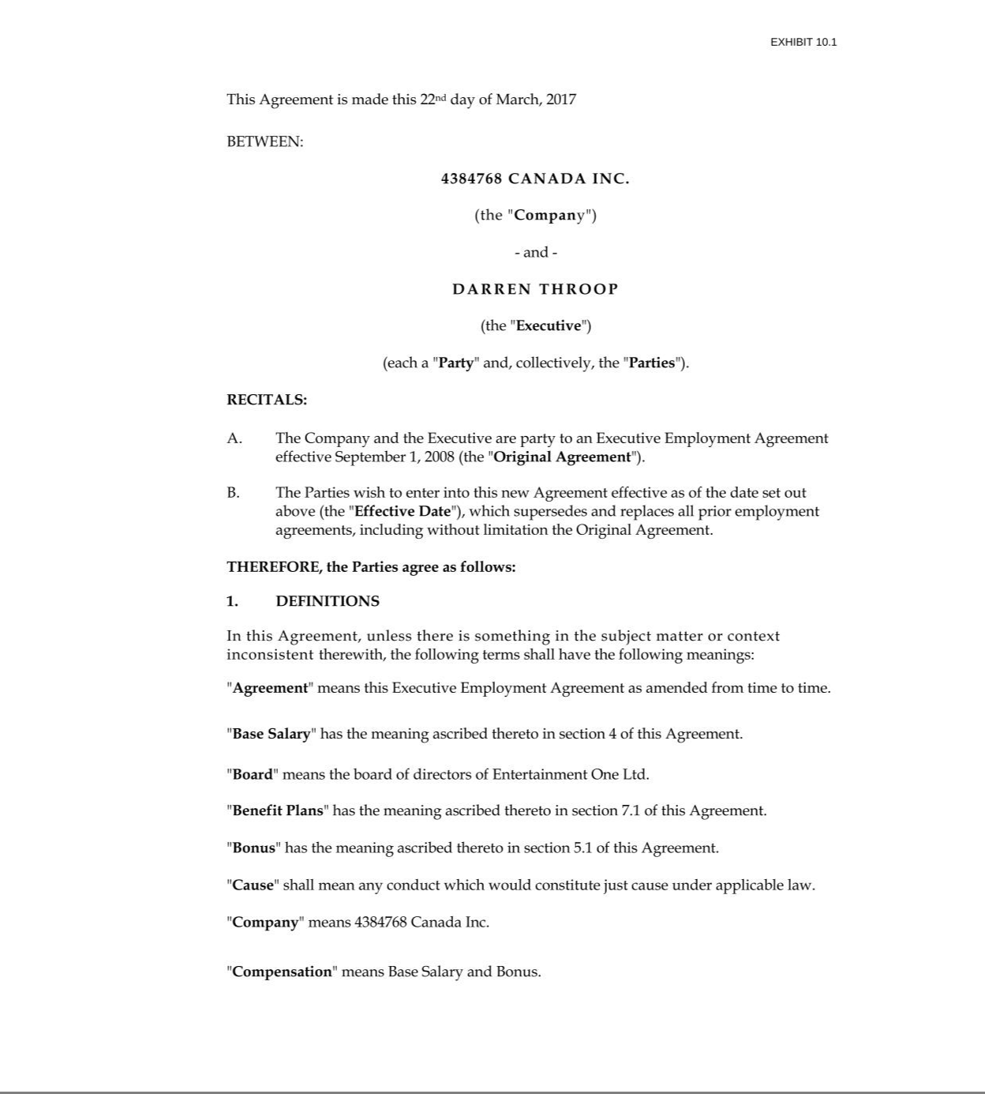

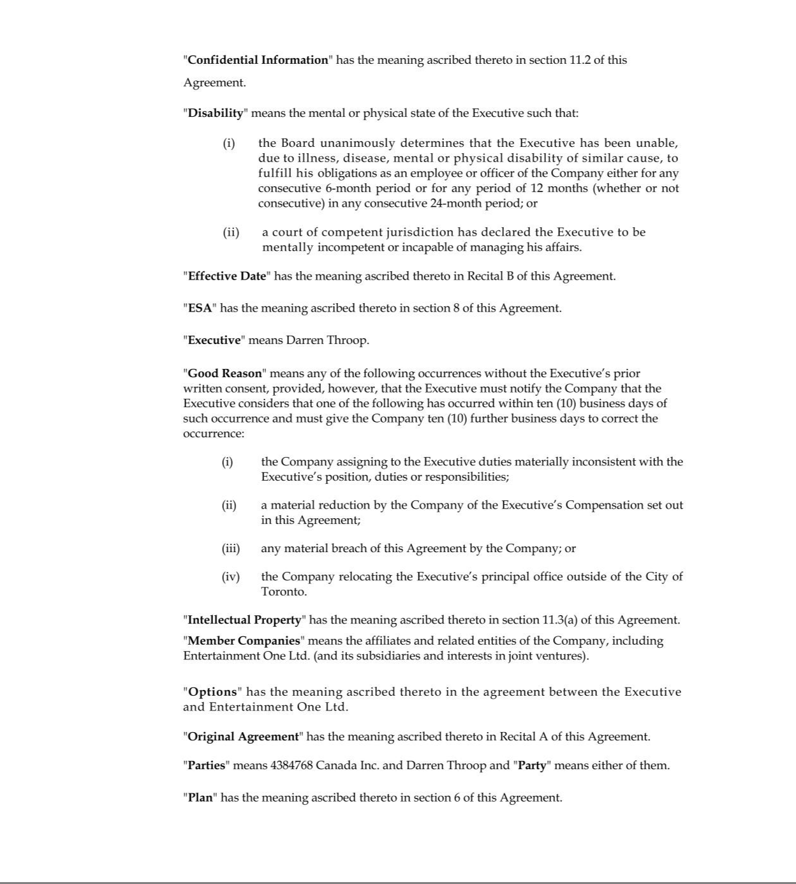

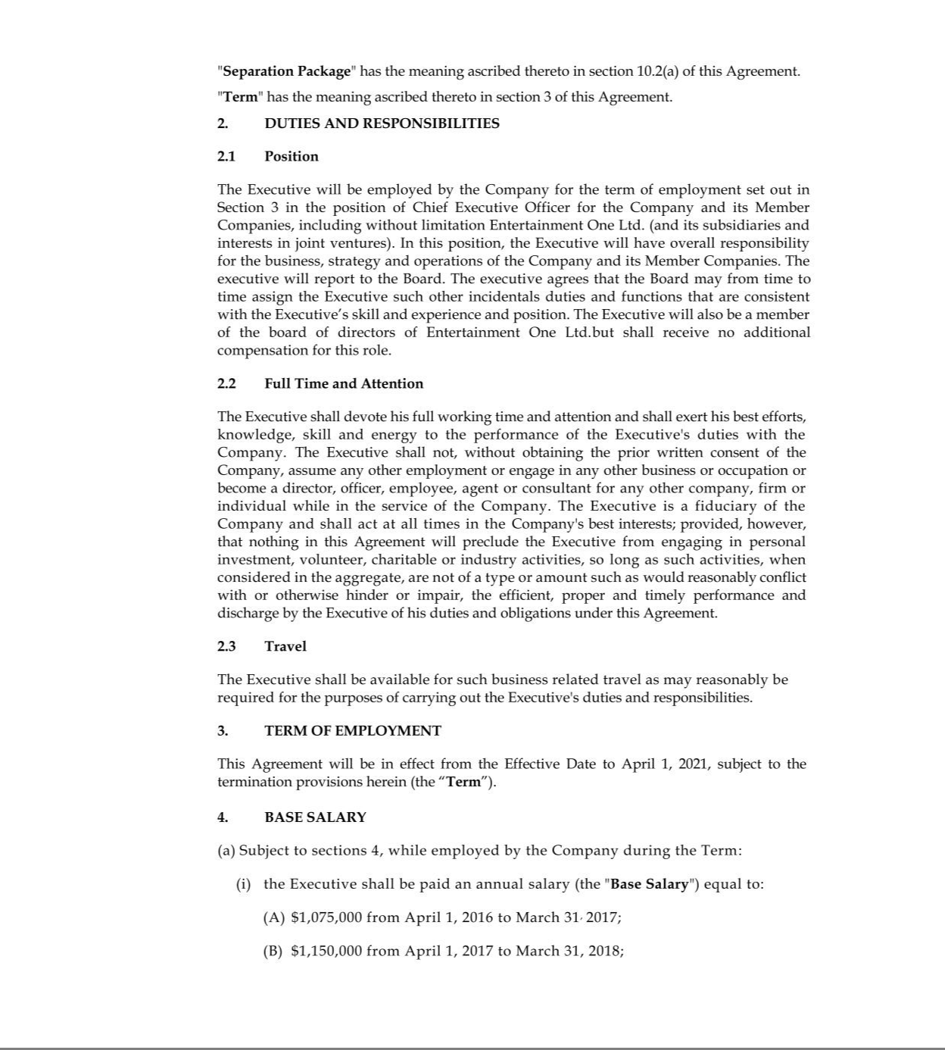

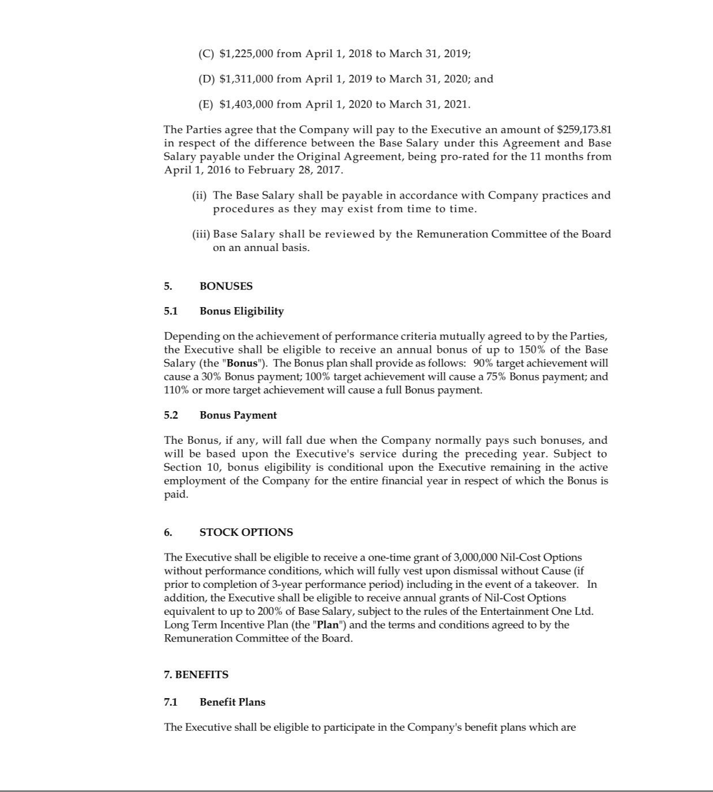

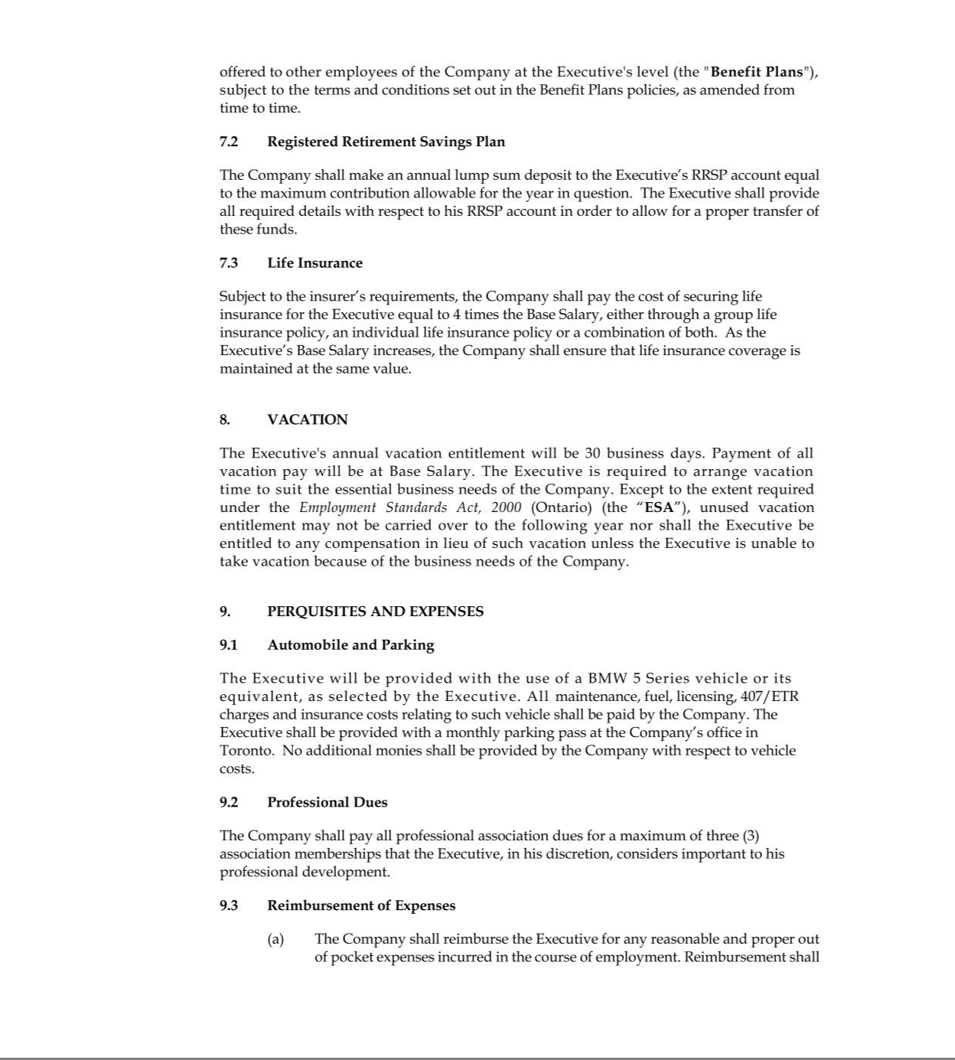

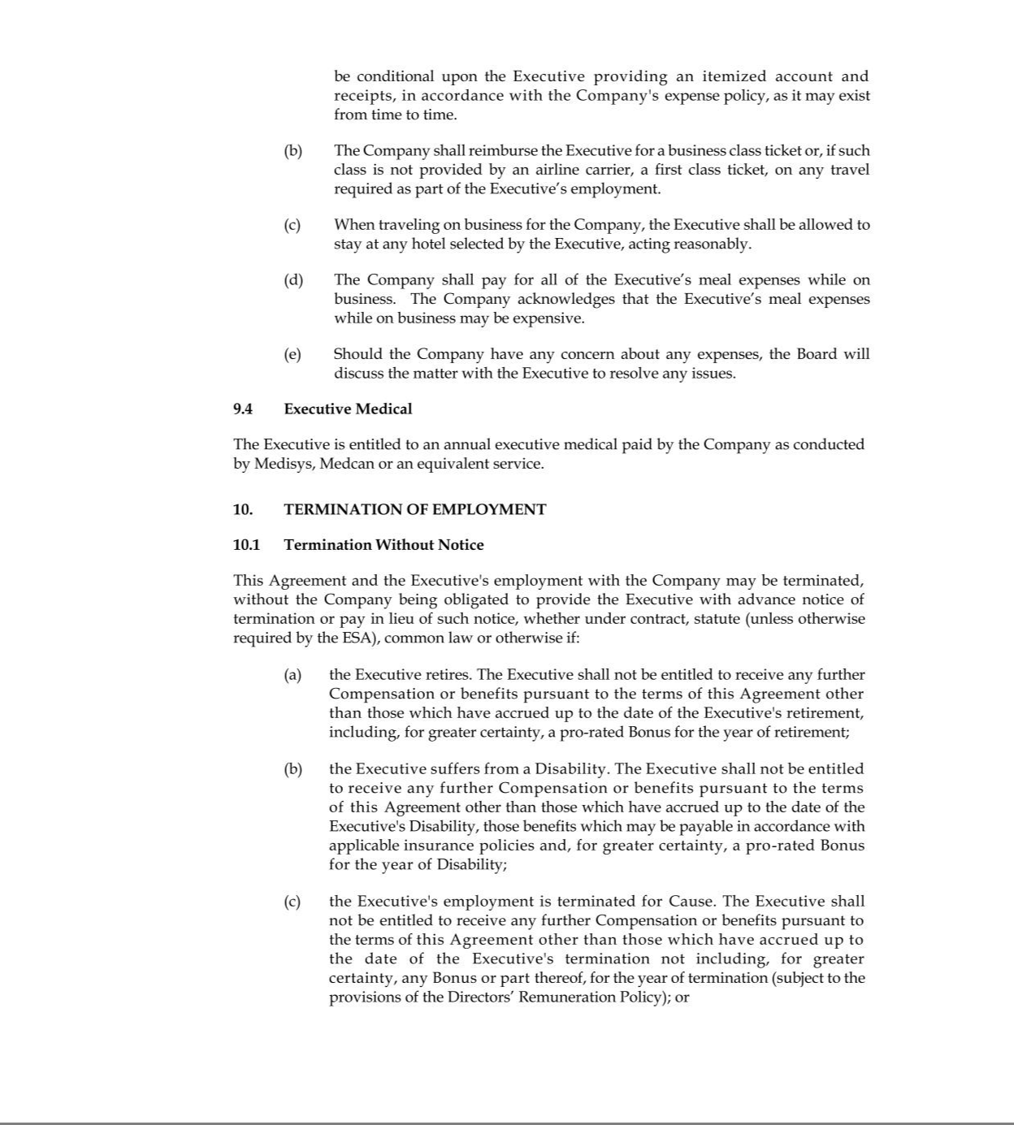

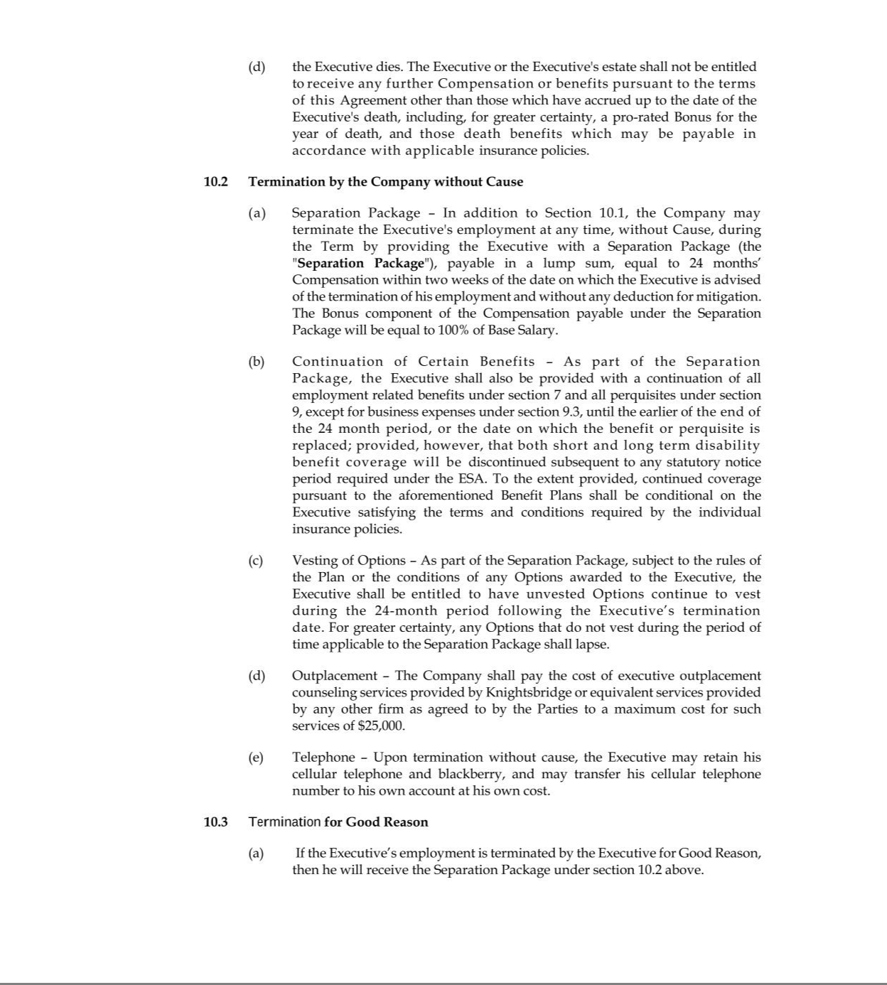

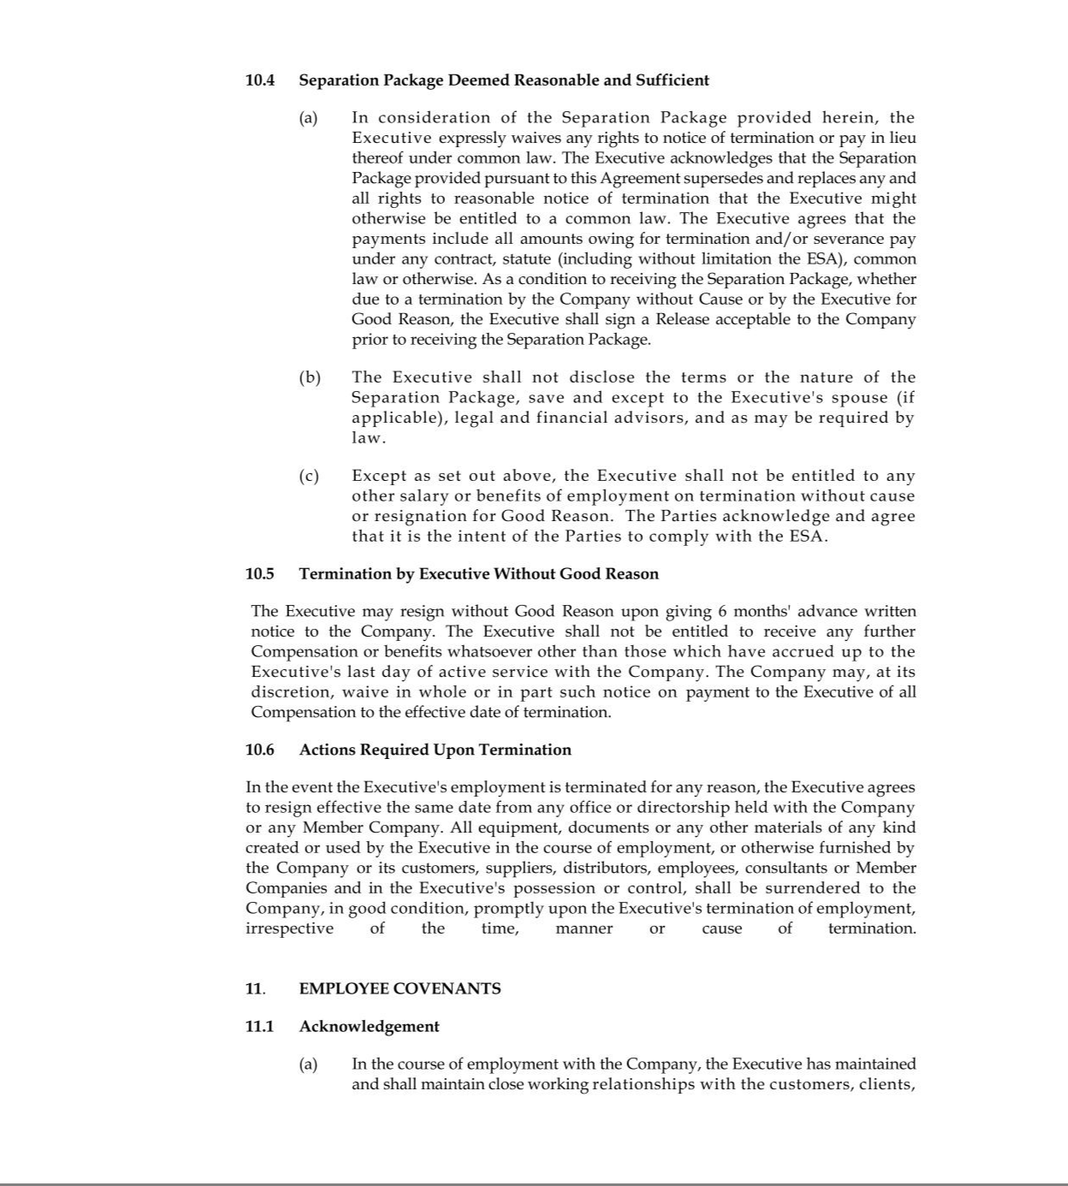

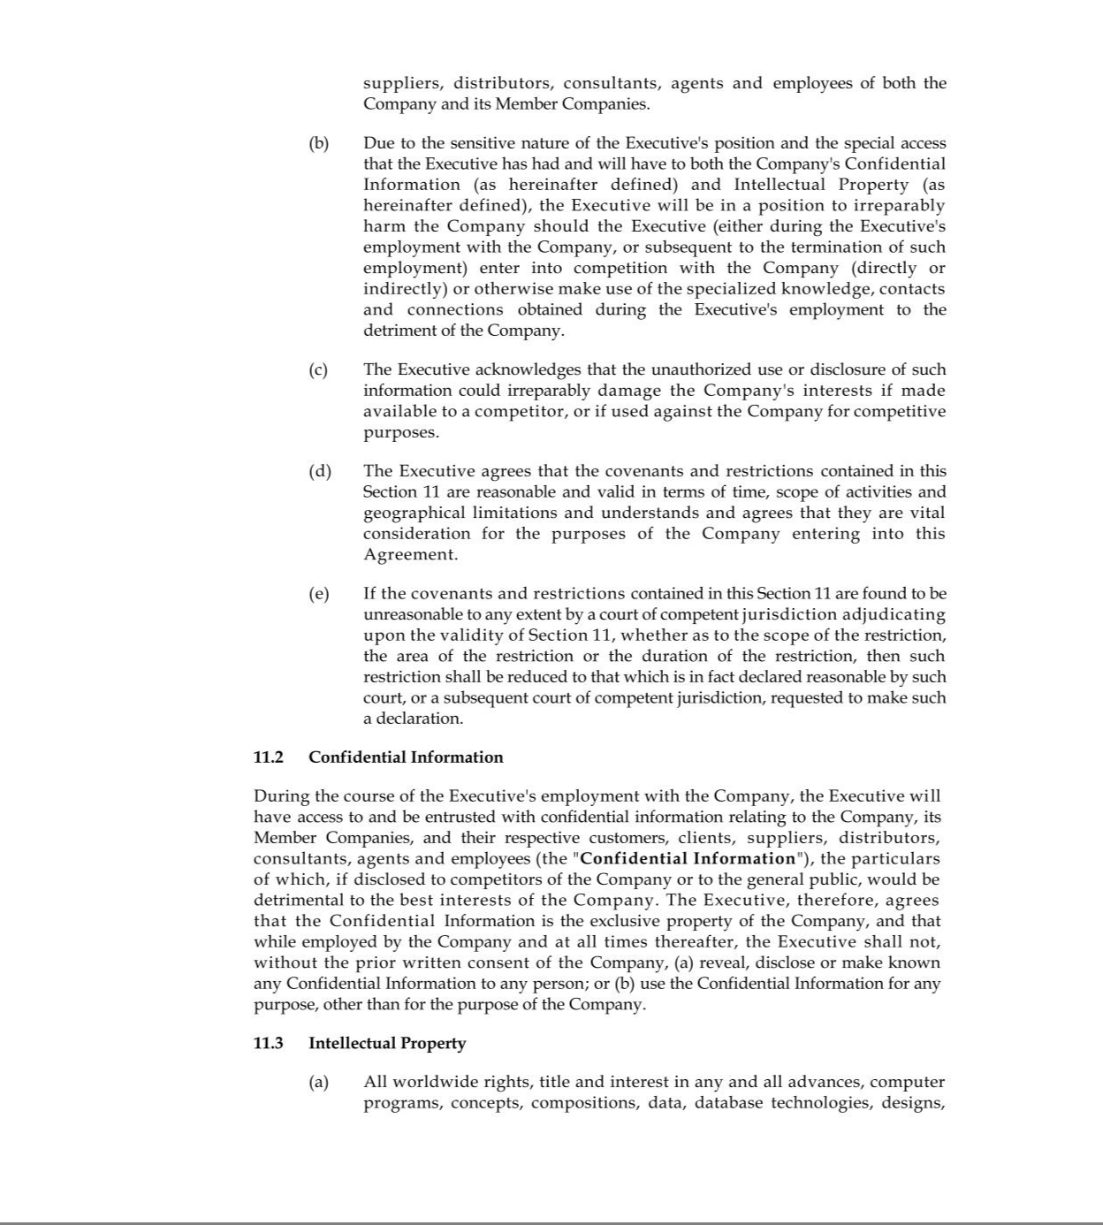

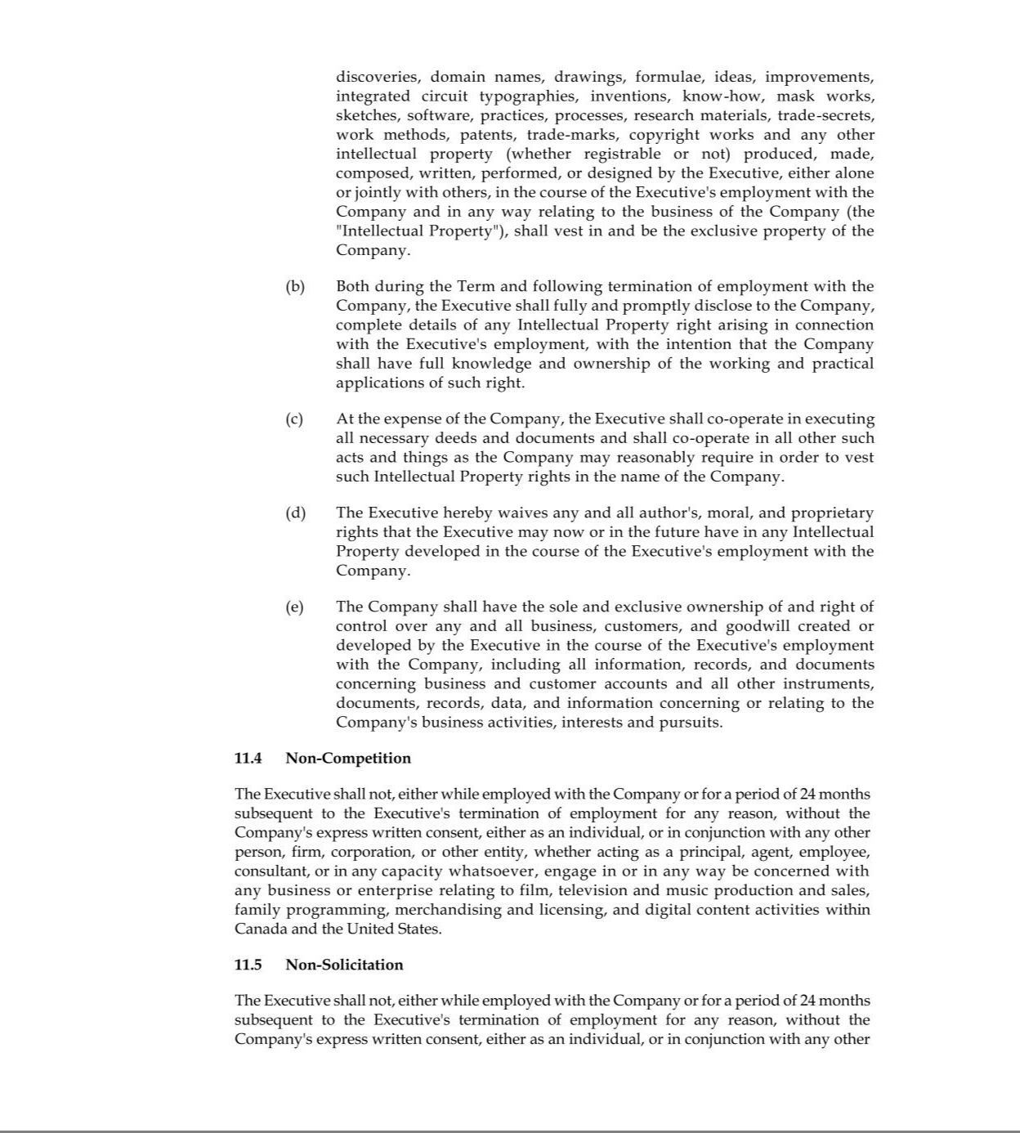

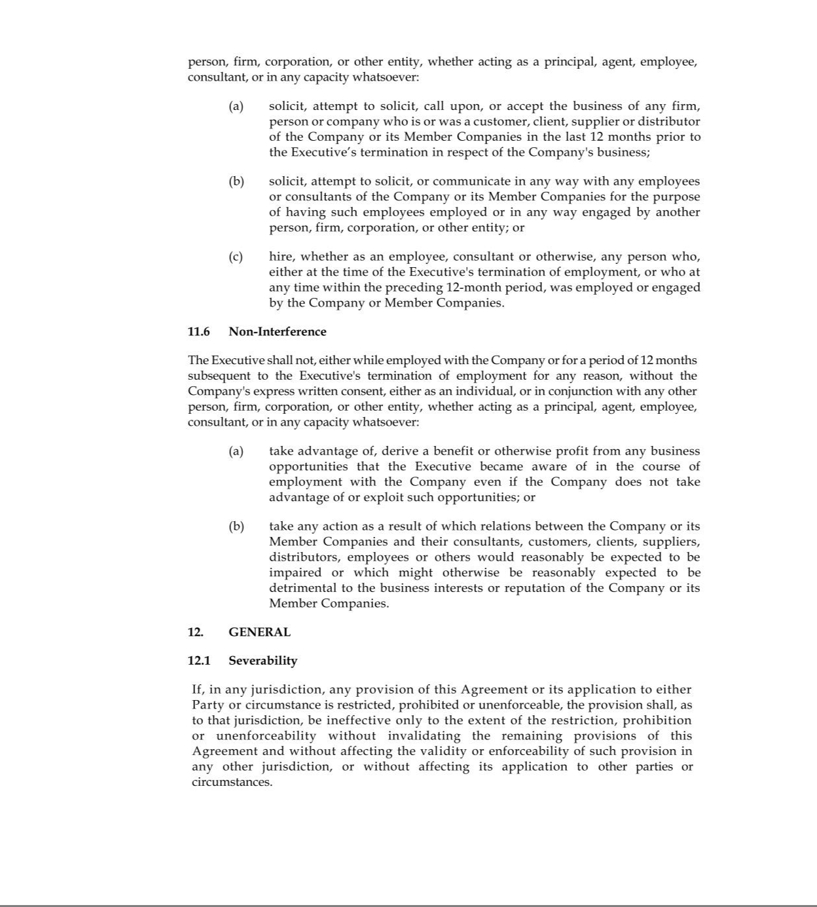

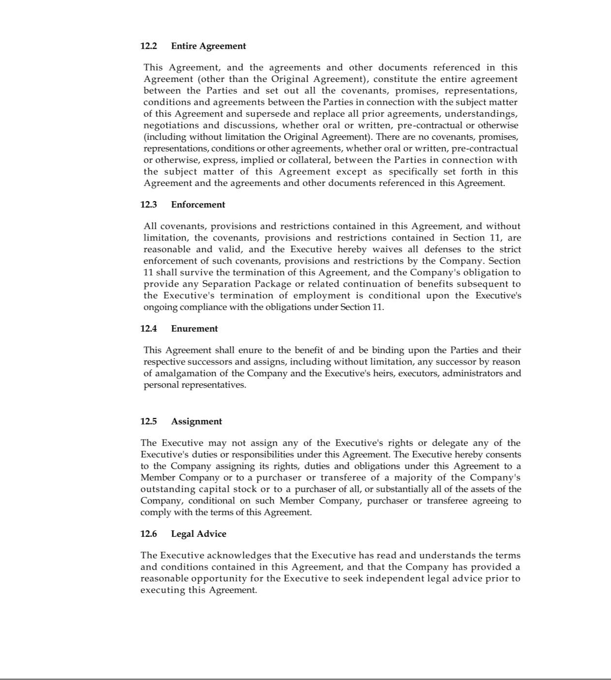

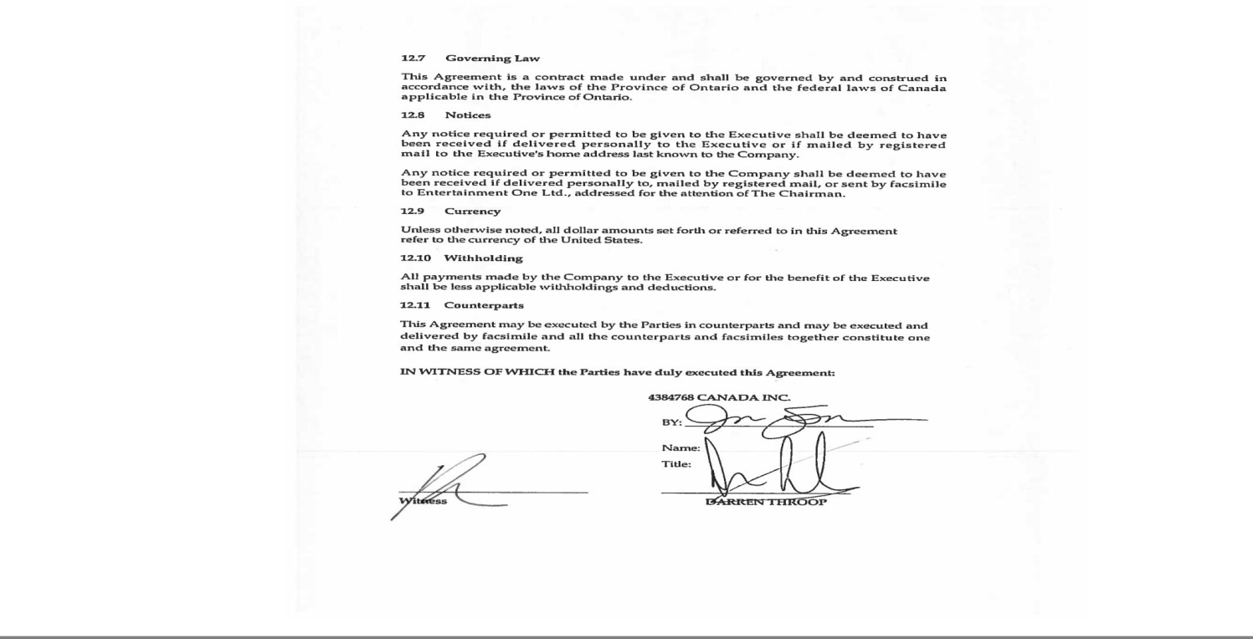

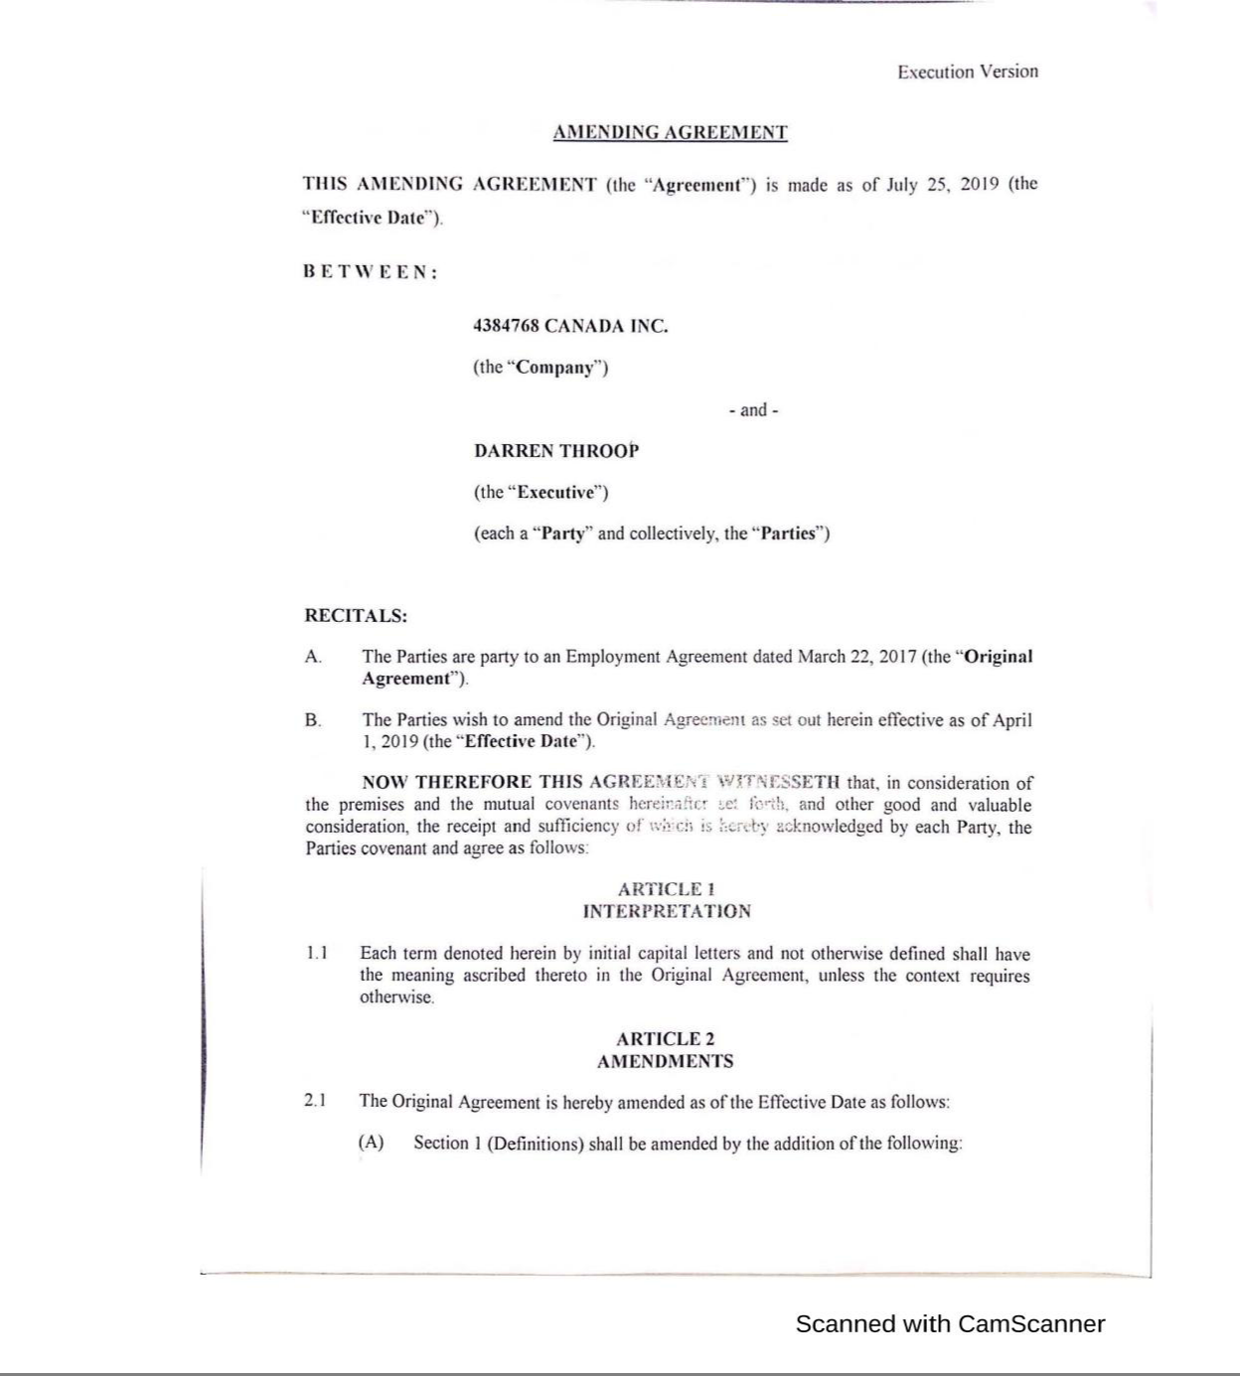

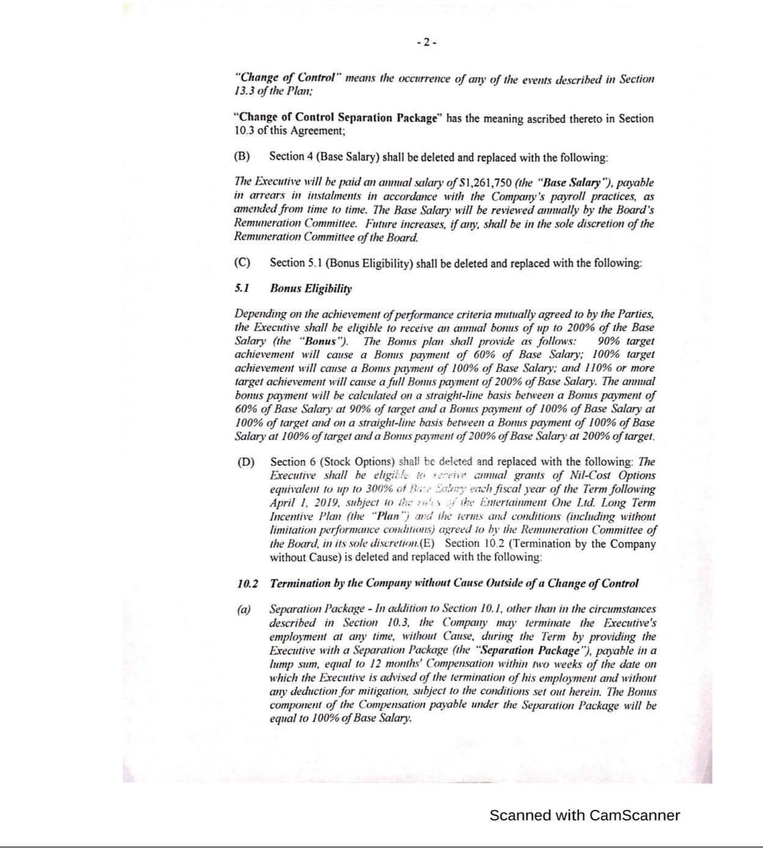

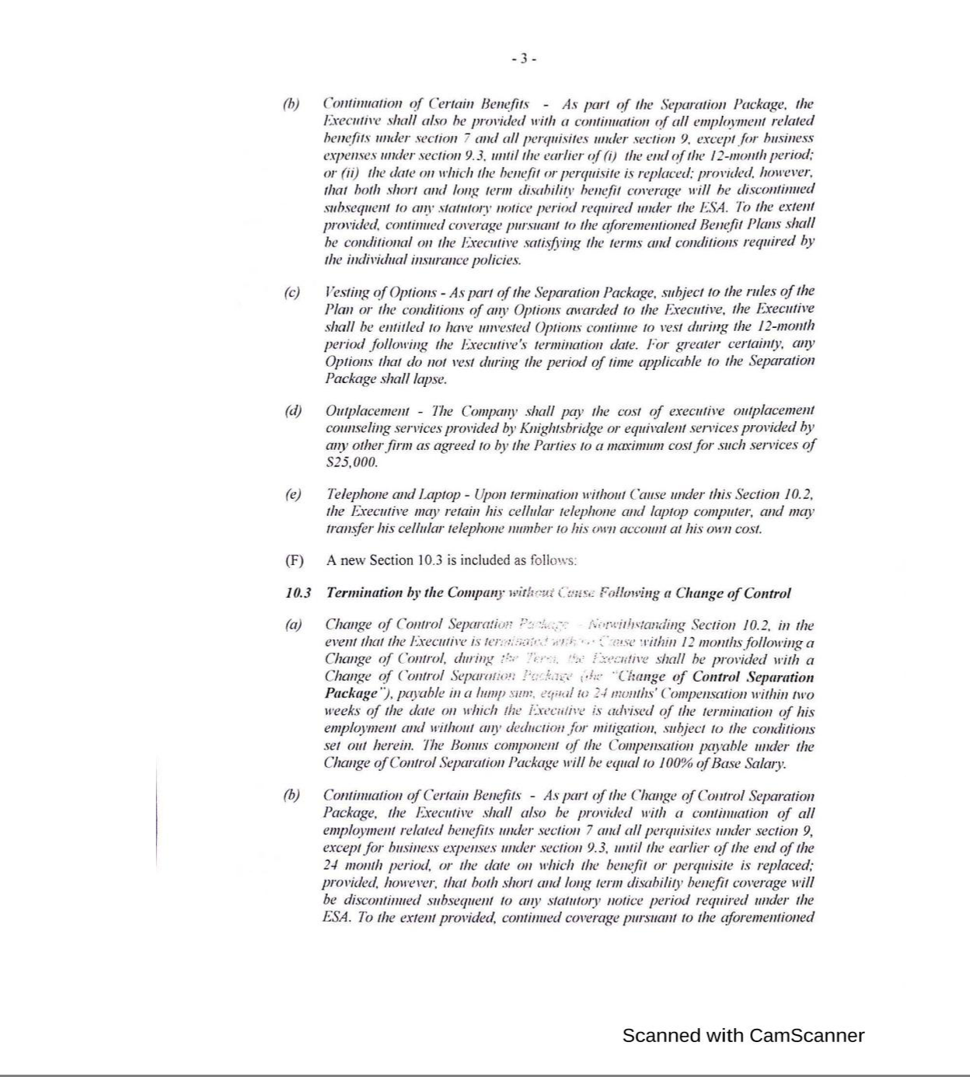

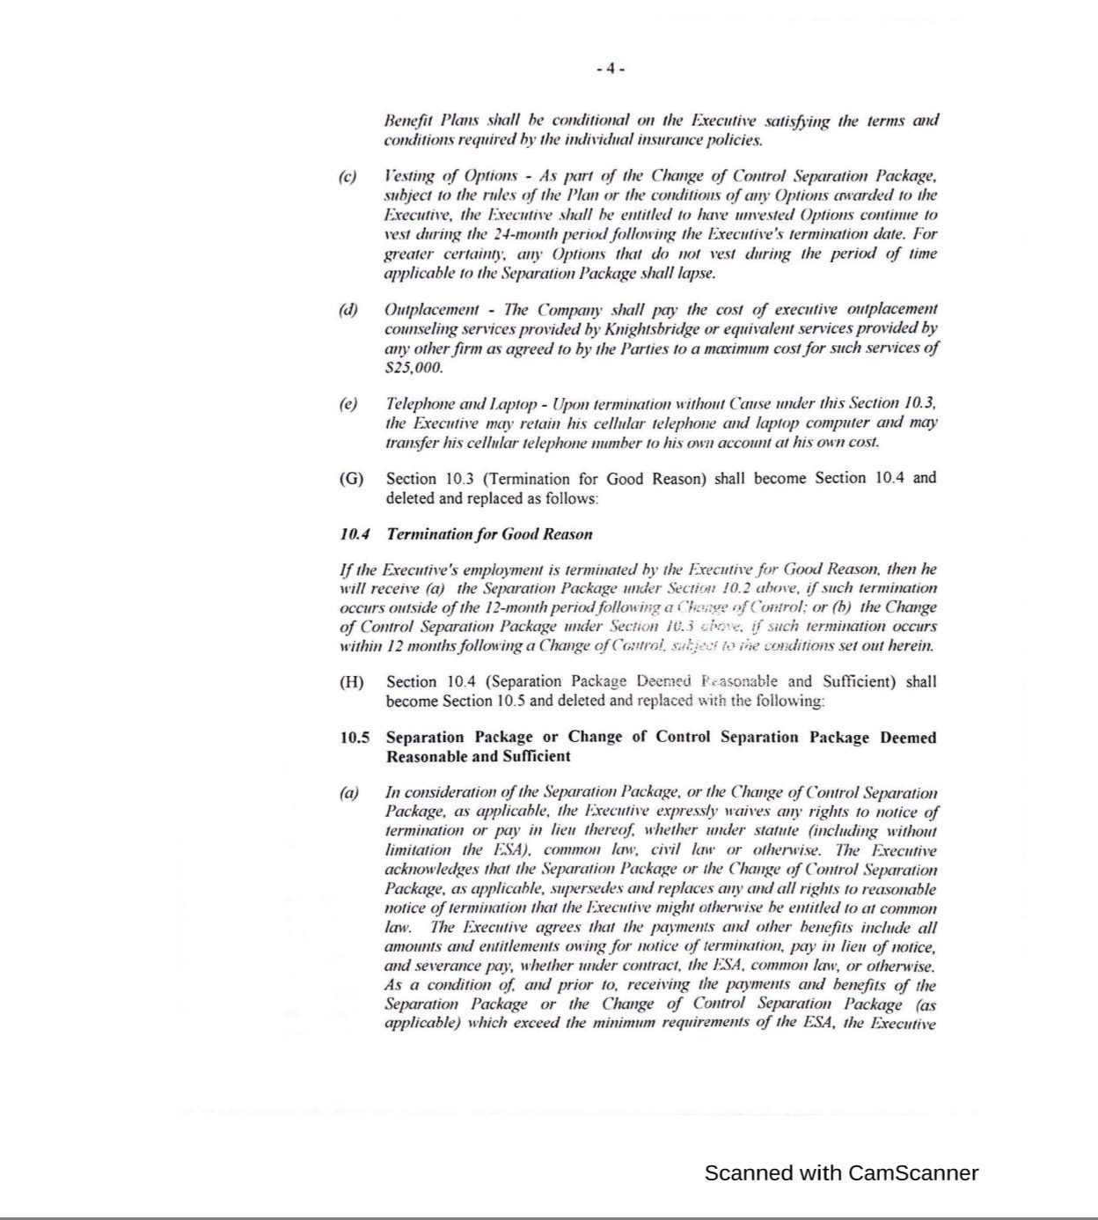

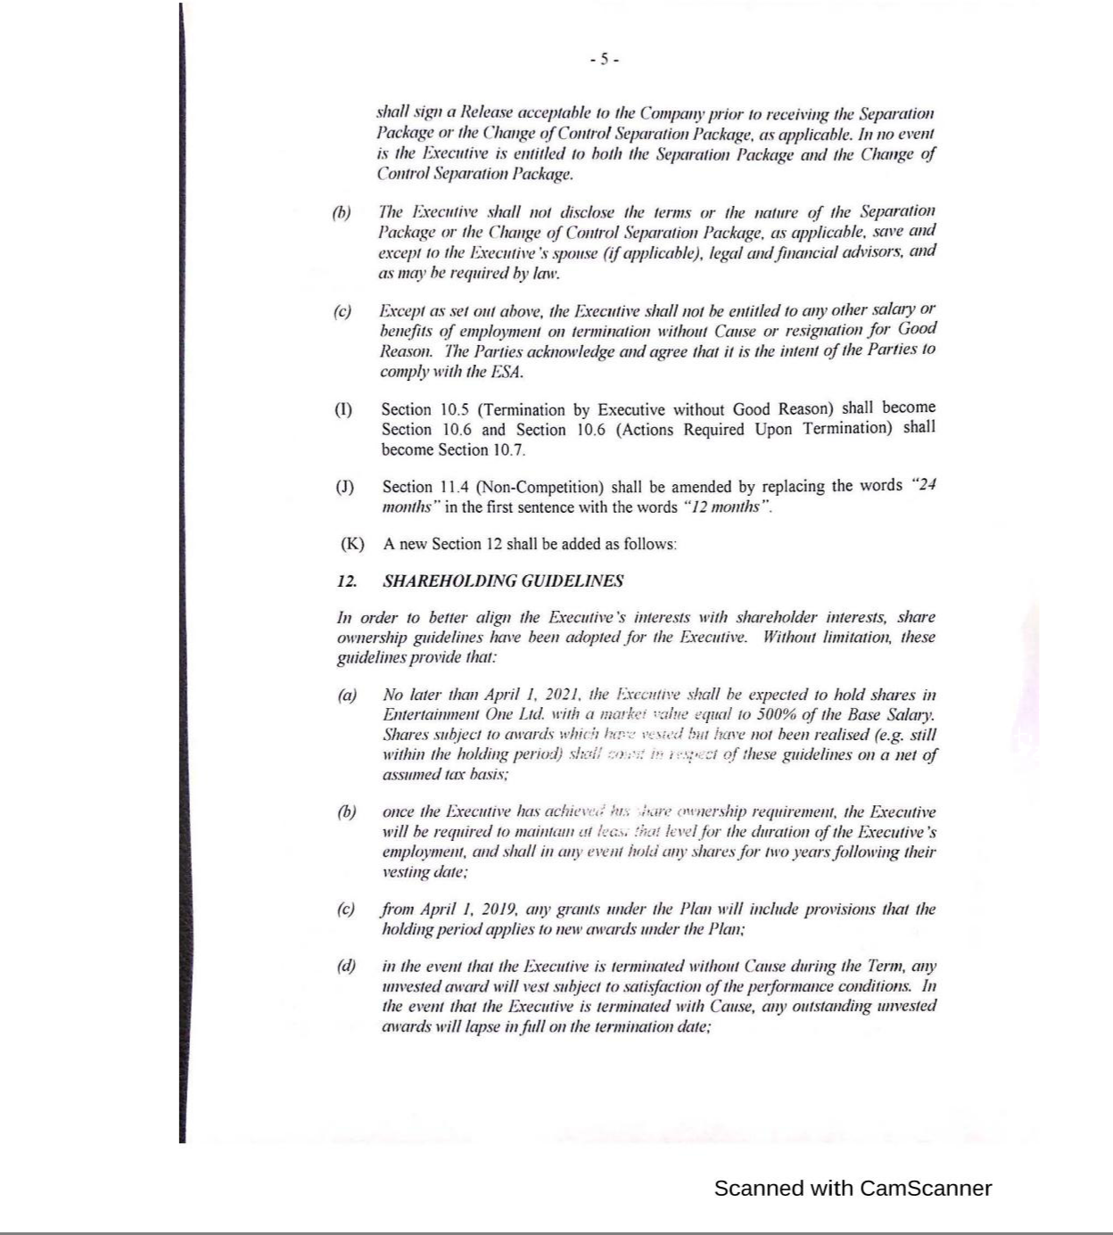

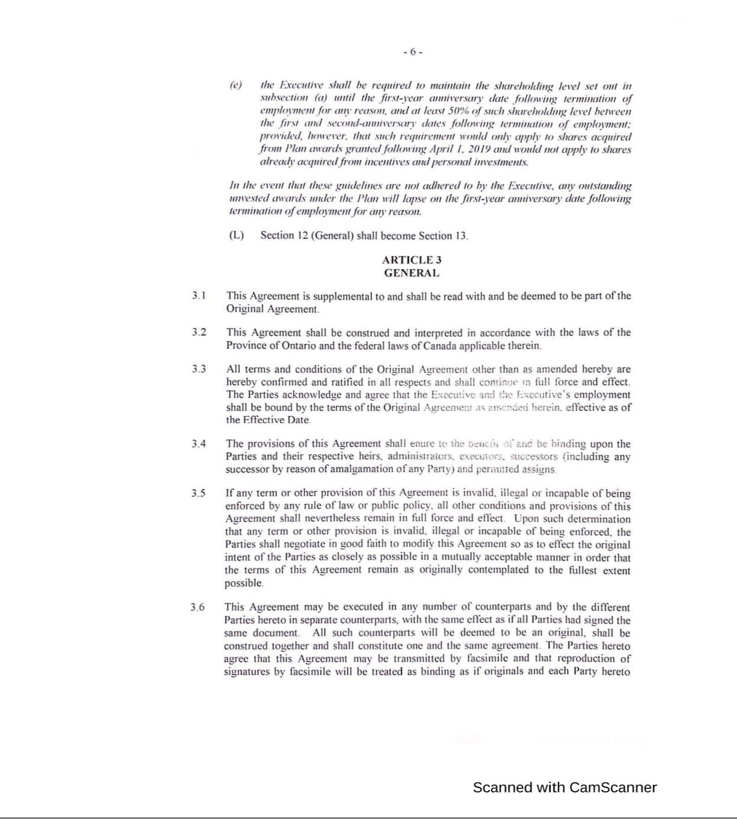

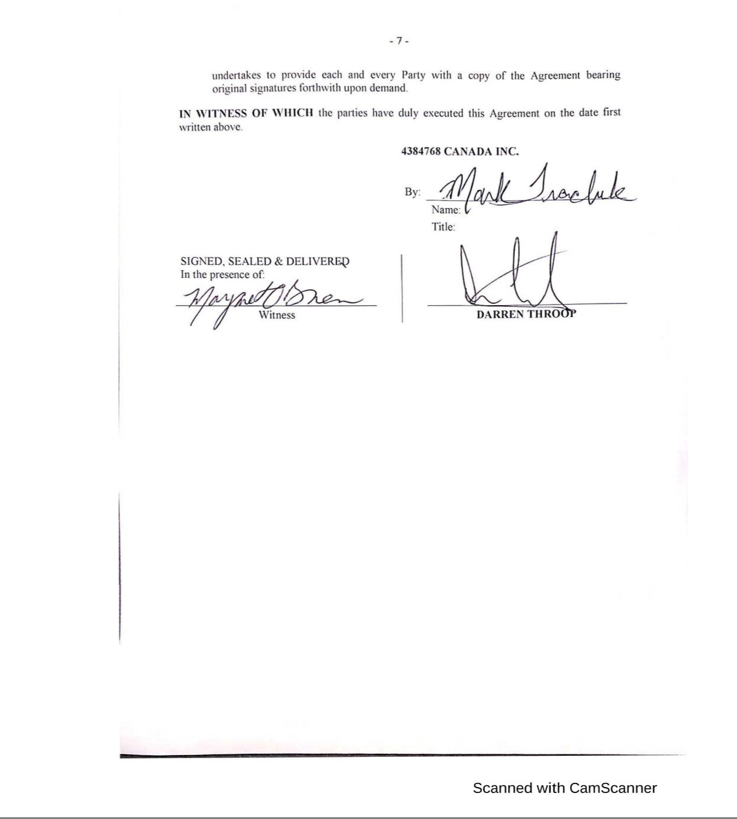

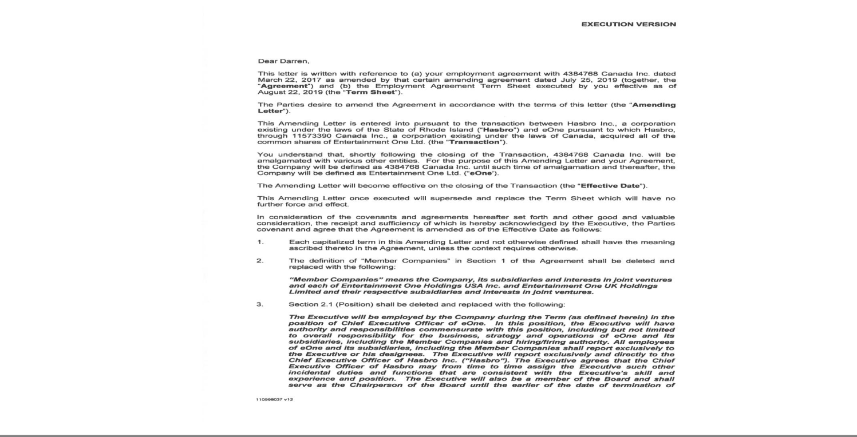

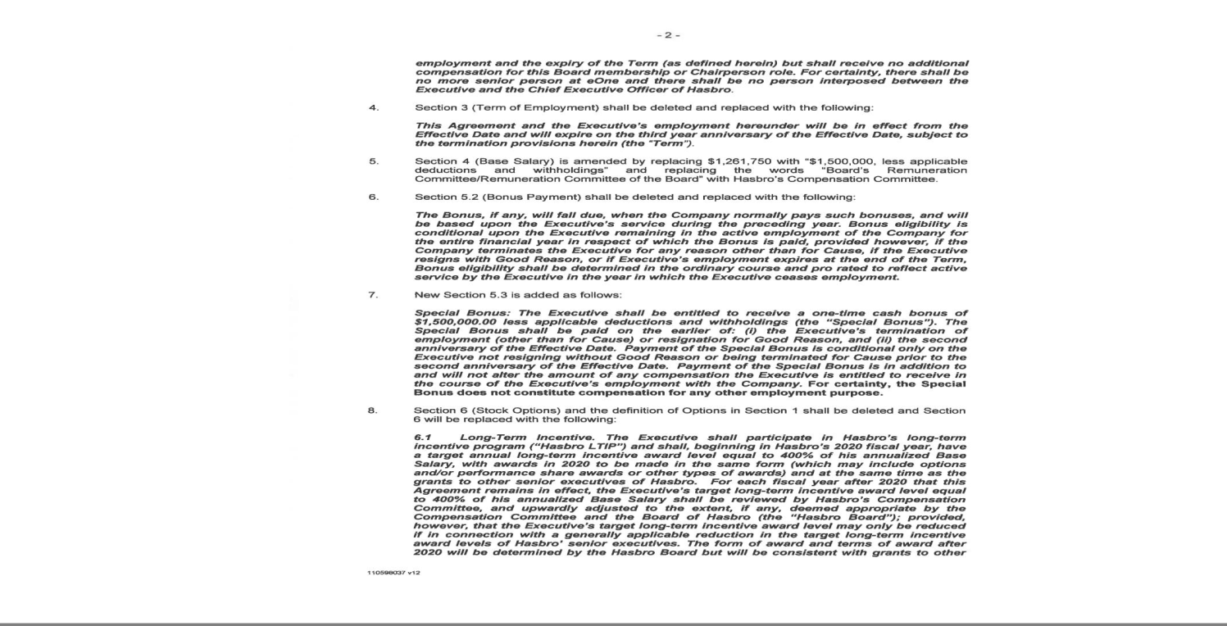

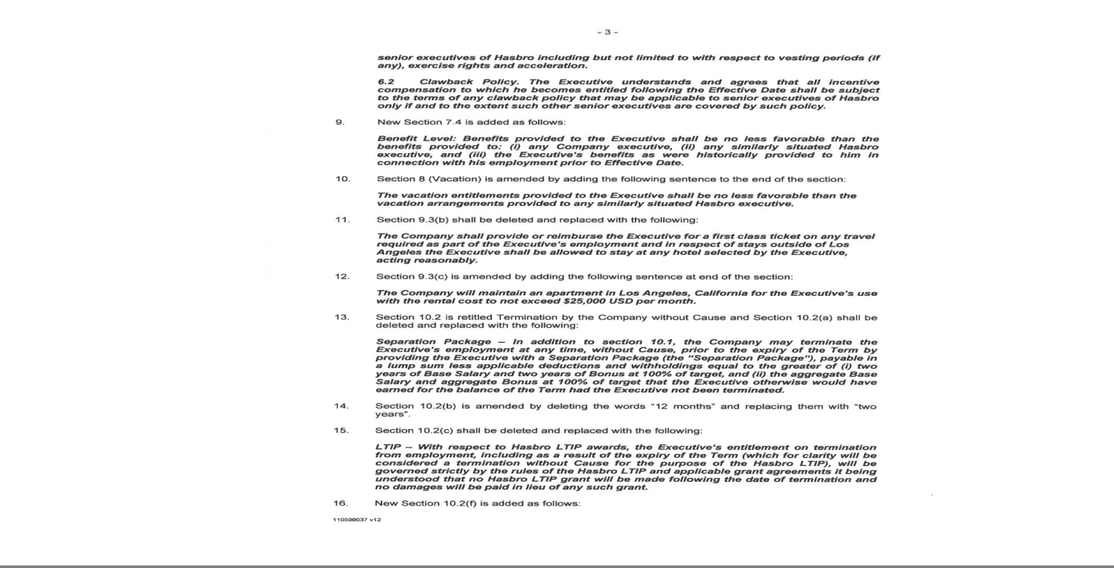

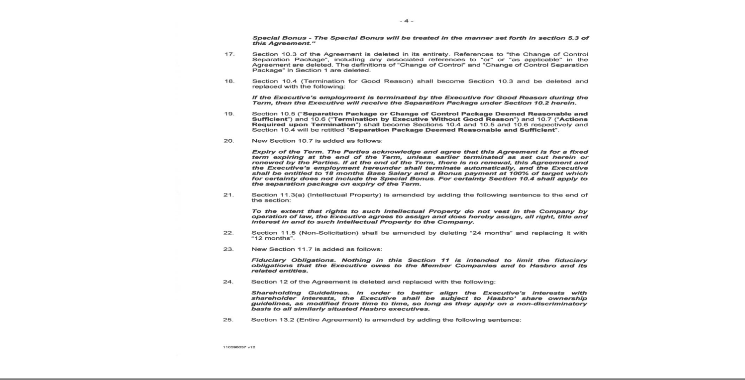

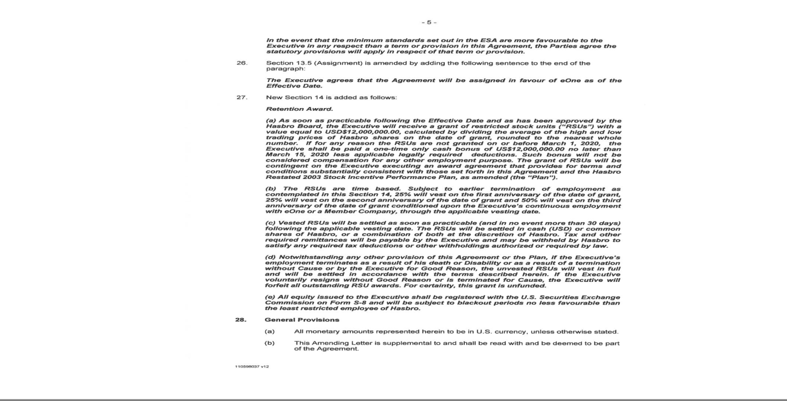

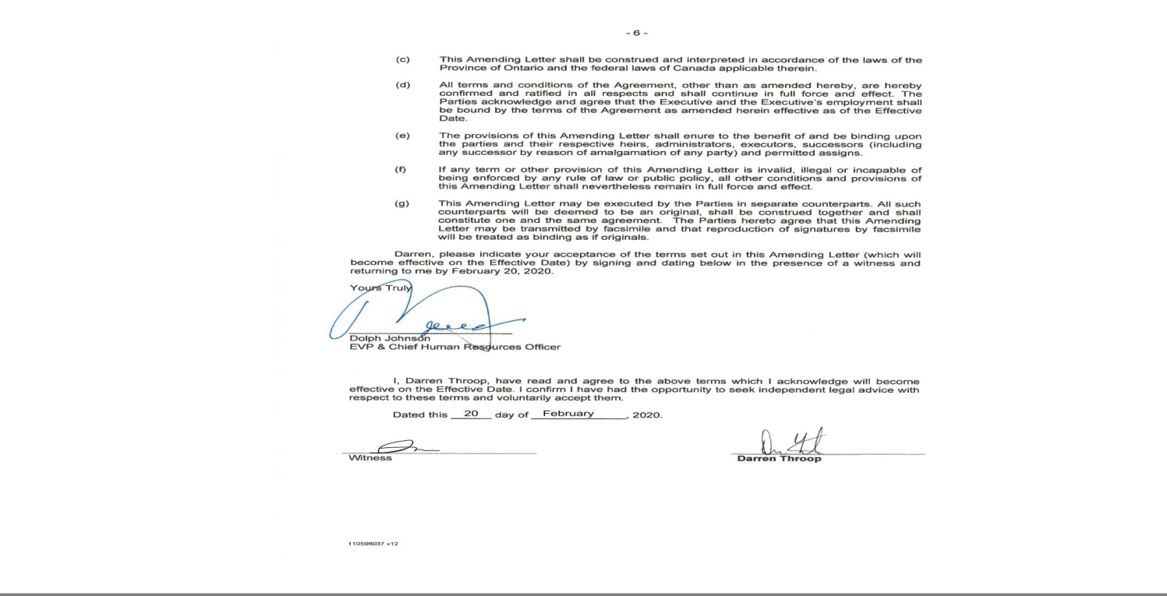

EXHIBIT 10.2

HASBRO, INC. CHANGE IN CONTROL SEVERANCE PLAN

FOR DESIGNATED SENIOR EXECUTIVES, AS AMENDED

- Purpose

The purpose of this Hasbro, Inc. Change in Control Severance Plan for Designated Senior Executives (the “Plan”) is to diminish the distraction of Covered Executives (as defined below) in the event of a threatened or pending Change in Control with respect to Hasbro, Inc. (the “Company”).

- Eligibility for Severance Benefits

A Covered Executive shall qualify for severance benefits under this Plan if within 24 months after a Change in Control (as defined below) the following requirements of this

Section 2(a) have been met:

- the Covered Executive’s employment is terminated by the Company without Cause (as defined below) or the Covered Executive resigns from the Company for Good Reason (as defined below);

- the Covered Executive is not entitled to greater severance compensation in connection with such employment termination under any individual agreement or other severance plan (other than with respect to equity compensation); and

- the Covered Executive satisfies the conditions under the Release; Payment Timing provision set forth in Section 6 below.

- Important Definitions

- For purposes of this Agreement, the termination of a Covered Executive’s employment will be for “Cause” if it involves:

- an unauthorized use or disclosure of the Company’s confidential information or trade secrets, which use or disclosure causes material harm to the Company;

- a material breach of a material agreement with the Company;

- a material failure to comply with the Company’s written policies or rules resulting in material harm to the Company;

- a conviction of, or plea of “guilty” or “no contest” to, a felony under the laws of the United States or any State thereof or the equivalent under the applicable laws outside of the United States;

- gross negligence or willful misconduct resulting in material harm to the Company;

- continuing failure to perform assigned duties after receiving written notification of such failure;

- failure to cooperate in good faith with a governmental or internal investigation of the Company or its directors, officers or employees, if the Company has requested such cooperation;

- an intentional violation of Federal or state securities laws; or

- fraud, embezzlement, theft or dishonesty against the Company.

Provided that no finding of Cause shall be made pursuant to subsections (i) through (iii) and (v) through (vii) above unless the Company has provided the Covered Executive with written notice stating the facts and circumstances underlying the allegations of Cause and the Covered Executive has failed to cure such violation, if curable, within 30 calendar days following receipt thereof. The Board will determine whether a violation is curable and/or cured in its reasonable discretion.

- For purposes of this Plan, a “Change in Control” means the occurrence of any one of the following events:

- sale of all or substantially all (at least 85%) of the assets of the Company to one or more individuals, entities, or groups (other than an “Excluded Owner” as defined below);

- acquisition or attainment of ownership by a person, entity, or group (other than an Excluded Owner) of more than 50% of the undiluted total voting power of the Company’s then-outstanding securities eligible to vote to elect members of the Board (“Company Voting Securities”);

- completion of a merger or consolidation of the Company with or into any other entity (other than an Excluded Owner) unless the holders of the Company Voting Securities outstanding immediately before such completion, together with any trustee or other fiduciary holding securities under a Company benefit plan, hold securities that represent immediately after such merger or consolidation more than 50% of the combined voting power of the then outstanding voting securities of either the Company or the other surviving entity or its ultimate parent; or

- individuals who constitute the Board of Directors on the date hereof (“Incumbent Directors”) cease for any reason during a 12 month period to constitute at least a majority of the Board; provided, that any individual who becomes a member of the Board subsequent to the date hereof, whose election or nomination for election was approved by a vote of at least a majority of the Incumbent Directors shall be treated as an Incumbent Director unless he/she assumed office as a result of an actual or threatened election contest with respect to the election or removal of directors.

For the purposes of this Plan, an “Excluded Owner” consists of the Company, any entity owned, directly or indirectly, at least 50% by the Company, any entity that, directly or indirectly, owns at least 50% of the Company, any Company benefit plan, and any underwriter temporarily holding securities for an offering of such securities.

Notwithstanding the foregoing, where required to avoid extra taxation under Section 409A, a Change in Control must also satisfy the requirements of Treas. Reg. Section 1.409A-3(a)(5).

- For purposes of this Plan, a “Covered Executive” will be any employee of the Company as shown on the Company’s payroll records who, at the occurrence of the Change in Control, (i) is employed in the positions listed on Attachment A, and (ii) is not covered under any individual agreement that provides special cash benefits following such a Change in Control.

- For the purposes of this Plan, “Disability” means, as determined by the Board, based upon appropriate medical evidence, that a Covered Executive has become physically or mentally incapacitated so as to render him/her incapable of performing his/her usual and customary duties, with or without a reasonable accommodation, for 180 days or more within a 365 day consecutive period. A Covered Executive is also disabled if he or she is found to be disabled within the meaning of the Company’s long-term disability insurance coverage as then in effect (or would be so found if he/she applied for the coverage or benefits).

- For purposes of this Plan, “Good Reason” means, without the Covered Executive’s written consent, the occurrence of any of the following events or actions during the 24 months following a Change in Control:

- a material reduction in the Covered Executive’s base salary plus Target Bonus in effect immediately preceding the Change in Control other than a general reduction that is also applied to other similarly situated employees;

- a material reduction in the Covered Executive’s position or reporting status in effect immediately prior to the Change in Control, unless the Covered Executive is provided with a comparable position or reporting status, or any material diminution in the Covered Executive’s duties, responsibilities, powers or authorities relative to the Covered Executive’s duties, responsibilities, powers or authorities in effect immediately prior to the Change in Control; or

- any relocation of the Covered Executive’s principal place of employment by more than 50 miles; or

- a material breach by the Company or any successor of any material provision of this agreement, an employment agreement or other agreement under which the Covered Executive provides services to the Company.

No resignation will be treated as resignation for Good Reason unless (1) the Covered Executive has given written notice to the Company of his/her intention to terminate his/her employment for Good Reason, describing the grounds for such action, no later than 60 days after the first occurrence of such circumstances, (2) the Covered Executive has provided the Company with at least 30 days in which to cure the circumstances, and (3) provided that the Company is not successful in curing the circumstance, the Covered Executive ends his/her employment within 180 days following the cure period.

- For the purposes of this Plan, “Non-Competition Period” means the period while the Covered Executive is employed by the Company and for 18 months after the Covered Executive’s employment ends for any or no reason and will be extended for any period of time during the 18 months in which a Covered Executive is in breach of Section 11 below.

- For the purposes of this plan “Severance Benefit” means the payments described in the Computation of Severance Benefit provision.

- For the purposes of this Plan, “Target Bonus” means the percentage of earned salary which constitutes the target bonus for the Covered Executive assuming target company performance under the annual incentive plan in place at the time of termination.

- For purposes of this Plan, “Termination Date” means the date on which the Covered Executive’s employment with the Company ends.

- Computation of Severance Benefit

If a Covered Executive’s employment by the Company is terminated by the Company without Cause during the 24 month period following a Change in Control or the Covered Executive resigns from the Company with Good Reason during the 24 month period following a Change in Control, the Covered Executive will be entitled to the following, provided that the Covered Executive satisfies the Release conditions under the provisions set forth herein in Section 6, together with the Covered Executive’s accrued base salary (and vacation if Company policy or applicable law so provides), accrued but unpaid bonuses, equity acceleration, unreimbursed business expenses in accordance with the Company’s policies for which expenses the Covered Executive has provided appropriate documentation, and any amounts or benefits to which the Covered Executive is then entitled under the terms of the benefit plans then sponsored by the Company in accordance with their terms (and not accelerated to the extent acceleration does not satisfy Section 409A of the Internal Revenue Code of 1986, as amended (“Section 409A” of the “Code”)):

- two times the sum of the Covered Executive’s annual base salary in effect on the date of termination (or, if higher, immediately preceding the Change in Control) and Target Bonus, reduced by an amount equal to the total of severance payments to which the Covered Executive is entitled to receive or will receive under any other severance plan, policy or individual agreement applicable to the Covered Executive’s employment termination (“Cash Severance”); and

- payment by the Company of the employer and employee premiums for continuation health coverage under COBRA for the Covered Executive and his/her covered dependents for the shorter of 12 months following cessation of employment and the period for which the individuals are eligible for and elect such coverage.

Except as the law provides otherwise or as provided in this section, neither the Covered Executive nor his/her beneficiary or estate will have any rights or claims under this Plan to receive severance or any other post-employment compensation after the Covered Executive’s employment ends. If the Covered Executive’s employment ends before the consummation of a Change in Control or ends after such consummation for any reason other than his/her resignation for Good Reason or the Company’s termination of his/her employment without Cause, the Covered Executive will not be entitled to receive and shall forfeit the payments in this Plan. This Plan does not provide benefits for terminations as a result of death or Disability.

- Intentionally Omitted

- Release; Payment Timing

As a condition to receiving the amounts and benefits set forth in clause (a) of the Computation of Severance provision, the Covered Executive must, after and within 60 days following, his/her cessation of employment (or such shorter period as the Company requires), execute and not revoke a severance agreement and release of claims provided by the Company (the “Severance Agreement”), which Severance Agreement will release all releasable claims other than to payments under this Plan, to outstanding equity, and to indemnification (the “Release”) and will include obligations for post-employment (i) cooperation with the Company, (ii) compliance with any restrictive covenants then in effect or that may be required by the Company consistent with the Non-Competition/Forfeiture provision and (iii) additional provisions consistent with (x) parts (g) and

- of the Miscellaneous provision; and (y) the Further Effect of Termination on Board and Officer Positions provision.

The Company will pay the Cash Severance, after and if the Covered Executive signs the Release and any revocation period expires, in a single lump sum in the next payroll following the date after which the revocation period expires (or, if he/she is subject to the six month delay in the Compliance with Code Section 409A provision, the date it provides), provided that if the 60th day falls in the calendar year after the year in which such employment ends, the payment will be made no earlier than the first day of such later calendar year). Benefits under clause (b) of the Computation of Severance provision will occur at the same time (or such earlier post-Release date as Section 409A permits).

- Employee Retirement Income Security Act

The Plan constitutes an unfunded severance benefits plan that is intended to be a welfare benefit plan within the meaning of Section 3(1) of the Employee Retirement Income Security Act of 1974, as amended (“ERISA”), subject to Parts 4 and 5 of Title I of ERISA.

- Plan Administrator. The “Plan Administrator” shall be the Compensation Committee of the Board (or its successor) or its designee, unless the Company appoints another person or committee as Plan Administrator. The Plan Administrator shall be the “administrator” within the meaning of Section 3(16) of ERISA and the Named Fiduciary for purposes of Section 402 of ERISA.

- Powers and Authorities. The Plan Administrator shall have full power and discretionary authority to administer the Plan in accordance with its terms and subject to the requirements of applicable law. The Plan Administrator shall have the authority and responsibility to: (i) construe the terms of the Plan, including the authority to remedy any omissions, ambiguities or inconsistencies in the provisions of the Plan, (ii) resolve all questions of fact under the Plan, including, without limitation, questions concerning eligibility, participation and benefits and all other related or incidental matters, and (iii) establish such procedures for the Plan as it deems advisable, including the establishment of a claims procedure consistent with Section 503 of ERISA.

- Decisions. The Plan Administrator’s decisions and determinations (including determinations of the meaning and reference of terms used in the Plan) shall be conclusive and binding upon all Covered Executives and their beneficiaries, heirs and assigns, in the absence of clear and convincing evidence that the Plan Administrator acted in a manner that was arbitrary and capricious.

- Confidentiality

To participate in this Plan, the Covered Executive must agree that the existence or terms of any Change in Control, or any other such information regarding any corporate restructuring or refinancing, is within the scope of the Covered Executive’s contractual and noncontractual obligations with respect to the Company’s confidential information.

- No Effect on Running Business or Employment

The existence of this Plan does not affect in any way the right or power of the Company or its stockholders to make or authorize any adjustments, recapitalizations, reorganizations, or other changes in Company’s capital structure or its business, or any merger or consolidation of the Company, or any issuance of bonds, debentures, preferred or other stock, with preference ahead of or convertible into, or otherwise affecting the Company’s common stock or the rights thereof, or the dissolution or liquidation of the Company, or any sale or transfer of all or any part of its assets or business, or any other corporate act or proceeding, whether or not of a similar character to those described above. Nothing in this Plan imposes any requirement on the Company to enter into or complete a Change in Control. Nothing in this Plan restricts the Company’s rights or those of any of its affiliates to terminate the Covered Executive’s employment or other relationship at any time, with or without Cause and for any or no reason.

- Further Effect of Termination on Board and Officer Positions

If the Covered Executive’s employment ends for any reason, he/she will cease immediately to hold any and all officer or director positions the Covered Executive then has with the Company or any affiliate, absent a contrary direction from the Board (which may include either a request to continue such service or a direction to cease serving upon notice without regard to whether the Covered Executive’s employment has ended). The Covered Executive, through the Severance Agreement, will irrevocably appoint the Company to be his/her attorney-in-fact to execute any documents and do anything in his/her name to effect the Covered Executive’s ceasing to serve as a director and officer of

the Company and any subsidiary, should the Covered Executive fail to resign following a request from the Company to do so. A written notification signed by a director or duly authorized officer of the Company that any instrument, document or act falls within the authority conferred by this clause will be conclusive evidence that it does so. The Company will prepare any documents, pay any filing fees, and bear any other expenses related to this section.

- Non-Competition/Forfeiture

During the Non-Competition Period, the Covered Executive shall not, directly or indirectly, whether as owner, partner, investor (other than passive ownership of two percent or less of the voting stock of any publicly traded company), consultant, agent, employee, co-venturer or otherwise, compete with the Company or any of its Affiliates within the United States or in any country in which the Company or any of its Affiliates is then doing business. Specifically, but without limiting the foregoing, the Covered Executive shall not engage in any manner in any activity that is directly or indirectly competitive or potentially competitive with the business of the Company or any of its Affiliates as conducted or under consideration at any time during Covered Executive’s

employment. While the Covered Executive is employed by the Company and during the Non-Competition Period, the Covered Executive will not hire or attempt to hire any employee of the Company or any of its Affiliates, assist in such hiring by any Person, encourage any such employee to terminate his or her relationship with the Company or any of its Affiliates, or solicit or encourage any customer or vendor of the Company or any of its Affiliates to terminate or diminish its relationship with them, or, in the case of a customer, to conduct with any Person any business or activity with such customer that it conducts or could conduct with the Company or any of its Affiliates.

In the event that a Covered Executive violates this Section 11, as determined by the Plan Administrator in its sole discretion, the Covered Executive shall be deemed to have waived and forfeited any portion of the Severance Benefits provided for herein with respect to which payment has not yet been made and shall, within 30 days thereafter, reimburse the Company for all Severance Benefits previously received from the Company under this Plan. The restrictions contained in this Section are necessary for the protection of the business and goodwill of the Company. Any breach of Section 11 is likely to cause the Company substantial and irrevocable damage that is difficult to measure. Therefore, in the event of any such breach or threatened breach, the Company, in addition to such other remedies as may be available and the cessation and return of severance provided above, the Company shall have the right to obtain an injunction from a court restraining such a breach or threatened breach and the right to specific performance of the provisions of this Section.

- Miscellaneous

- Notices. All notices hereunder shall be in writing and shall be deemed given when sent by certified or registered mail, postage prepaid, return receipt requested, if to the Covered Executive, to the address set forth on the cover sheet or at the most recent address shown on the records of the Company, and if to the Company, to the Company’s principal office, attention of the Corporate Secretary (or, if the Covered Executive is the Corporate Secretary, to the Chief Executive Officer).

- Amendment and Termination. This Plan and the benefits described herein may be amended or terminated by either the Board of the Company or the Compensation Committee of the Company with notice given to the Covered Executives within 90 days prior to the end of any calendar year to be effective at the beginning of the following calendar year; provided, however that any amendment that is determined by the Board or the Committee, as applicable, in its sole discretion, (i) to be necessary or appropriate to minimize or eliminate adverse tax treatment to Covered Executives under Code Section 409A or otherwise or (ii) to have no material adverse effect on Covered Executives, may be implemented at any time effective immediately. If notice of an amendment or termination is not given to the Covered Executives within 90 days prior to the end of any calendar year, the Plan will automatically be extended for successive one year terms. No amendment or termination of this Plan during the 24 months following a Change in Control may adversely affect a Covered Executive without his or her consent,

provided that an acceleration in payment in a manner consistent with the plan termination rules of Section 409A will not be treated as an adverse effect.

- No Mitigation. A Covered Executive shall not be required to mitigate the amount of any payment provided for in this Plan by seeking other employment or otherwise and shall not be required to offset against such payment any payments he/she may receive from further employment.

- No Fiduciary or Employment Relationship. Nothing contained in this Plan and no action taken pursuant to the provisions of this Plan shall create or be construed to create a trust of any kind or fiduciary relationship or contract for employment between the Company and any Covered Executive or other employee, and nothing in this Plan shall affect the right of the Company to terminate the employment of any Covered Executive or any other employee for any reason whatsoever.

- Compliance with Code Section 409A. All payments under this Plan are subject to any required tax or other withholdings. If and to the extent any portion of any payment, compensation or other benefit provided to a Covered Executive in connection with his/her employment termination is determined to constitute “nonqualified deferred compensation” within the meaning of Section 409A and he/she is a specified employee as defined in Section 409A(a)(2)(B)(i), as determined by the Company in accordance with its procedures, by which determination the Covered Executive, through the Participation Agreement, hereby agrees that he/she is bound, such portion of the payment, compensation or other benefit shall not be paid before the earlier of (i) the expiration of the six month period measured from the date of the Covered Executive’s “separation from service” (as determined under Section 409A) or (ii) the date of the Covered Executive’s death following such separation from service (the “New Payment Date”). The aggregate of any payments that otherwise would have been paid to a Covered Executive during the period between the date of separation from service and the New Payment Date shall be paid to him/her in a lump sum in the first payroll period beginning after such New Payment Date. For purposes of this Plan, each amount to be paid or benefit to be provided shall be construed as a separate identified payment for purposes of Section 409A, and any payments that are due within the “short term deferral period” as defined in Section 409A or are paid in a manner covered by Treas. Reg. Section 1.409A 1(b)(9)(iii) shall not be treated as deferred compensation unless applicable law requires otherwise. Neither the Company nor a Covered Executive shall have the right to accelerate or defer the delivery of any such payments or benefits except to the extent specifically permitted or required by Section 409A. This Plan is intended to comply with the provisions of Section 409A and the Plan shall, to the extent practicable, be construed in accordance therewith. Terms defined in the Plan shall have the meanings given such terms under Section 409A if and to the extent required to comply with Section 409A. In any event, the Company makes no representations or warranty and shall have no liability to a Covered Executive or any other person, if any provisions of or payments under this Plan are determined to constitute deferred

compensation subject to Code Section 409A but not to satisfy the conditions of that section.

- Parachute Cutback. The Company will make the payments under this Plan to the Covered Executives without regard to whether the deductibility of such payments (or any other payments or benefits) would be limited or precluded by Section 280G of the U.S. Internal Revenue Code of 1986 (the “Code”) and without regard to whether such payments would subject the Covered Executives to the federal excise tax levied on certain “excess parachute payments” under Section 4999 of the Code; provided, however, that if the Total After-Tax Payments (as defined below) would be increased by the reduction or elimination of any payment and/or other benefit (including the vesting of any equity awards), then the amounts payable under this Policy (and the equity awards) will be reduced or eliminated as follows, as determined by the Company, in the following order: (i) any cash payments, (ii) any taxable benefits, (iii) any nontaxable benefits, and (iv) any vesting of equity awards in each case in reverse order beginning with payments or benefits that are to be paid the farthest in time from the date of change in control, to the extent necessary to avoid imposition of the excise tax under Code Section 4999. The Company’s independent, certified public accounting firm will determine whether and to what extent payments or vesting under this Plan are required to be reduced in accordance with the preceding sentence. If there is an underpayment or overpayment under this Plan (as determined after the application of this paragraph), the amount of such underpayment or overpayment will be immediately paid to the Covered Executive or refunded by the Covered Executive, as the case may be, with interest at the applicable federal rate provided for in Section 7872(f)(2) of the Code. For purposes of this Agreement, “Total After-Tax Payments” means the total of all “parachute payments” (as that term is defined in Section 280G(b)(2) of the Code) made to or for the benefit of you (whether made under the Agreement or otherwise), after reduction for all applicable federal taxes (including, without limitation, the tax described in Section 4999 of the Code).

- Nondisparagement. The Covered Executive may not make any oral or written communication to any person or entity that has the effect of damaging the reputation of, or otherwise working in any way to the detriment of, the Company, its officers, directors or management other than as required by law or in performance of his or her duties to the Company (such as in a performance review).

- Severability. The invalidity, illegality or unenforceability of any provision of this Plan shall in no way affect the validity, legality or enforceability of any other provision.

- Successors and Assigns. This Plan shall be binding upon and inure to the benefit of the parties hereto and their respective successors and assigns.

- Income and Employment Taxes. The Company or any of its affiliates shall have the right to make all payments pursuant to the Plan to Covered Executives net of any applicable federal, state and local taxes required to be paid or withheld, and to withhold

if required in connection with the vesting acceleration. The Company or an affiliate shall have the right to withhold from wages or other amounts otherwise payable to such Covered Executive such withholding taxes as may be required by law, or to otherwise require the Covered Executive to pay such withholding taxes. If the Covered Executive shall fail to make such tax payments as are required, the Company or an affiliate shall, to the extent permitted by law, have the right to deduct any such taxes from any payment of any kind otherwise due to such Covered Executive or to take such other action as may be necessary to satisfy such withholding obligations.

- Governing Law and Choice of Forum. To the extent not preempted by ERISA, this Plan shall be governed by and interpreted in accordance with the laws of Rhode Island, without giving effect to the principles of the conflicts of laws thereof. Any action, suit, or other legal proceeding that is commenced to resolve any matter arising under or relating to any provision of this Plan shall be commenced only in a court of the State of Rhode Island (or, if appropriate, a federal court located within the State of Rhode Island) which shall have exclusive jurisdiction and shall be decided by a judge who shall preside without the participation of a jury.

ATTACHMENT A - LIST OF ELIGIBLE POSITIONS (as of March 2021)

- Deborah Thomas - Executive Vice President, Chief Financial Officer

- Kathrin Belliveau - Senior Vice President, Chief Purpose Officer

- Chris Cocks - President and Chief Operating Officer, Wizards of the Coast and Digital Gaming

- Thomas Courtney - Executive Vice President, Chief Global Operations Officer

- Michael Hogg - Executive Vice President, Chief Commercial Officer

- Dolph Johnson - Executive Vice President, Chief Human Resources Officer

- Eric Nyman - Chief Consumer Officer and Chief Operating Officer of Hasbro Consumer Products

- Tarrant Sibley - Executive Vice President, Chief Legal Officer

- Steven Zoltick - Executive Vice President, Chief Information Officer

Exhibit 31.1

CERTIFICATION

I, Brian Goldner, certify that:

- I have reviewed this quarterly report on Form 10-Q of Hasbro, Inc.;

- Based on my knowledge, this report does not contain any untrue statement of a material fact or omit to state a material fact necessary to make the statements made, in light of the circumstances under which such statements were made, not misleading with respect to the period covered by this report;

- Based on my knowledge, the financial statements, and other financial information included in this report, fairly present in all material respects the financial condition, results of operations and cash flows of the registrant as of, and for, the periods presented in this report;

- The registrant's other certifying officers and I are responsible for establishing and maintaining disclosure controls and procedures (as defined in Exchange Act Rules 13a-15(e) and 15d-15(e)) and internal control over financial reporting (as defined in Exchange Act Rules 13a-15(f) and 15d-15(f)) for the registrant and have:

  - Designed such disclosure controls and procedures, or caused such disclosure controls and procedures to be designed under our supervision, to ensure that material information relating to the registrant, including its consolidated subsidiaries, is made known to us by others within those entities, particularly during the period in which this report is being prepared;

  - Designed such internal control over financial reporting, or caused such internal control over financial reporting to be designed under our supervision, to provide reasonable assurance regarding the reliability of financial reporting and the preparation of financial statements for external purposes in accordance with generally accepted accounting principles;

  - Evaluated the effectiveness of the registrant's disclosure controls and procedures and presented in this report our conclusions about the effectiveness of the disclosure controls and procedures, as of the end of the period covered by this report based on such evaluation; and

  - Disclosed in this report any change in the registrant’s internal control over financial reporting that occurred during the registrant’s most recent fiscal quarter (the registrant’s fourth fiscal quarter in the case of an annual report) that has materially affected, or is reasonably likely to materially affect, the registrant’s internal control over financial reporting; and

- The registrant's other certifying officers and I have disclosed, based on our most recent evaluation of internal control over financial reporting, to the registrant's auditors and the audit committee of the registrant's board of directors (or persons performing the equivalent functions):

  - All significant deficiencies and material weaknesses in the design or operation of internal control over financial reporting which are reasonably likely to adversely affect the registrant's ability to record, process, summarize and report financial information; and

  - Any fraud, whether or not material, that involves management or other employees who have a significant role in the registrant's internal control over financial reporting.

Date: April 29, 2021

/s/ Brian Goldner

Brian Goldner
Chairman and Chief
Executive Officer

Exhibit 31.2

CERTIFICATION

I, Deborah Thomas, certify that:

- I have reviewed this quarterly report on Form 10-Q of Hasbro, Inc.;

- Based on my knowledge, this report does not contain any untrue statement of a material fact or omit to state a material fact necessary to make the statements made, in light of the circumstances under which such statements were made, not misleading with respect to the period covered by this report;

- Based on my knowledge, the financial statements, and other financial information included in this report, fairly present in all material respects the financial condition, results of operations and cash flows of the registrant as of, and for, the periods presented in this report;

- The registrant's other certifying officers and I are responsible for establishing and maintaining disclosure controls and procedures (as defined in Exchange Act Rules 13a-15(e) and 15d-15(e)) and internal control over financial reporting (as defined in Exchange Act Rules 13a-15(f) and 15d-15(f)) for the registrant and have:

  - Designed such disclosure controls and procedures, or caused such disclosure controls and procedures to be designed under our supervision, to ensure that material information relating to the registrant, including its consolidated subsidiaries, is made known to us by others within those entities, particularly during the period in which this report is being prepared;

  - Designed such internal control over financial reporting, or caused such internal control over financial reporting to be designed under our supervision, to provide reasonable assurance regarding the reliability of financial reporting and the preparation of financial statements for external purposes in accordance with generally accepted accounting principles;

  - Evaluated the effectiveness of the registrant's disclosure controls and procedures and presented in this report our conclusions about the effectiveness of the disclosure controls and procedures, as of the end of the period covered by this report based on such evaluation; and

  - Disclosed in this report any change in the registrant’s internal control over financial reporting that occurred during the registrant’s most recent fiscal quarter (the registrant’s fourth fiscal quarter in the case of an annual report) that has materially affected, or is reasonably likely to materially affect, the registrant’s internal control over financial reporting; and

- The registrant's other certifying officers and I have disclosed, based on our most recent evaluation of internal control over financial reporting, to the registrant's auditors and the audit committee of the registrant's board of directors (or persons performing the equivalent functions):

  - All significant deficiencies and material weaknesses in the design or operation of internal control over financial reporting which are reasonably likely to adversely affect the registrant's ability to record, process, summarize and report financial information; and

  - Any fraud, whether or not material, that involves management or other employees who have a significant role in the registrant's internal control over financial reporting.

Date: April 29, 2021

/s/ Deborah Thomas

Deborah Thomas
Executive Vice President and
Chief Financial Officer

Exhibit 32.1

CERTIFICATION PURSUANT TO

SECTION 1350, CHAPTER 63 OF TITLE 18, UNITED STATES CODE,

AS ADOPTED PURSUANT TO

SECTION 906 OF THE SARBANES-OXLEY ACT OF 2002

Pursuant to Section 1350, Chapter 63 of Title 18, United States Code, as adopted pursuant to Section 906 of the Sarbanes-Oxley Act of 2002, the undersigned, as Chief Executive Officer of Hasbro, Inc., a Rhode Island corporation (the “Company”), does hereby certify that to the best of the undersigned’s knowledge:

- the Company’s Quarterly Report on Form 10-Q for the quarter ended March 28, 2021, as filed with the Securities and Exchange Commission (the “10-Q Report”), fully complies with the requirements of Section 13(a) or 15(d) of the Securities Exchange Act of 1934; and

- the information contained in the Company's 10-Q Report fairly presents, in all material respects, the financial condition and results of operations of the Company.

/s/ Brian Goldner
Brian Goldner
Chairman and Chief Executive Officer of Hasbro, Inc.

Dated: April 29, 2021

A signed original of this written statement required by Section 906 has been provided to Hasbro, Inc. and will be retained by Hasbro, Inc. and furnished to the Securities and Exchange Commission or its staff upon request.

Exhibit 32.2

CERTIFICATION PURSUANT TO

SECTION 1350, CHAPTER 63 OF TITLE 18, UNITED STATES CODE,

AS ADOPTED PURSUANT TO

SECTION 906 OF THE SARBANES-OXLEY ACT OF 2002

Pursuant to Section 1350, Chapter 63 of Title 18, United States Code, as adopted pursuant to Section 906 of the Sarbanes-Oxley Act of 2002, the undersigned, as Chief Financial Officer of Hasbro, Inc., a Rhode Island corporation (the “Company”), does hereby certify that to the best of the undersigned’s knowledge:

- the Company’s Quarterly Report on Form 10-Q for the quarter ended March 28, 2021, as filed with the Securities and Exchange Commission (the “10-Q Report”), fully complies with the requirements of Section 13(a) or 15(d) of the Securities Exchange Act of 1934; and

- the information contained in the Company's 10-Q Report fairly presents, in all material respects, the financial condition and results of operations of the Company.

/s/ Deborah Thomas
Deborah Thomas
Executive Vice President and Chief Financial Officer of Hasbro, Inc.

Dated: April 29, 2021

A signed original of this written statement required by Section 906 has been provided to Hasbro, Inc. and will be retained by Hasbro, Inc. and furnished to the Securities and Exchange Commission or its staff upon request.

